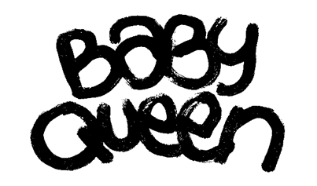

**RELEASES NEW SINGLE ‘WE CAN BE ANYTHING’**

**SECOND SINGLE FROM BABY QUEEN’S FORTHCOMING DEBUT ALBUM**

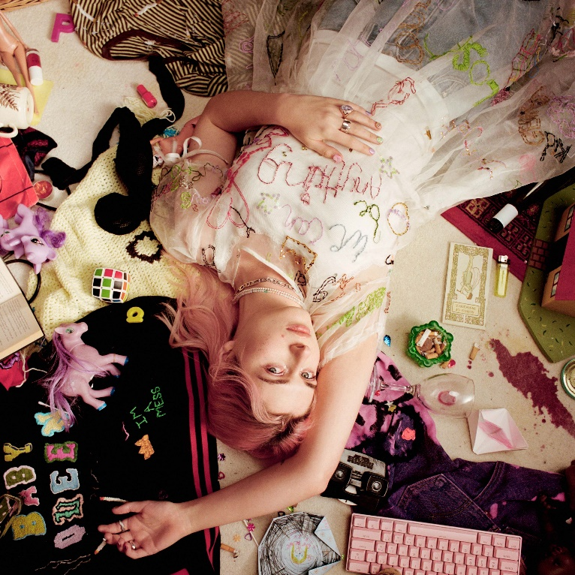

[LISTEN](http://babyqueen.lnk.to/WCBA)

[WATCH](http://babyqueen.lnk.to/WCBA/youtube)

**BABY QUEEN** today shares her new single **‘We Can Be Anything’** via Polydor Records**.**

**‘We Can Be Anything’** is the follow-up to recent single **‘Dream Girl’**, which ushered in a new era for **BABY QUEEN** and was her biggest streaming launch to date. Both tracks offer a taste of **BABY QUEEN**’s eagerly awaited forthcoming debut album – details of which are still to be revealed.

**‘We Can Be Anything’** comes with a video directed by Claryn Chong which picks up the story from **BABY QUEEN**’s recent video for **‘Dream Girl’**. Watch it [HERE](http://babyqueen.lnk.to/WCBA/youtube)

Elaborating on the powerful sentiment behind **‘We Can Be Anything’**, **BABY QUEEN** aka Bella Latham says, *“I’ve been having a prolonged existential crisis for the better part of the past 5 years and would consider myself to be a nihilist in many ways, which has made being alive quite bleak at times. I think human beings really crave purpose but there is ultimately no clear-cut reason we’re here and if there is one, we’re just not intelligent enough to figure it out. Despite it all, life is beautiful and i think our lack of purpose and our insignificance gives us the greatest level of freedom. Society, culture, rules, laws - these are all constructs. I like to believe that as long as you’re not hurting people, you do have the freedom and the prerogative to do with your life what you will. That’s what this song is about: non-confinement and non-conformity in the face of what is essentially absurdity. I just want people to listen to it and feel free - because they are free”*

Having spent the best part of the 2020s taking over London’s anarchic anti-pop scene and writing songs for a generation falling out of love with social media that transformed her into her genre’s reigning star, **BABY QUEEN** is discovering the more grounded and introspective side of herself too, leading to the creation of some of the most pure, excellent and affecting music of her life so far.

**‘BABY QUEEN** released a string of singles last year; ‘Lazy’, Nobody Really Cares’ and the wistful, romantic ‘Colours of You’, a track written specifically for Netflix’s global hit LGBTQ+ drama *‘Heartstopper’*, which returns this August.

[LEAD PRESS PHOTO](https://umusic.app.box.com/s/88cdmg6gk70o6db792v21agqeg0cci9y/file/1227533141564) (credit: NICOLE NGAI)

**FOLLOW BABY QUEEN:**

[**INSTAGRAM**](https://eur02.safelinks.protection.outlook.com/?url=https%3A%2F%2Fplayerapi.plaympe.com%2Fclick%2FeyJ0eXAiOiJKV1QiLCJhbGciOiJIUzI1NiJ9.eyJ1cmwiOiJodHRwczovL3d3dy5pbnN0YWdyYW0uY29tL3F1ZWVub2Z0aGViYWJpZXMvIiwicmVjaXBpZW50aWQiOjEzMTY2OCwicmVsZWFzZWlkIjoiMTM1MDY1MyJ9.yfPhAQ4Xp5AQBqQTQdYqgUYN55wCv2Lqzma8BsN9ZFc&data=04%7C01%7Csusie.ember%40umusic.com%7C8106a90e73f24ff81f5708d91ebd5f40%7Cbbcb6b2f8c7c4e2486e46c36fed00b78%7C1%7C0%7C637574620959694451%7CUnknown%7CTWFpbGZsb3d8eyJWIjoiMC4wLjAwMDAiLCJQIjoiV2luMzIiLCJBTiI6Ik1haWwiLCJXVCI6Mn0%3D%7C1000&sdata=Drh7sHEhltphibkQb7NPBLFQ%2Bss%2Fkn5u4h7fnsSfpNM%3D&reserved=0)**//**[**TIKTOK**](https://eur02.safelinks.protection.outlook.com/?url=https%3A%2F%2Fplayerapi.plaympe.com%2Fclick%2FeyJ0eXAiOiJKV1QiLCJhbGciOiJIUzI1NiJ9.eyJ1cmwiOiJodHRwczovL3d3dy50aWt0b2suY29tL0BxdWVlbm9mdGhlYmFiaWVzIiwicmVjaXBpZW50aWQiOjEzMTY2OCwicmVsZWFzZWlkIjoiMTM1MDY1MyJ9.2MtOY8QwkdmQAKh-FbLa6X5Scu2CPkULuFDhzoaTJ3Y&data=04%7C01%7Csusie.ember%40umusic.com%7C8106a90e73f24ff81f5708d91ebd5f40%7Cbbcb6b2f8c7c4e2486e46c36fed00b78%7C1%7C0%7C637574620959699429%7CUnknown%7CTWFpbGZsb3d8eyJWIjoiMC4wLjAwMDAiLCJQIjoiV2luMzIiLCJBTiI6Ik1haWwiLCJXVCI6Mn0%3D%7C1000&sdata=rvPeSzxGrrYBBGHdE35xtpF7ukO9foS0e8FvjJNL7xo%3D&reserved=0)**//**[**FACEBOOK**](https://eur02.safelinks.protection.outlook.com/?url=https%3A%2F%2Fplayerapi.plaympe.com%2Fclick%2FeyJ0eXAiOiJKV1QiLCJhbGciOiJIUzI1NiJ9.eyJ1cmwiOiJodHRwczovL3d3dy5mYWNlYm9vay5jb20vcXVlZW5vZnRoZWJhYmllcy8iLCJyZWNpcGllbnRpZCI6MTMxNjY4LCJyZWxlYXNlaWQiOiIxMzUwNjUzIn0.CRFaz1fQT0qiY46QTgaF8Qh6YoYdV89j9ibfZv1vBV8&data=04%7C01%7Csusie.ember%40umusic.com%7C8106a90e73f24ff81f5708d91ebd5f40%7Cbbcb6b2f8c7c4e2486e46c36fed00b78%7C1%7C0%7C637574620959704407%7CUnknown%7CTWFpbGZsb3d8eyJWIjoiMC4wLjAwMDAiLCJQIjoiV2luMzIiLCJBTiI6Ik1haWwiLCJXVCI6Mn0%3D%7C1000&sdata=OR%2BdrhVzlhoyqwwdvGl6w8SMkUS8qfnjNAQnm8FPhrk%3D&reserved=0)**//**[**TWITTER**](https://eur02.safelinks.protection.outlook.com/?url=https%3A%2F%2Fplayerapi.plaympe.com%2Fclick%2FeyJ0eXAiOiJKV1QiLCJhbGciOiJIUzI1NiJ9.eyJ1cmwiOiJodHRwczovL3R3aXR0ZXIuY29tL2JhYnlvZnRoZXF1ZWVuIiwicmVjaXBpZW50aWQiOjEzMTY2OCwicmVsZWFzZWlkIjoiMTM1MDY1MyJ9.C9wD33MObjpV_WWvna0bgVtitnPnYOIk1eU60hh2amk&data=04%7C01%7Csusie.ember%40umusic.com%7C8106a90e73f24ff81f5708d91ebd5f40%7Cbbcb6b2f8c7c4e2486e46c36fed00b78%7C1%7C0%7C637574620959709390%7CUnknown%7CTWFpbGZsb3d8eyJWIjoiMC4wLjAwMDAiLCJQIjoiV2luMzIiLCJBTiI6Ik1haWwiLCJXVCI6Mn0%3D%7C1000&sdata=3dBR31cZkRpRqKnJ6wqMiSSZ3HwuCmA1gZmjtLarZik%3D&reserved=0) **//**[**YOUTUBE**](https://www.youtube.com/channel/UC9S9t9qA3hf0DqvOd3YdHqQ)

**For more information please contact** [**jenny@chuffmedia.com**](mailto:jenny@chuffmedia.com)