

**CAITY BASER UNVEILS BRAND NEW SINGLE**

**HERALDS A BOLD, FRESH NEW DIRECTION FOR THE BRIT NOMINATED UK SINGER AND ARTIST**

**‘WATCH THAT GIRL (SHE’S GONNA SAY IT)’ OUT NOW VIA CAPITOL RECORDS UK / CHOSEN MUSIC**

[***LISTEN HERE***](https://caitybaser.lnk.to/WTG)



*Single artwork for Caity Baser’s ‘Watch That Girl (She’s Gonna Say It). All press assets available* [*here*](https://drive.google.com/open?id=1465OdVOS_-RUBFReow_pZpu0sTAbQeIB&usp=drive_fs)*.*

Caity Baser has released her brand new single, ‘Watch That Girl (She’s Gonna Say It)’, out now via Capitol Records UK.

The song signals a bold & fearless new direction for the 22-year-old BRIT Award-nominated singer, both in terms of sound and lyric.

Co-written and performed by Caity with acclaimed duo Oh Wonder, the single’s fresh, more sophisticated sonic direction for Caity includes a lush, all-live instrumentation—a first in her career. Featuring vibrant arrangements of live guitars, piano, drums, horns, strings, organ, and a chanting choir, the song’s production and Caity’s vocal performance include nods to many of Caity’s favourite inspirations such as the timeless sounds of Motown, writers of the great American songbook, theatrical classics and many of legendary divas who have shaped music history.

This new sound is matched by a deeper lyrical maturity. Where Caity’s past hits often explored themes of boys and relationship struggles, this single signals a shift in tone. ‘Watch That Girl (She’s Gonna Say It)’ finds Caity confronting her past head-on, weaving themes of growth, self-reflection, and empowerment into her songwriting and combining recollections of her real-life experiences with imagery and symbolism previously unexplored by Baser. Despite this evolution, Caity’s trademark honesty and vulnerability remain central, continuing the candid storytelling her fans have come to love.

Of the single, Caity says:

*“I’m back! Surprise!! And I am SO happy to introduce you to my brand new song Watch That Girl (She’s Gonna Say It). The start of my new musical journey and I’m so excited to share it with you all!*

*It is different from what you’ve heard from me before, but hopefully you can hear it’s the same me, and just like always: I’m being as honest and true to myself as possible.*

*At some point after festival season last year l went into the studio and let my feelings out, like I’d never done before. I am confronting what’s inside my head - the good, the bad and the ugly - and this is my start of it all. No more hiding from my past; just going straight at it. And it feels fucking great! I am so happy. And I hope it can give you the same feels when you listen to it xx”*

‘Watch That Girl (She’s Gonna Say It)’ is the first new music to come from Caity Baser in 2025, following a landmark breakthrough year for her in 2024.

Her mixtape ‘Still Learning’, released last year, earned Caity a top 10 in the UK album charts and followed her nomination for the BRITs Rising Star Award. She hit the road for her UK tour which saw her perform at sold-out venues across the country, totalling over 30,000 tickets sold - including London’s Hammersmith Apollo. She performed twice at last year’s Glastonbury Festival and capped off the year with a one-off, special Christmas show just for her fans, to give back to them after supporting her so much throughout her career. The theme of accessibility and unity with her fanbase has been an ongoing one for Caity, including when she announced her tour ticket prices would be capped to help her young fans during the cost of living crisis.

Caity Baser’s critical acclaim has also been widespread for such a young star. She has been the cover star of esteemed music and culture publications such as NME, Dork Magazine, Notion Magazine and was praised by The Guardian for her live show and its “*chatty, bratty, cartwheeling celebration of girlhood”*. Rolling Stone UK chose Caity as their Future Of Music artist and she has been similarly championed by The BBC, The Independent, DIY, CLASH, Hunger, Daily Star, The Sun, The Mirror as well as Capital Radio, BBC Radio 1’s Mollie King, Greg James, Jack Saunders and more.

‘Watch That Girl (She’s Gonna Say It)’, the new single by Caity Baser, is out now via Capitol Records UK/Chosen Music. More music and news will follow from her very soon.

For more on Caity Baser:

[Instagram](https://www.instagram.com/caitybaser/) | [Twitter](https://twitter.com/BaserCaity) | [TikTok](https://vm.tiktok.com/ZMeWEqbX9/) | [Website](https://caitybaser.com/) | [Facebook](https://www.facebook.com/CaityBaserOfficial) | [Spotify](https://open.spotify.com/artist/7dJCdUO0l0K2WXzrzjYpmC?si=hejaYPcQQQSjwXQz1ntW-Q) | [Apple Music](https://music.apple.com/gb/artist/caity-baser/1555239928) | [Amazon](https://music.amazon.co.uk/artists/B08XLQ2RQY/caity-baser?)

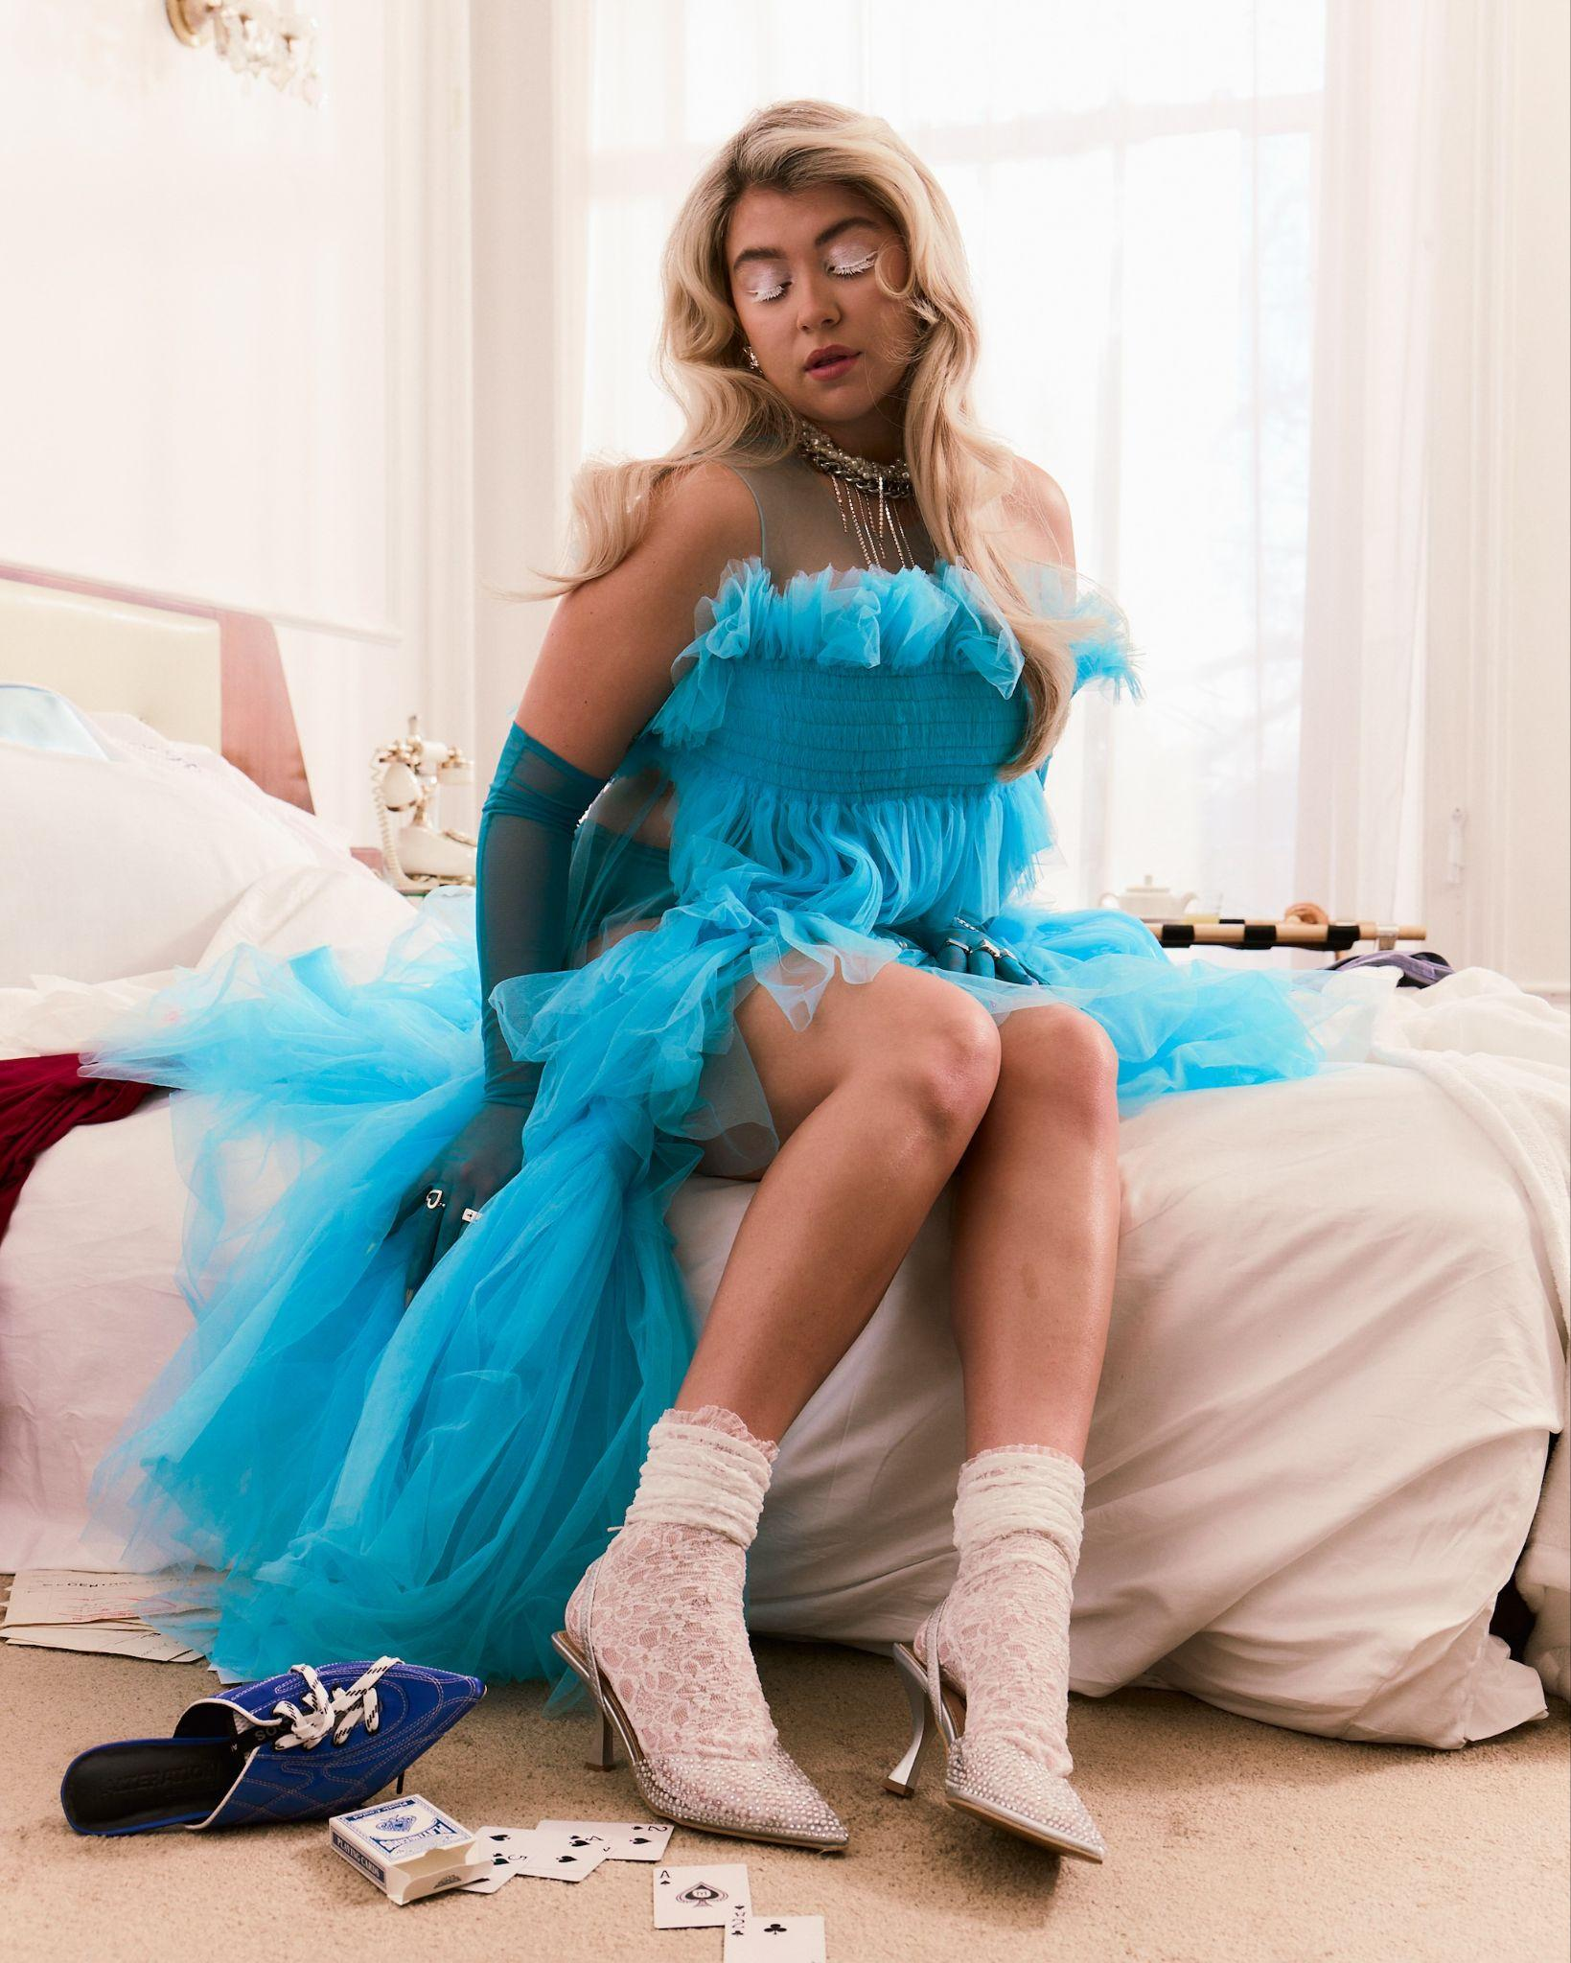

*Caity Baser press shot, credit Finn Waring. All press assets available* [*here*](https://drive.google.com/open?id=1465OdVOS_-RUBFReow_pZpu0sTAbQeIB&usp=drive_fs)*.*

***For more info contact:***

***Warren Higgins***

[***warren@chuffmedia.com***](mailto:warren@chuffmedia.com)