CANADIAN BREAKTHROUGH ARTIST ‘TALK’ SHARES EPIC BELTER“WASTELAND”

LISTEN here.

FOLLOWS SOLD-OUT UK SHOW AT LONDON’S LOWER THIRD

DEBUT ALBUM LORD OF THE FLIES & BIRDS & BEES
OUT OCTOBER 20TH


Photo Credit: Carina Allen

Ahead of his debut album Lord of the Flies & Birds & Bees out October 20th, platinum-selling artist TALK releases his epic new single “Wasteland” via EMI/Capitol Records/Range Music. Listen here.

Massive guitar riffs stack alongside TALK’s stadium-sized vocal on this belting track, which builds to a rousing chorus, transporting you directly to the front of a euphoric festival crowd.

Born Nicholas Durocher and raised in Ottawa, the 25-year-old TALK is a multi-instrumental wizard, trained in piano, guitar, drums, bass, banjo, harmonica and the mandolin.

Durocher was built for the spotlight; he burst onto the scene with viral single ‘Run Away To Mars’, an emotional ballad with intergalactic ambition. The track tapped into the common sense of loneliness experienced during the pandemic and resonated with millions of people around the globe.

“Wasteland” will feature on TALK’s debut album with previously released songs “A Little Bit Happy” and “Afraid Of The Dark”. Lord of The Files & Birds & Bees was executive produced by prolific songwriter/producer Justin Tranter, who stepped in shortly after hearing TALK’s vocals on his viral single, “Run Away To Mars.” “I was sentTALK’s first single, “Run Away To Mars”, a day after it came out and I was blown away. I immediately wanted to write with him. He is vulnerable, he is rock ‘n roll, and he’s a SINGER – in all capital letters,” Justin said.

Over the last few months TALK has been playing sold out shows across Europe and recently played a sold-out show at London’s Lower Third.

A singular artist, bright bold and a modern rockstar, TALK is a one to watch for 2024 !

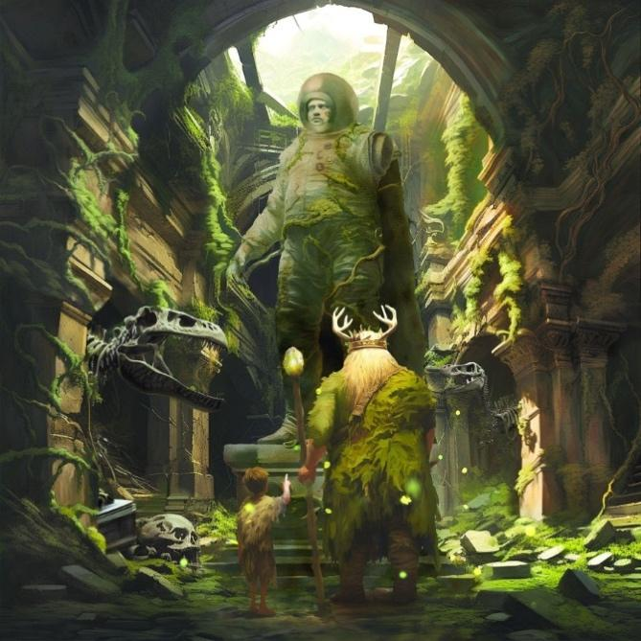

Album packshot - Download Hi-Resolution Single Graphic Here

For more information please contact
Warren Higgins
Warren@chuffmedia.com on 07762 130 510

