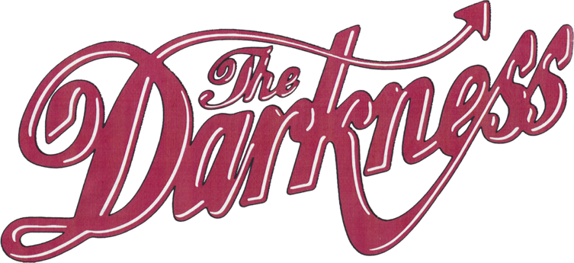


‘WALKING THROUGH FIRE’
BRAND NEW SINGLE RELEASED
WATCH HERE / LISTEN HERE

DREAMS ON TOAST
NEW ALBUM OUT MARCH 28TH 2025
VIA COOKING VINYL
PRE-ORDER HERE

TOURING UK IN MARCH 2025
WITH SUPPORT FROM ASH
TICKETS ON SALE NOW HERE

The Darkness have released their scorching new single ‘Walking Through Fire’, the latest song to be taken from their forthcoming album Dreams On Toast out March 28th via Cooking Vinyl. Watch the in-the-studio visualizer HERE. Pre-order the album now HERE.

‘Walking Through Fire’ is an epic Darkness anthem with signature guitar solos, a thunderous rhythm section and high-flying falsetto flourishes which deliver an amusing ode to the band’s love of rock ‘n’ roll and the state of the music industry in 2025.

Regarding the single Justin Hawkins says, “The life of an artist is gruelling endeavour, leavened with rare moments of shining success. We wade through sweet treacle every day, to make things for others to love.

For we chosen few, this is akin to climbing a mountain for the glorious view, whilst studiously avoiding looking at the discarded condom that has attached itself to our stylish yet practical hiking footwear.

To rephrase in less oblique tones, nothing worthwhile is ever easy, and that is why we, The Darkness, are WALKING THROUGH FIRE… thinking of you.”

Produced by Dan Hawkins, Dreams On Toast flawlessly captures The Darkness at their peak, celebrating their influences and strengthening their sound, while also embarking on avenues never before heard from the band. It’s an indisputably grand display from the inspired and passionate quartet.

The diversity of the record has been displayed in recent singles such as the ‘70s pop genius of ‘The Longest Kiss’, searing hard rock of ‘Rock And Roll Party Cowboy’ and the self-deprecating glam punk rock of ‘I Hate Myself’. There are further sonic delicacies to be revel in on the forthcoming record, including the ‘60s inspired balladry of ‘Hot On My Tail’, a monologue from actor Stephen Dorff on the romantic closer ‘Weekend In Rome’, and even a country classic with ‘Cold Hearted Woman’.

Destined to further cement The Darkness as one of Britain’s most important, eclectic and courageous rock bands, Dreams On Toast finds Justin, Dan, Frankie and Rufus continuing to push boundaries. Over two decades deep into their multi-platinum, award-winning career, they offer up unexpected surprises to bedazzle and amaze fans once again in 2025.

The Darkness will be taking the album on the road with the Dreams On Toast UK headline tour seeing them play 18 shows across the country finishing at London’s OVO Wembley Arena on March 29th. This will be followed by a further 21 dates across Europe.

Full dates and tickets are available here https://www.thedarknesslive.com/.

Full UK dates are listed below:

THE DARKNESS 2025 UK HEADLINE TOUR DATES
06/03 - Ipswich, Regent’s Theatre (SOLD OUT)
07/03 - Ipswich, Regent’s Theatre (SOLD OUT)
08/03 - Oxford, New Theatre (SOLD OUT)
09/03 - Swansea, Arena
11/03 - Guildford, G Live (SOLD OUT)
12/03 - Hull, Connexin Arena
14/03 - Liverpool, Guild Of Students (SOLD OUT)
15/03 - Wolverhampton, Civic Hall (SOLD OUT)
17/03 - York, Barbican (SOLD OUT)
18/03 - Edinburgh, Usher Hall (SOLD OUT)
20/03 - Glasgow, Royal Concert Hall (SOLD OUT)
21/03 - Newcastle, O2 City Hall (SOLD OUT)
22/03 - Manchester, O2 Apollo (SOLD OUT)
24/03 - Bristol, Beacon Theatre (SOLD OUT)
25/03 - Portsmouth, Guildhall
27/03 - Leicester, De Montford Hall (SOLD OUT)
28/03 - Cambridge, Corn Exchange (SOLD OUT)
29/03 - London, OVO Arena Wembley

DREAMS ON TOAST TRACK LISTING
- Rock And Roll Party Cowboy
- I Hate Myself
- Hot On My Tail
- Mortal Dread
- Don’t Need Sunshine
- The Longest Kiss
- The Battle For Gadget Land
- Cold Hearted Woman
- Walking Through Fire
- Weekend In Rome

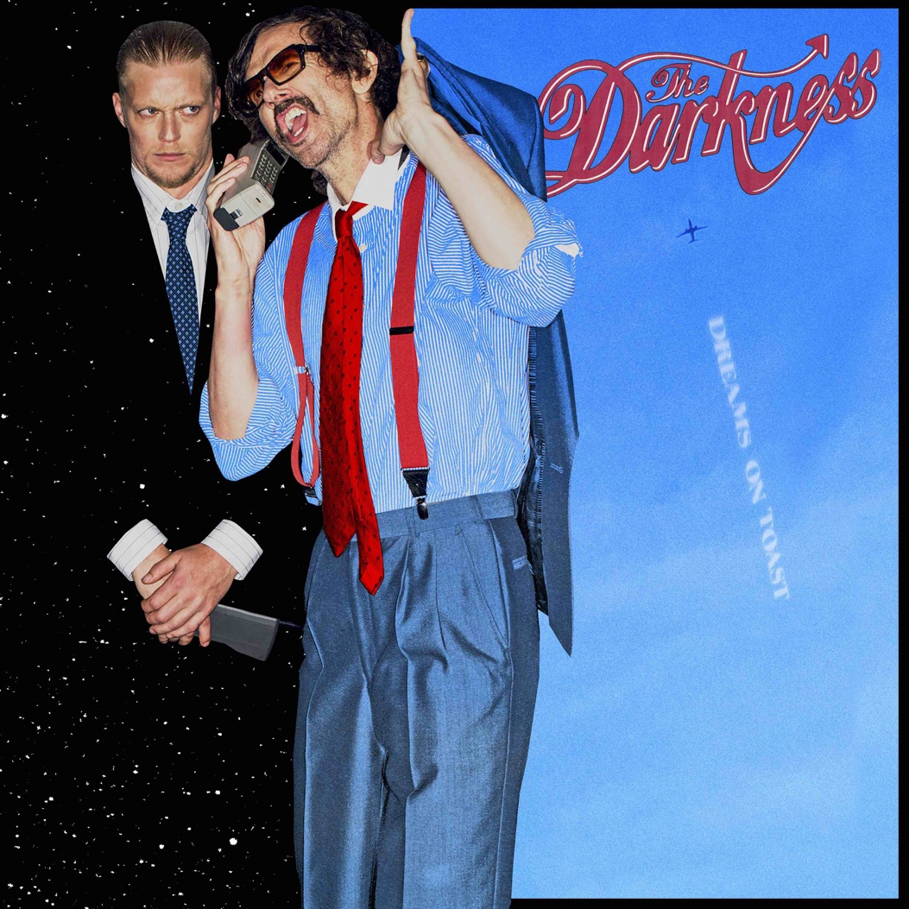
Dreams On Toast album artwork designed by Grammy nominated artist Perry Shall

For all media enquiries please contact warren@chuffmedia.com

