JONAS BROTHERS ARE BACK WITH SOARING NEW SINGLE “WINGS” TODAY

ACCOMPANIED BY OFFICIAL VIDEO FEATURING HALEY LU RICHARDSON

SET TO MAKE HIGHLY ANTICIPATED RETURN WITH NEW RECORD THE ALBUM OUT MAY 12TH

EXECUTIVE PRODUCED BY SINGER, SONGWRITER & PRODUCER JON BELLION

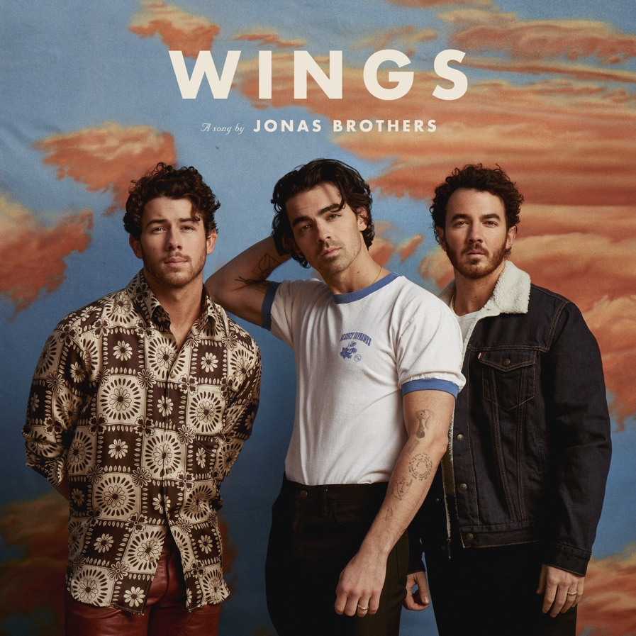
Download Press Assets HERE
LISTEN TO “WINGS” HERE
WATCH THE OFFICIAL VIDEO HERE
PRE-ORDER/PRE-SAVE THE ALBUM HERE

NEW YORK, NY – FEBRUARY 24TH, 2023 – Today, GRAMMY® Award-nominated powerhouse trio Jonas Brothers return with their anxiously-awaited new single “Wings,” out now via Republic Records—listen to “Wings” HERE. “Wings” launches a new era for the band and is the first single from their sixth full-length record—and one of the most anticipated releases of the year—The Album, out May 12th.

The new song is released alongside the official music video featuring actress and self-proclaimed Jonas Brothers fan Haley Lu Richardson [White Lotus]. Shot in Las Vegas and directed by Josh Rimmey and Zach Williams, the feel-good video includes an impromptu hotel room dance party and surprise cameo by the Jonas Brothers themselves.

Kicking off another chapter, The Album marks Jonas Brothers’ first body of work since 2019’s Platinum-Certified Happiness Begins, which debuted at #1 on the Billboard 200 and spawned the GRAMMY® Award-nominated, 5x-Platinum, Billboard Hot 100 #1 smash hit “Sucker.” Pre-order/Pre-save The Album now HERE.

Executive produced by sonic visionary artist Jon Bellion [Justin Bieber, Maroon 5, Halsey], “Wings” revs up with shimmering keys, as it embraces late 70’s pop with thick bass, hummable synth runs, and heavenly harmonies. Wrapped up with lush guitar, a head-nodding beat, and no shortage of fiery falsetto, it culminates on the instantly chantable chorus “You are the wings I need to fly away.” The band began teasing the song on socials last month to online chatter and debuted it in full for the very first time last weekend at their “Jonas Brothers: Live in Las Vegas” residency.

The Jonas Brothers said, “‘Wings’ is the perfect start to this new chapter for us. Working with Jon pushed us to explore our artistry in a way we never have before. The song is a great first taste of that creative exploration and what’s to come with THE ALBUM.”

Jon Bellion chimed in, saying, “We wanted to wipe the palette clean and demolish every expectation and box the brothers have ever been put into out the gate. We pushed ourselves to launch this thing musically into space while grounding it in a sort of Americana / Laurel Canyon nostalgia. There was a time when structure and composition mattered not only loops and vibes, and we dove into that mind frame. We went so deep into the spirit and energy of the late 70’s, the mustaches and long hair method acting approach started to just become our actual reality. The brothers have a God given ability and talent that deserves this level of record making at this point, and I just wanted to honor how special they are with this music.”

Jonas Brothers notably wrote and recorded The Album with Bellion at the helm. Together, they unlocked the next level for the band, embracing formative influences and igniting their sound from every angle. They delivered an unpredictable, undeniable, and unstoppable record uplifted by their inimitable chemistry and endless creativity.

This is The Album. This is Jonas Brothers in 2023.

THE ALBUM TRACKLIST
- “Miracle”
- “Montana Sky”
- “Wings”
- “Sail Away”
- “Americana”
- “Celebrate!”
- “Waffle House”
- “Vacation Eyes”
- “Summer in the Hamptons”
- “Summer Baby”
- “Little Bird”
- “Walls” feat. Jon Bellion

ABOUT JONAS BROTHERS
Jonas Brothers lean on an unbreakable familial bond to elevate pop music. Standing out as one of the most successful groups of the 21st century, New Jersey-born brothers—Nick Jonas, Joe Jonas, and Kevin Jonas—have sold north of 20 million albums and counting, garnered two GRAMMY® Award nominations, earned 25 Billboard Hot 100 hits, logged three consecutive #1 debuts on the Billboard 200, and generated billions of streams. Among many accolades, they’ve claimed a star on the Hollywood Walk of Fame and headlined legendary venues on both coasts, including Madison Square Garden in New York and The Hollywood Bowl in Los Angeles. In 2019, they notably ignited the comeback of the decade with their Platinum-Certified Republic Records debut, Happiness Begins. It yielded the history-making, 5x-Platinum smash “Sucker,” which minted them as “the first group in the 21st century to debut at #1 on the Hot 100,” exploded as the “longest running #1 Pop Airplay Single of 2019,” and received a GRAMMY® Award nomination in the category of “Best Pop Duo/Group Performance.” Bowing at #1 on the Billboard 200, Happiness Begins impressively scored the “biggest sales week of 2019 at time of release” and housed the Double-Platinum “Only Human” and platinum “Cool.” The band supported the album with the worldwide “Happiness Begins Tour”—selling over 1.2 million tickets—and the Amazon Original documentaries Chasing Happiness and Happiness Continues. Along the way, the members simultaneously juggled prolific solo careers. However, nothing quite matches their union as Jonas Brothers, and it powers their 2023 full-length The Album, produced by Jon Bellion and introduced by the single “Wings.”
JONAS BROTHERS: TIKTOK | INSTAGRAM | TWITTER | FACEBOOK | YOUTUBE | WEBSITE
For more information and press enquiries please contact

Jenny Entwistle
Jenny@chuffmedia.com

