YARD ACT

SHARE NEW SINGLE & VIDEO ‘WE MAKE HITS’

SECOND ALBUM WHERE’S MY UTOPIA? - OUT 1 MARCH 2024 ON ISLAND

UK & EU SPRING 2024 TOURING - INCLUDING EVENTIM APOLLO HAMMERSMITH (27 MARCH)

5,750 CAPACITY MILLENNIUM SQUARE LEEDS SHOW (3 AUGUST)

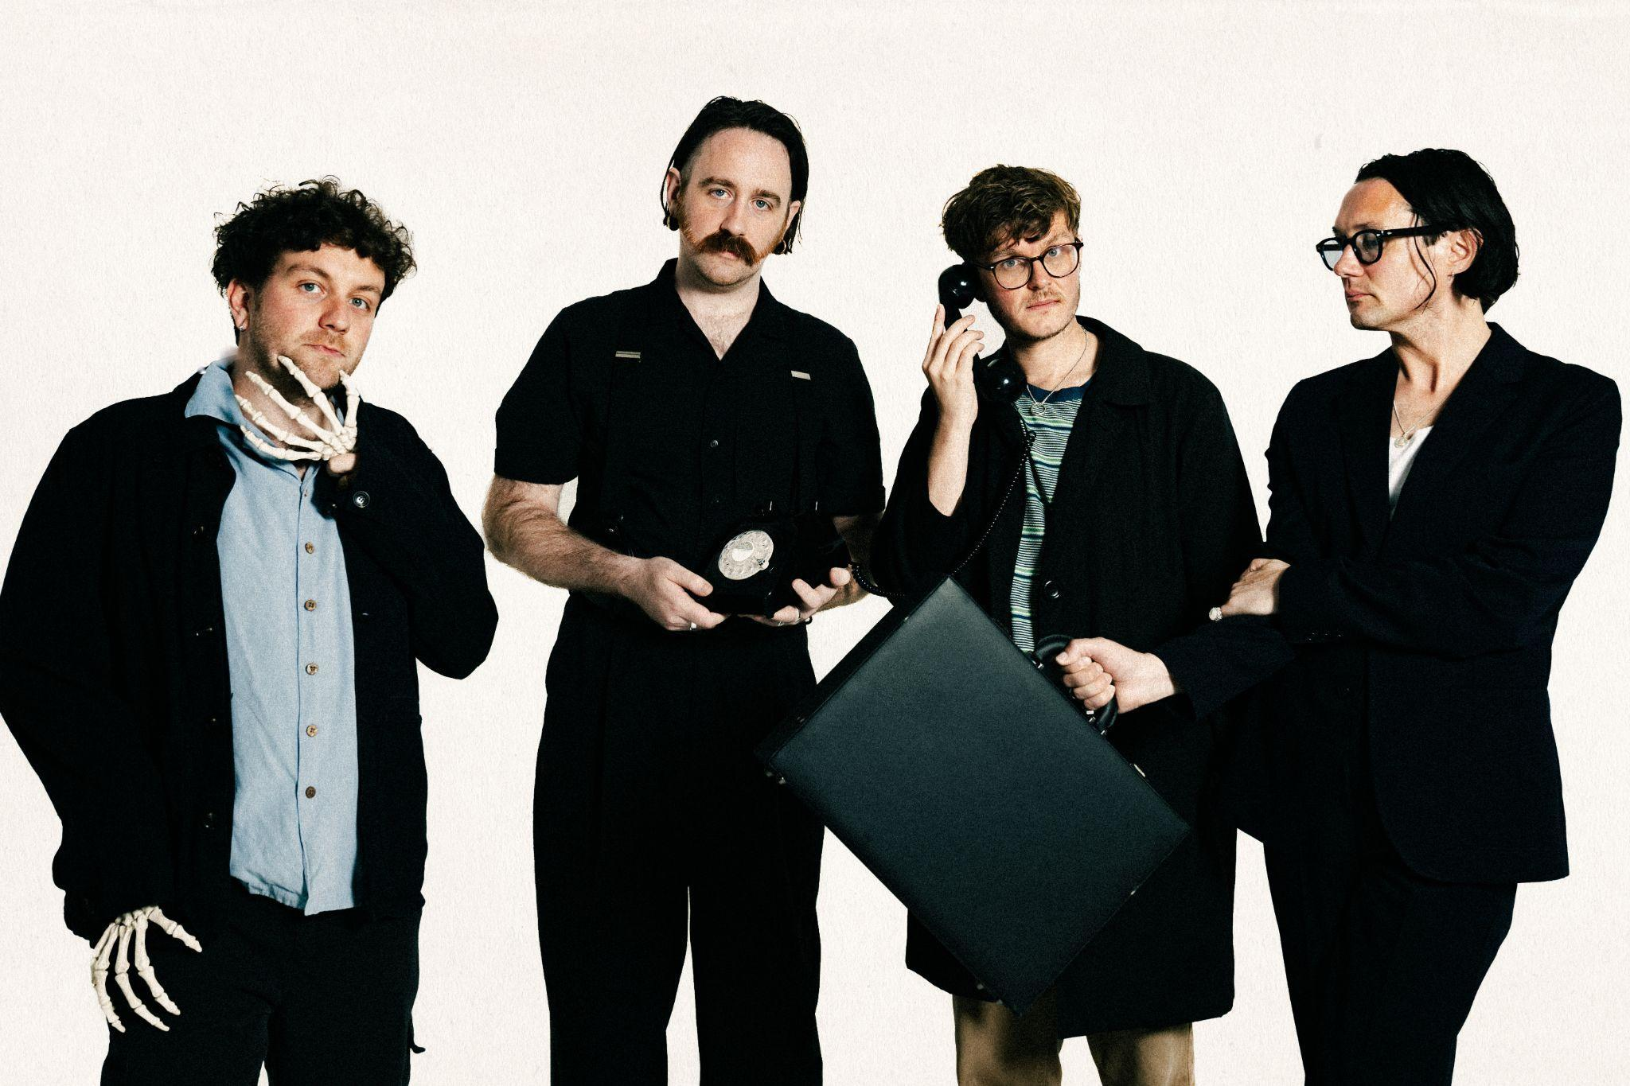

Photo credit: Phoebe Fox

Listen to ‘We Make Hits’ HERE

Watch the ‘We Make Hits’ video HERE

Preorder Where’s My Utopia? HERE

Yard Act have today shared ‘We Make Hits’, another taste of their upcoming second album Where My Utopia? - due out on 1 March 2024 via Island. The single debuted on Steve Lamacq’s brand new Teatime Session show on BBC Radio 6 Music earlier today.
Where’s My Utopia? is the follow up to the Leeds band’s breakout debut record The Overload which arrived in January 2022. The Overload was shortlisted for the Mercury Prize after a slew of positive reviews, national radio playlistings and a placing at #2 in the Official Charts. The new album is a co-production between Yard Act and Gorillaz member Remi Kabaka Jr.

Yard Act have announced a huge run of shows in the UK and EU for spring 2024 - including the Eventim Apollo Hammersmith on 27 March - and their biggest hometown show to date at the 5,750 capacity Millennium Square Leeds on 3 August.

‘We Make Hits’ follows the album’s lead single ‘Dream Job’, which arrived in October to huge acclaim. The videos for both tracks are directed by James Slater; the band and director’s 7th and 8th collaborations. Yard Act’s James Smith says of ‘We Make Hits’: “QUOTE.”

Speaking about the ‘Petroleum’ video, Slaters said: “QUOTE.”

Yard Act opened the main stage at Reading & Leeds Festival last summer as well as making appearances at Latitude (headlining the BBC Sounds stage, no less), Fuji Rocks, and Boardmasters. The band also returned to North America in November 2023 with a run of headline shows across the US, culminating in a slot at Mexico City’s Corona Capital Festival. Yard Act delivered an unprecedented five night residency at their hometown’s Brudenell Social Club in 2023 which was awarded four stars each in reviews from Rolling Stone UK, The Telegraph, and The Times. The band were joined by a stellar lineup of comedians; Phill Jupitus, Nish Kumar, Lolly Adefope, and Harry Hill. Yard Act also made their festival headline bow at Dot To Dot in Bristol & Nottingham, performed at Primavera (Barcelona, Madrid & Porto) and played their maiden shows in Australia and New Zealand, truly making their mark on the global stage

***

What do you do when everything you’ve ever wanted suddenly lands in your lap, but the questions still keep on coming?

Since first steering their golden Rover into swift public acclaim back in 2020, Leeds quartet Yard Act have become one of the great indie success stories of the decade so far. Along the way, they’ve ticked off milestones ranging from a Number Two chart placing and Mercury Prize nomination for debut album The Overload, to a co-sign from Elton John who joined the band to guest on a string-laden reworking of album closer ‘100% Endurance’.

Yet, whilst the band’s trajectory continuously shot upwards, vocalist James Smith and his wife had also welcomed in a son. And it’s this duelling sense of responsibility and ambition, guilt, love, drive and everything in between that forms the narrative backbone of brilliantly exploratory second album Where’s My Utopia?

Written in snapshots of time between a relentless touring schedule, and produced jointly by the band and Gorillaz’ Remi Kabaka Jr, the quartet’s second act is a giant leap forward into broad and playful new sonic waters. “The main reason that ‘post-punk’ was the vehicle for Album One was because it was really affordable to do, but we always liked so much other music and this time we've had the confidence to embrace it,” James explains. Across the record, influences ranging from Fela Kuti to Ennio Moricone via Spiller’s ‘00s pop smash ‘Groovejet’ make themselves known.

It’s a celebratory palette upon which Smith allowed himself to reach lyrically deeper into himself than ever. Gone, largely, are the outward-facing character studies of yore, replaced with a set of songs that stare fully into the headlights of life, wrangling with the frontman’s own fears and foibles to create a sort of Promethean narrative - but with jokes. “You can commit to the idea that we’re just animals who eat and fuck and then we die, and that’s fine,” he suggests. “But for me, creativity always seems to be the best way of articulating the absolute minefield of what human existence is.”

***

Praise for Yard Act’s The Overload:

“lives up to its hype with flying colours”
DIY 5*

“A stellar debut”
Rolling Stone UK 5*

“We hope the rest of 2022’s musical output is as good as this album.”
Dork 5*

“will remain omnipresent in the music press for another 12 months to come”
The Forty Five 5*

“a resounding success”
The Scottish Express 5*

“A debut album bursting with character”
Uncut 4 ½ *

“an album of deeply relatable storytelling for the plight of the ordinary people”
The Line Of Best Fit 4 ½ *

“An exhilarating record”
MOJO Album of the Month 4*

“witty post-punks confront post-Brexit Britain”
The Guardian Album of the week 4*

“The much lauded rock band from Leeds justifies the hype with a set of 11 smart, fierce tracks”
The Telegraph Album of the week 4*

“an exciting prospect for 2022”
The Times 4*

“an overload of good ideas”
The Daily Star 4*

“rabble-rousing, likeable post-punk rock”
The Sun 4*

“Seldom do you hear such sentimentality and beauty in music as brusque as this”
NME 4*

“the greatest lyrical party you will have in a long time”
Gigwise 4*

***

See Yard Act live in 2024:

13 Mar | The Nick Rayns LCR (UEA), Norwich, UK
14 Mar | Rock City, Nottingham , UK
15 Mar | O2 Academy, Glasgow, UK
16 Mar | O2 Apollo, Manchester, UK
17 Mar | Northumbria University, Newcastle, UK
19 Mar | Mandela Hall, Belfast, UK
20 Mar | Vicar Street, Dublin, IE
22 Mar | Invisible Wind Factory, Liverpool, UK
23 Mar | O2 Academy, Bristol, UK
25 Mar | The Dome, Brighton, UK
27 Mar | Eventim Apollo, London, UK

04 Apr | Stereolux, Nantes, FR
05 Apr | Cabaret Sauvage, Paris, FR
06 Apr | Rock School Barbey, Bordeaux, FR
08 Apr | LAV, Lisbon, PT
09 Apr | Mon, Madrid, ES
11 Apr | La 2, Barcelona, ES
12 Apr | Le Transbordeur, Lyon, FR
13 Apr | Locomotiv Club, Bologna, IT
14 Apr | Santeria Toscana 31, Milan, IT
16 Apr | Mascotte, Zurich, CH
17 Apr | Muffathalle, Munich, DE
18 Apr | Festsaal Kreuzberg, Berlin, DE
19 Apr | Loppen, Copenhagen, DK
20 Apr | Slaktkyrkan, Stockholm, SE
24 Apr | Uebel & Gefährlich, Hamburg, DE
25 Apr | Paradiso Main Hall, Amsterdam, NL
26 Apr | Doornroosje, Nijmegen,NL
27 Apr | Kantine, Cologne, DE
28 Apr | Les Nuits Botanique, Brussels, BE

30 May | Belly Up Tavern, Solana Beach, CA
31 May | The Regent Theater, Los Angeles, CA
1 Jun | Pappy and Harriet's, Pioneertown, CA
3 Jun | The Catalyst Atrium, Santa Cruz, CA
4 Jun | The Independent, San Francisco, CA
6 Jun | Mississippi Studios, Portland, OR
7 Jun | Rickshaw Theatre, Vancouver, BC
8 Jun | The Crocodile, Seattle, WA

3 Aug | Millenium Square, Leeds, UK

***

Yard Act - Where’s My Utopia? - out 01/03/2024 via Island

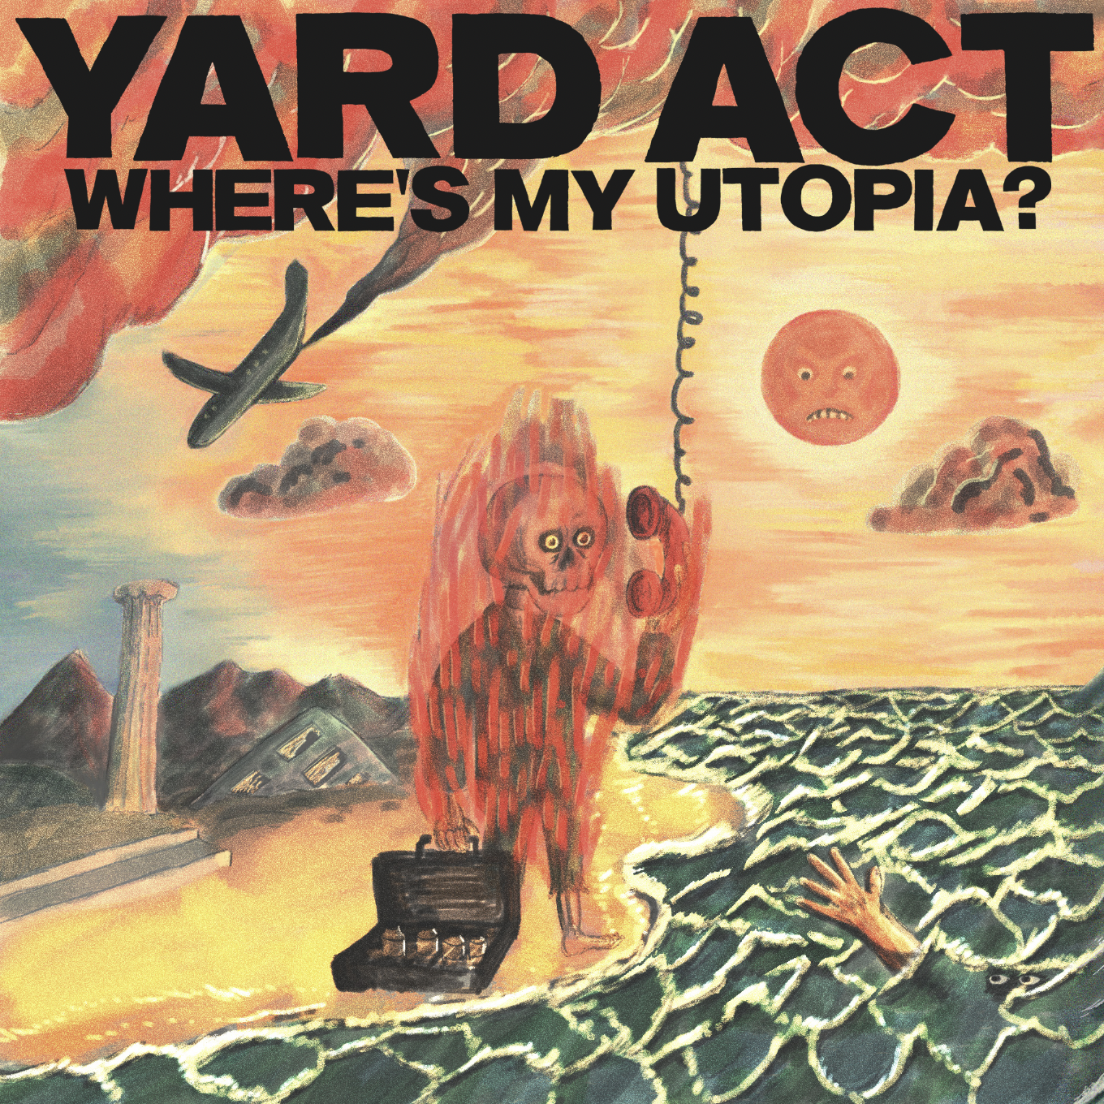

1. An Illusion
2. We Make Hits
3. Down By The Stream
4. The Undertow
5. Dream Job
6. Fizzy Fish
7. Petroleum
8. When The Laughter Stops (ft. Katy J Pearson)
9. Grifter's Grief
10. Blackpool Illuminations
11. A Vineyard for the North

For more info contact Warren warren@chuffmedia.com

