OLIVIA DEAN

SHARES NEW SINGLE ‘UFO’
WATCH VISUALS HERE

SELLS OUT LONDON’S ROUNDHOUSE IN HOURS

ADDED TO ALREADY SOLD OUT MARCH 2023
UK + EUROPE TOUR DUE TO HUGE DEMAND

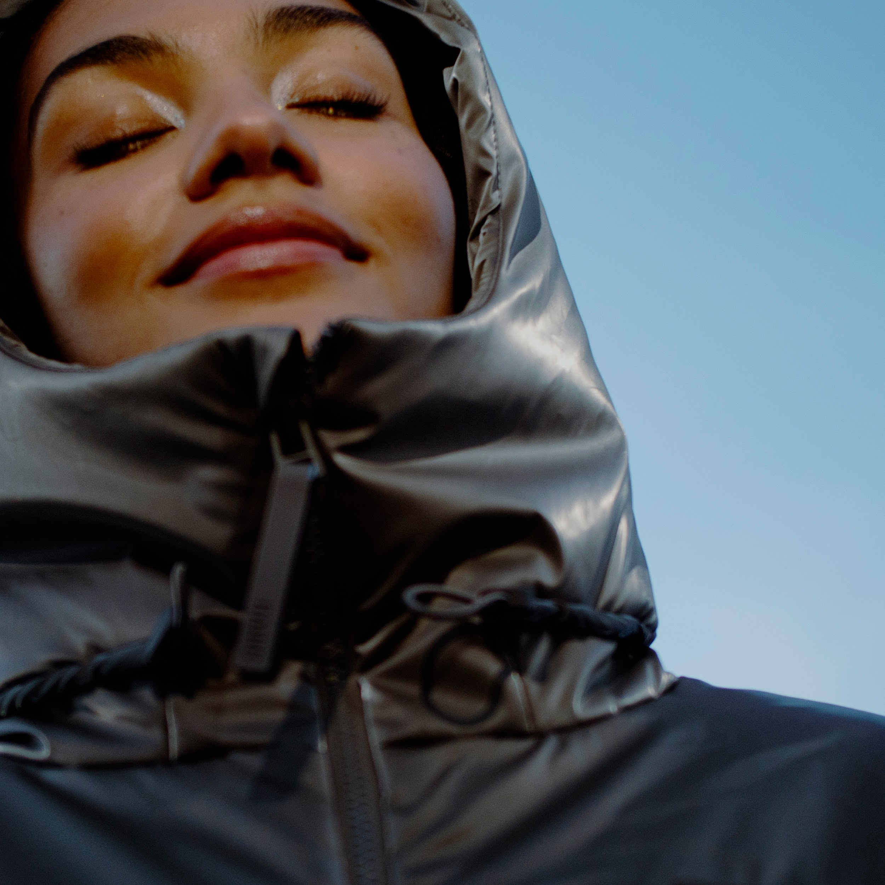
Hi-res assets here // Photo credit: Raminta Ceponyte

Olivia Dean today shares her new single ‘UFO’ via EMI Records. Dubbed a “shy love song”, ‘UFO’ takes a more stripped back approach to Dean’s infectious pop songwriting, with uniquely synthesized vocals and softly glimmering instrumental moments. It comes paired with a shimmering, metallic, one-take visualiser. ‘UFO’ is the forthcoming single from Olivia Dean’s yet-to-be-announced debut album, due for release this year.

She shares “UFO was born out of a conversation over a cup of tea with Matt Hales (co-writer and producer). We were joking about how love is a “sexy problem” to have and thought it would be funny to try and put it in a song. I wanted it to feel intimate and existential and so we kept it simple with guitar and a vocoder. It’s a shy love song, thoughts I would normally keep to myself but am learning to share.”

Listen to ‘UFO’

Watch the video for ‘UFO’

The new release follows Olivia’s recent announcement of her biggest headline show to date, due to take place at London’s Roundhouse on 17th March 2023, which she completely sold out in a matter of hours. The additional date was added to her sold out UK and Europe tour set to take place across March, where she’ll play to over 10,000 fans. Olivia will this week support Kojey Radical at his Brits Week for War Child show at London’s XOYO, and will support Loyle Carner’s forthcoming sold out show at OVO Wembley Arena on 16th March. See below for full list of dates.

Olivia Dean recently made her much-anticipated return with new single and accompanying video ‘Danger’, which has been added to the BBC Radio 1 playlist. Olivia opened the red carpet at December’s Fashion Awards with a special performance of the track.

Following performances at Glastonbury, Rock en Seine, Standon Calling and Cross The Tracks festivals in summer 2022, Olivia has been busy working on her long-awaited debut album, expected for release in 2023.

Olivia Dean - photo credit: Raminta Ceponyte

Olivia Dean 2023 tour dates
3 February - XOYO, London - SOLD OUT ^
7 March - Trinity, Bristol - SOLD OUT
8 March - King Tut’s, Glasgow - SOLD OUT
9 March - Wardrobe, Leeds - SOLD OUT
11 March - O2 Institute 2, Birmingham - SOLD OUT
12 March - Gorilla, Manchester - SOLD OUT
13 March - O2 Academy 2, Oxford - SOLD OUT
15 March - KOKO, London - SOLD OUT
16 March - OVO Arena Wembley, London - SOLD OUT *
17 March - Roundhouse, London - SOLD OUT
20 March - Tolhuistuin, Amsterdam - SOLD OUT
21 March - Ancienne Belgique, Club, Brussels - SOLD OUT
22 March - Badaboum, Paris - SOLD OUT
24 March - Emmauskirche, Berlin - SOLD OUT

^ supporting Kojey Radical
* supporting Loyle Carner

About Olivia Dean

Born and raised in Walthamstow, Olivia Dean is one the UK’s brightest rising stars, praised for her endearing, down-to-earth lyrics and magnetic, feel-good live performances. To date, Dean has released three acclaimed EPs Ok Love You Bye, What Am I Gonna Do On Sundays? and Growth and in 2021 achieved her first top 20 single with her cover of ‘The Christmas Song’, recorded for Amazon Originals.

Since 2019 Olivia has been gathering fans apace, now with over 5 million monthly listeners globally, and she was streamed over 150 million times in 2022 alone. She has supporters across BBC Radio 1, Beats 1, The Guardian, Sunday Times Style, Dazed, The FADER, NME, ELLE, gal-dem, Vanity Fair, Clash and more tipping her for greatness. She has become a regular feature at fashion week, is a Chanel ambassador and has starred on the cover of fashion titles from Wonderland to Puss Puss.

During the pandemic, Dean connected with fans by performing from the side of her bright yellow truck, which she toured in offering free shows to communities around the UK. Her first official gig back at the Camden Jazz Cafe sold out instantly and went on to be watched over 7 million times after it went viral on Tiktok. 2023 is set to be Olivia’s biggest year to date, with the expected release of her debut album and her biggest shows to date.

Praise for Olivia Dean:

“With a talent and musicality that sound both natural and effortless, she’s got to be a hot tip”
- Sunday Times Culture

“The self-love ballad is tricky, but the Londoner balances defiance with genuine romance, the psychedelic soul evoking tweeting birds and dappled sun rays.” - The Guardian

“delivered by her silken vocals draped over tender, soul-filled production in a way that could both break and mend hearts.” - Dazed

“destined for musical success... Our kinda gal.” - Sunday Times Style

"A gorgeous collection of soul-laced songs... that are anchored by Dean’s remarkable voice." - NME

“Dean’s songs are self-love singles that empower young women. Her relatable internetisms, compelling storytelling and powerhouse pop vocals come with just the right amount of tongue-in-cheek humour.” - ELLE

“With harmonies floating like a soft feather in the morning breeze, this soothing track proves this Londoner is one to watch” - gal-dem

“Olivia Dean has a talent for writing songs about the triumphs and tribulations of a relationship” - Hypebae

Follow Olivia Dean on Instagram / Facebook / Twitter

For all media enquiries please contact Warren@chuffmedia.com on 07762 130510

