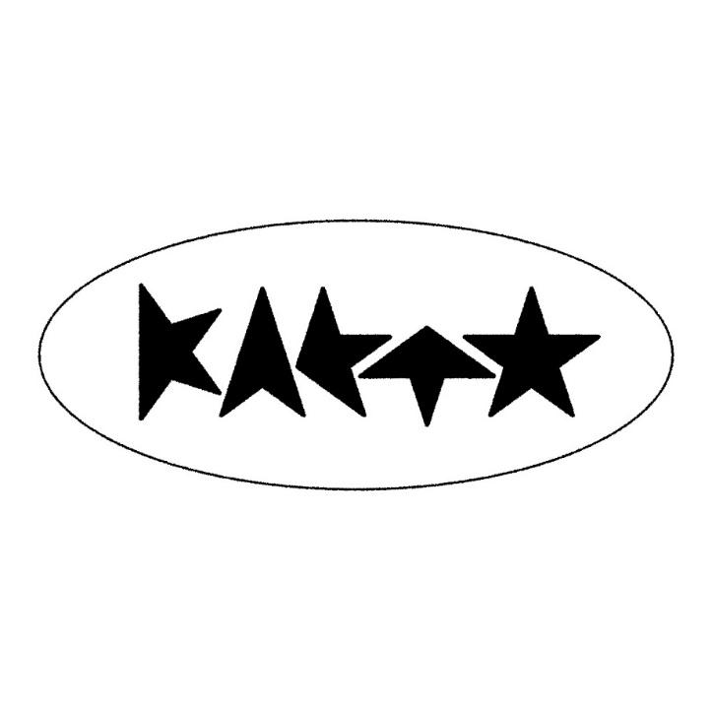
KAETO SHARES NEW SINGLE + VIDEO
‘U R MINE’
LISTEN HERE / WATCH HERE
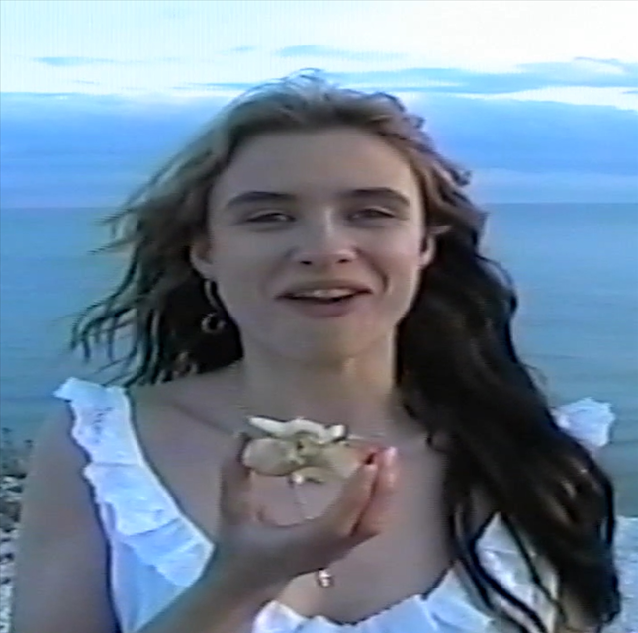
DOWNLOAD 'U R MINE' ARTWORK
ANNOUNCES DEBUT MIXTAPE ‘INTRO’
SET FOR RELEASE SEPTEMBER 20TH
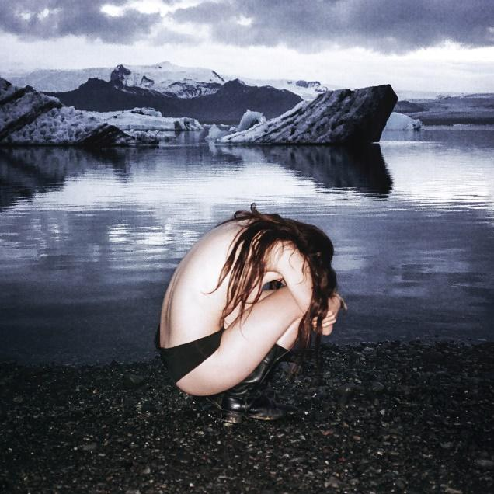
DOWNLOAD INTRO ARTWORK
KAETO today (July 12th) shares her new single ‘U R MINE’ and announces details of her hotly awaited debut mixtape INTRO, to be released September 20th via Polydor Records.

Building around a hypnotic, minor-chord piano pattern and propelled by an infectious, groove-laden drumbeat, ‘U R MINE’ unfurls into an alt-pop epic, Kaeto’s mesmeric vocal lifting the whole thing skyward. It is the thrilling sound of dancefloor euphoria distilled into a short, sharp anthem and arrives alongside a video made by Kaeto and friends – watch HERE

‘U R MINE’ is one of 8 tracks that will feature on KAETO’s debut mixtape ‘INTRO’ alongside her recent single ‘HERO’. The mixtape was produced by KAETO and Mathias Wang (aka Junkmail) and will be available on black vinyl. Pre-save / pre-order ‘INTRO’ HERE

Speaking about ‘U R MINE’ Kaeto says, “This song was made by Mathi and myself and is one of my favourite songs we have written. He is so talented and I am really excited to share the rest of our project later this year. The song itself is a love letter to the body and its right to exist without the burden of what it ought to look like to everyone else. I’ve spent so much time punishing and shaming my body so it was really freeing to write about my gratitude for my body and how all of its parts together keep me moving and experiencing my life. In essence, it’s about reclaiming your body, stealing it away from the shapes it’s told to form and just accepting it for what it is: a wonderful and beautiful home deserving of being looked after.”

“My best friend Maddy features in the video. She is a truly incredible and special person. I wanted to capture the feeling that you have as a child before the onset of body image burdens when you’re able to just use your body as a vessel. The rest of the team was made up of my other incredibly talented friends: Maisy Banks, Reuben Davies Lindley, Dan Breuer, Sal Redpath and Joe Gollifer. It was such a hilarious day.”

KAETO has been captivating audiences with her mesmerising live performances, opening as special guest for Haim, Lauren Mayberry, Eliza and Bleachers and will support The Last Dinner Party on their UK tour in October.

About KAETO
The emerging London-based artist is fast carving a space for herself with her unique genre-spanning sound that blends elements of trip-hop, dance and electronic music with punk, alt-pop and more.

KAETO first attracted attention with her startling debut ‘Good Morning’. After signing with Polydor last summer, she released ‘No Body’, which i-D declared “the most commanding artist statement we’ve heard all year”. CLASH remarked “word is already out on this pop voyager, a daring voice carving out her own niche”, while DIY described her as “absolutely melting with confidence and style”. Following it up with the hypnotic ‘Little Me’, THE FORTY-FIVE recently tipped KAETO for big things, saying “The London-based artist has crafted a sound that is distinctly her own”.

It was back in 2019 that Kaeto first entered the studio with outside producers and began building a sound that would be all her own, but the route she’s taken since is a mark of her maverick and inventive approach to music. One such diversion was enrolling in Clown School, a move designed to throw herself into something creative and spontaneous and shake off the mundanity of modern life. It's why Kaeto’s music has such a free-spirited, loose-limbed sense of adventure about it. “I’m so unashamed of myself,” she says, “but music is where I go to explore these things.”


DOWNLOAD PRESS PHOTO
(credit: Maisy Banks)

FOLLOW KAETO
Instagram | Youtube |TikTok

For more on info contact warren@chuffmedia.com

