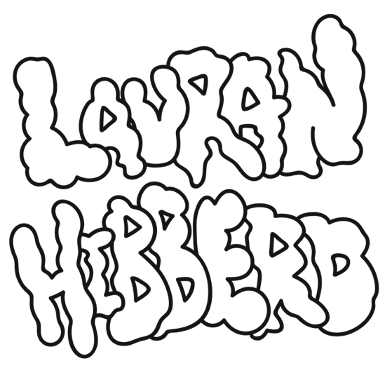
Lauran Hibberd announces UK album tour and shares new track ‘Step Mum’, out May 11th via Virgin Music
Photo Credit: Steve Glashier
“Such. Huge. Choruses…the next hottest thing” DIY

“A firecracker of a track” Billboard

“Tongue-in-cheek slacker-pop” NME

“Garage rock tunes...huge pop hooks” NYLON

“Grunge-inflected, punky bubblegum pop…she continues on her upward trajectory in explosively exciting fashion” The Line Of Best Fit

"Queen of slacker pop…if these bopping tunes are any indication, her next steps should be followed very closely" Dork

"Each song from the rising talent feels immaculately well packaged…cool-as-heck indie rock" Clash

"If you’re a fan of excellent indie then keep your eyes on Lauran Hibberd. We’re certain she won’t disappoint you" Gigwise

“Fizzy indie rock bangers” Music Week

“Slacker pop has a new frontrunner …every single one of Lauran Hibberd’s tracks is 10/10 great” Upset
“High-energy pop sensibilities and a tongue-in-cheek attitude” Rock Sound

Isle Of Wight power pop sensation Lauran Hibberd announces debut album tour and shares brand new track ‘Step Mum’, set for arrival May 11th via Virgin Music.

Speaking ahead of its release, Hibberd explained: “If you’ve been lucky enough to have not had one for yourself, you’ve probably already met her in a movie. I just realised there were not enough songs in the world about step mums, I had a big desire to change that. This song is as equally funny to me as it is scary for my dad. For legal reasons, this is not about my own stepmother”.

Heralding the latest addition to her stacked catalogue of adrenaline-fueled anthems, ‘Step Mum’ sees the indie riser continue her partnership with revered producer Larry Hibbitt (Nothing but Thieves, Don Broco, Dinosaur Pile-Up, Sea Girls) and accelerates Hibberd’s spectacular ascent towards the upper echelons of the indie landscape ahead of her August debut LP release.

Brimming with charisma and satire-fuelled hits, the DIY Magazine Class of 2022 star’s remarkable potential is exemplified by the groundswell of support across the press landscape (The Guardian, The Times, NME, The Line Of Best Fit, Dork, DIY, Billboard, Consequence of Sound, NYLON, Clash, Gigwise, Kerrang, Rock Sound, Upset) over the last few years, as well as significant praise across the BBC Radio 1 (Clara Amfo, Jack Saunders, Gemma Bradley) and BBC 6 Music (Chris Hawkins) airwaves, as she tackles the next phase in her thrilling development.

Fresh from nationwide dates supporting chart-toppers The Snuts and Stand Atlantic, as well as a sold-out 2021 UK headline tour, the enigmatic musician’s raucous live show has already seen her earn impressive support tours with Hippo Campus and The Regrettes in recent times. Earmarked for several prominent slots throughout the summer festival season, Hibberd will also be hitting the road this autumn to coincide with the release of her debut record.

Lauran Hibberd’s ‘Step Mum’ is out May 11th via Virgin Music and will be available on all digital platforms.

Live Dates
14th May - The Great Escape, Brighton
27th May - Bearded Theory
28th May - A Stone’s Throw Festival, Newcastle
4th June - Live At Leeds
4th June - Sonic Wave, Birmingham
16th June - Rock For The People, Czech Republic
9th July - 2000 Trees, Cheltenham
22nd July - Truck Festival
29th July - Y Not Festival
30th July - Camp Bestival
31st July - Kendal Calling
5th August - Wide Skies & Butterflies Festival

17th Sept - Arts Club (Loft), Liverpool
18th Sept - Brudenell Social Club, Leeds
19th Sept - King Tut’s, Glasgow
21st Sept - Mama Roux’s, Birmingham
22nd Sept - Clwb lfor Bach, Cardiff
23rd Sept - The Garage, London
24th Sept - Wedgewood Rooms, Portsmouth
30th Sept - Strings Bar & Venue, Newport

Lauran Hibberd Online
Facebook / Twitter / Instagram / Website / Spotify / TikTok

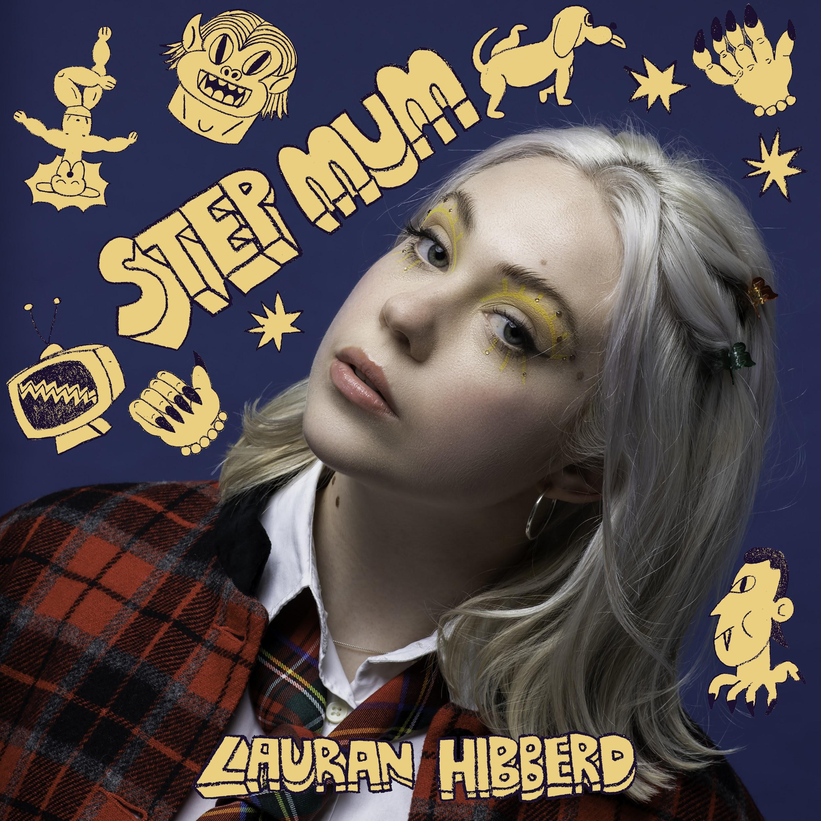

For more information and press enquiries please contact
Jenny Entwistle
Jenny@chuffmedia.com
Melanie Balbrick
assistant@chuffmedia.com

