Placebo share cover of classic Tears For Fears single ‘Shout’

UK/European headline tour dates begin in October

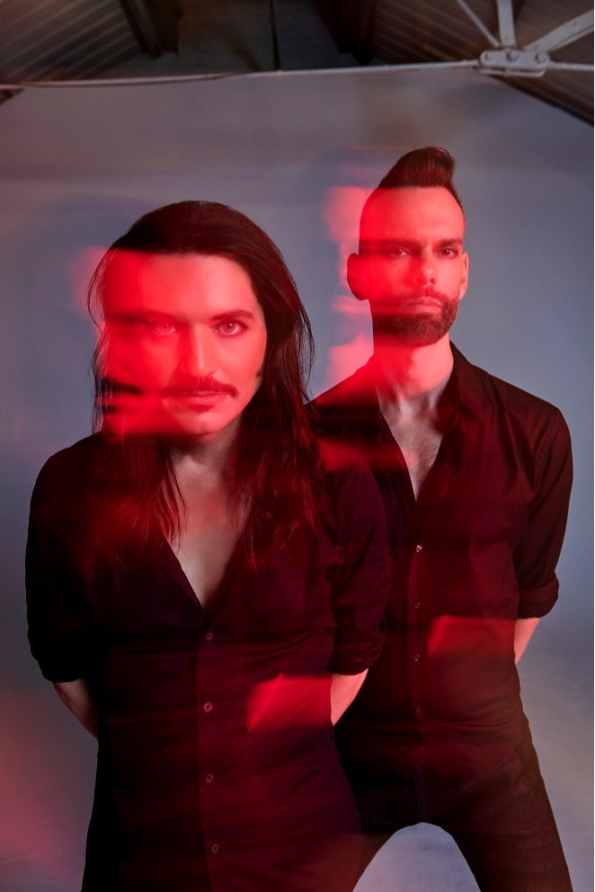
Placebo | Photo credit: Mads Perch | Download image here

////

Placebo are today sharing ‘Shout’, a cover of the iconic Tears For Fears single. ‘Shout’ – taken from the Tears For Fears album Songs From The Big Chair - peaked at #1 on the Billboard Hot 100 in 1985 and joins a rich lineage of Placebo cover versions of songs from the 80s. Artists such as Sinead O’Connor (‘Jackie’), The Smiths (‘Bigmouth Strikes Again’), The Pixies (‘Where Is My Mind?’) and - most famously of all - Kate Bush (‘Running Up That Hill’) have all been covered by the band.

In this latest Placebo interpretation, ‘Shout’ becomes a brooding industrial march. Given that the single’s original songwriter Roland Orzabal has said that ‘Shout’ concerns itself with political protest, it also makes for a fitting follow-on from Placebo’s latest album release Never Let Me Go, which marked itself out with commentary on tech-saturation, rising intolerance and the climate crisis.

Listen to ‘Shout’ on streaming services here.
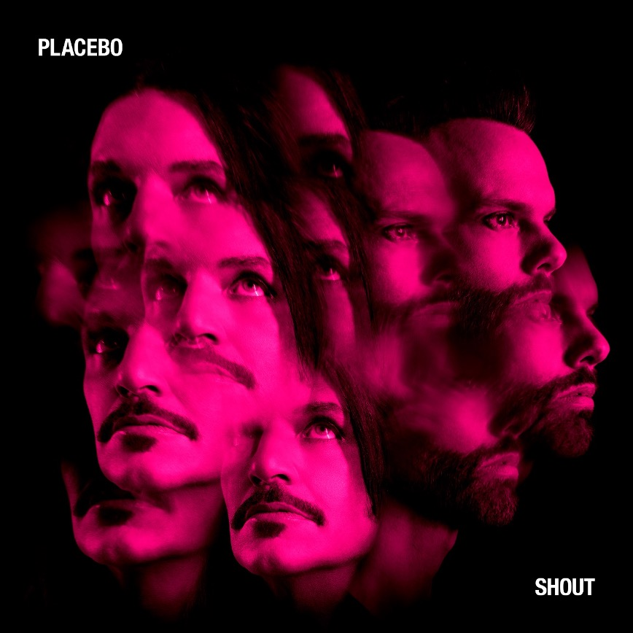
Placebo – ‘Shout’ single artwork | Download image here

////

Placebo will embark on what is going to be a sold out headline tour of the UK & Europe later this year. Tickets are available here.

PLACEBO UK + EUROPEAN 2022 HEADLINE TOUR DATES

OCTOBER 2022

Sat 1 - Frankfurt, Germany - Festhalle
Tue 4 - Stuttgart, Germany - Schleyerhalle
Thu 6 - Berlin, Germany - Mercedes-Benz Arena
Sat 8 - Copenhagen, Denmark – Vega – SOLD OUT
Mon 10 - Oslo, Norway - Sentrum Scene – SOLD OUT
Tue 11 - Stockholm, Sweden – Cirkus – SOLD OUT
Thu 13 - Helsinki, Finland - Ice Hall Black Box
Fri 14 - Tallin, Estonia - Saku Arena Black Box
Mon 17 - Warsaw, Poland - Expo XXI Hall 3
Wed 19 - Leipzig, Germany - Quarterback Immobilien Arena
Sat 22 - Hamburg, Germany - Barclaycard Arena
Mon 24 - Amsterdam, Netherlands - Ziggo Dome
Wed 26 - Munich, Germany - Olympiahalle
Thu 27 - Milan, Italy - Mediolanum Forum
Sat 29 - Zurich, Switzerland - Samsung Hall
Mon 31 - Prague, Czech Republic - O2 Universum

NOVEMBER

Wed 2 - Vienna, Austria - Stadthalle
Fri 4 - Esch El Azette, Luxembourg - Rockhal
Mon 7 - Cologne, Germany - Lanxess Arena
Tue 8 - Antwerp, Belgium - Sportpaleis
Thu 10 - Nancy, France - Zenith
Fri 11 - Paris, France - Accorhotels Arena – SOLD OUT
Sun 13 - Bordeaux, France - Arkea Arena
Mon 14 - Rennes, France - La Liberte – SOLD OUT
Fri 18 - Portsmouth, UK – Guildhall – SOLD OUT
Sat 19 - Brighton, UK - Brighton Centre – SOLD OUT
Mon 21 - Liverpool, UK - Eventim Olympia – SOLD OUT
Tue 22 - Manchester, UK - O2 Victoria Warehouse – SOLD OUT
Thu 24 - Cardiff, UK - Motorpoint Arena
Sat 26 - London, UK - O2 Brixton Academy – SOLD OUT
Sun 27 - London, UK - O2 Brixton Academy – SOLD OUT
Tue 29 - Leicester, UK - De Montford Hall – SOLD OUT
Wed 30 - Leeds, UK - O2 Academy Leeds – SOLD OUT

DECEMBER

Fri 2 - Newcastle, UK – O2 City Hall – SOLD OUT
Sat 3 - Glasgow, UK - O2 Academy Glasgow – SOLD OUT
Mon 5 - Dublin, Ireland - 3 Arena
Wed 7 - Cambridge, UK - Corn Exchange – SOLD OUT
Thu 8 - Birmingham, UK - O2 Academy 1 – SOLD OUT

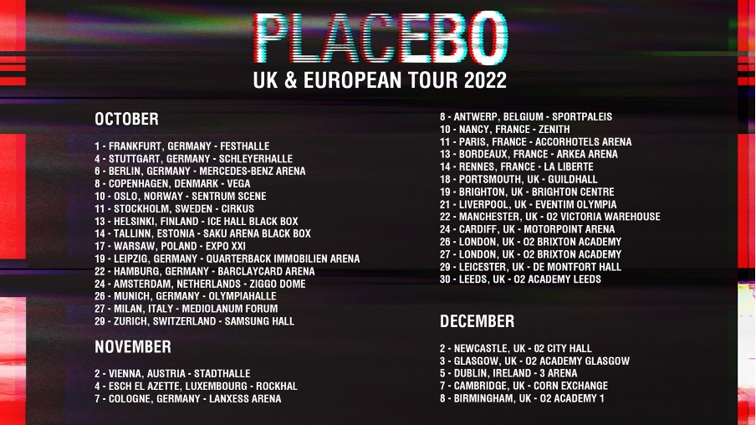
Placebo | 2022 UK/European headline tour poster | Download image here

For press only: Download the latest biography here.

Placebo: Website | Instagram | Facebook | Twitter

For more information please contact warren@chuffmedia.com on 07762 130510

