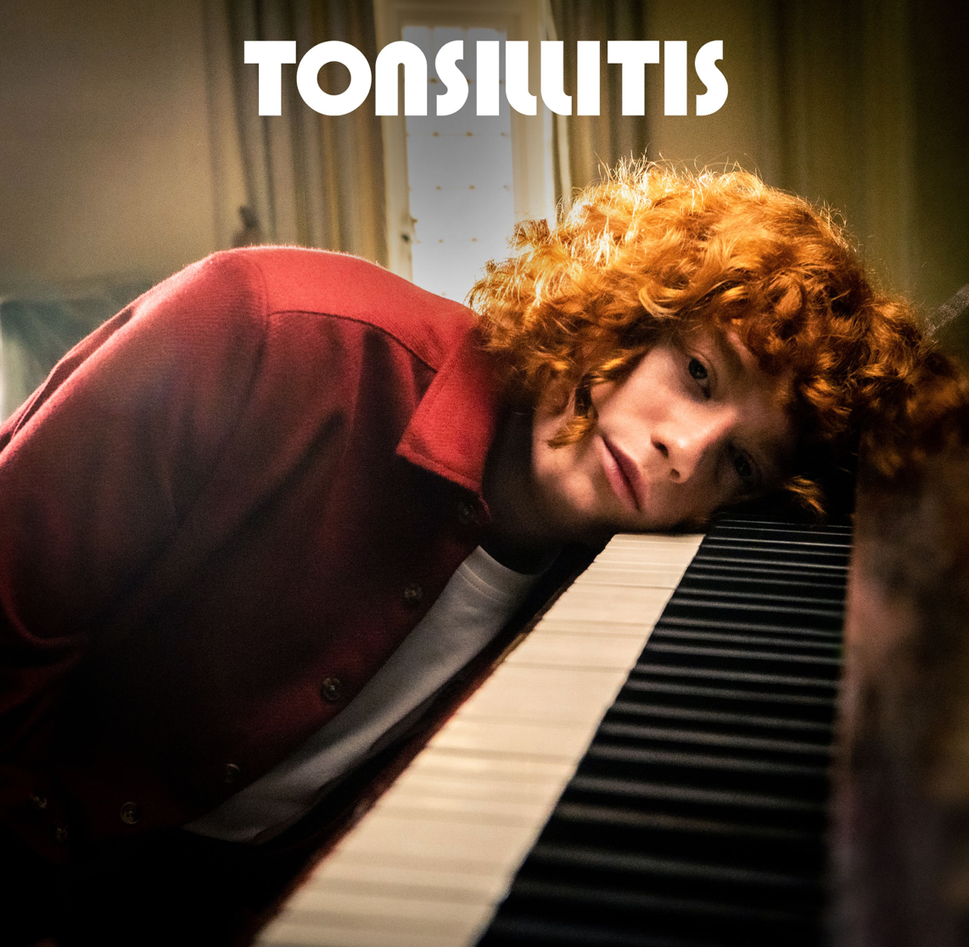

RISING STAR MICHAEL ALDAG RELEASES HIS NEW SINGLE ‘TONSILLITIS’

“Rising producer, singer and songwriter Michael Aldag is channelling the trials and tribulations of youth into his experimental, anthemic pop.” - THE LINE OF BEST FIT

Meet 19-year old Michael Aldag: a singer and a songwriter (but not a singer-songwriter), a producer, an accidental TikTok star and every inch a total popstar. Having only just begun his music career, Michael has already sold out shows in Liverpool and London (including a headline slow at BBC Introducing) with a further headline tour confirmed in May next year. He has also featured on The Line of Best Fit, Dork Magazine and Liverpool Echo.

Michael’s social media following is also on the rise, with him already striking the right note on TikTok. His short humorous clips that make fun of British culture and the lives of Gen Z has sent him well on his way to over half a million followers. “It’s a useful platform and my songs have got some humour in them as well so the two things are not world’s apart,” says Michael. “I hope it gives a more well-rounded view of me as a person.” The ambition of Michael’s music however reaches far beyond the four walls of a West Kirby box room: it’s anthemic, global, main-stage music you can sing your heart out to. “I really want to make people feel something,” says Michael. “I don't want it to be niche. I want it to be big, emotional, melodramatic, and with meaning.”

The start of Michael’s career saw him secure a place on the Liverpool branch of the Levi’s Music Project, a music accelerator scheme that saw him performing at fashion launches in Brussels and Barcelona, and a spot at the LIMF Academy, which selects and supports Merseyside-based artists. During this time he’s been recording a steady stream of music, including his upcoming single ‘Tonsillitis’ which is set for release on 13th August. ‘Tonsillitis’ came about during a bleak period in 2020, when Michael lost a close family member then soon after discovered his girlfriend had been cheating on him. “Tonsillitis is the most personal song I’ve ever written,” says Michael. “I was very low and very alone, but these days I can go back to that song and think: ‘Well, that was how bad I was feeling then, and now I’m feeling better about it’ — it’s a good port of call for any difficult future situations I find myself in.”

“My music’s for anybody who feels slightly-to-constantly overwhelmed and unsure of who they are, flailing around in this massive ridiculous world,” he states, and when you go in search of that music you’ll find another bio, on streaming services, that promises: “If you like hearing ginger boys whining over some synths then you’re going to love me.” Totally Michael Aldag.

LIVE DATES
16 SEPTEMBER, BBC INTRODUCING, THE LEXINGTON LONDON - SOLD OUT
25 SEPTEMBER, KAZIMIER, LIVERPOOL - SOLD OUT
29 SEPTEMBER: COLOURS, LONDON - SOLD OUT

TIKTOK | INSTAGRAM | TWITTER | YOUTUBE

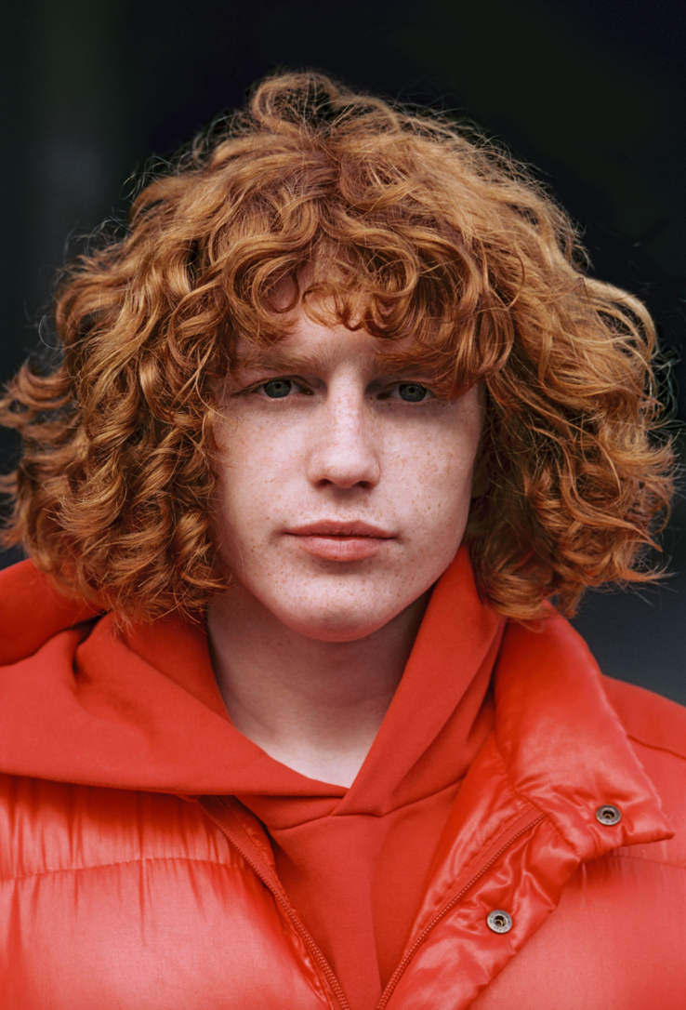

For more information and press enquiries please contact

Jenny Entwistle
Jenny@chuffmedia.com

