**EMINEM TEAMS UP WITH BABYTRON AND BIG SEAN FOR “TOBEY,” OUT NOW**

**LISTEN** [**HERE**](https://eminem.lnk.to/Tobey)

**THE NEW ALBUM, “THE DEATH OF SLIM SHADY (COUP DE GRÂCE),” COMING JULY 12**

**PRE-ORDER** [**HERE**](https://eminem.lnk.to/TheDeathofSlimShadyPresave)

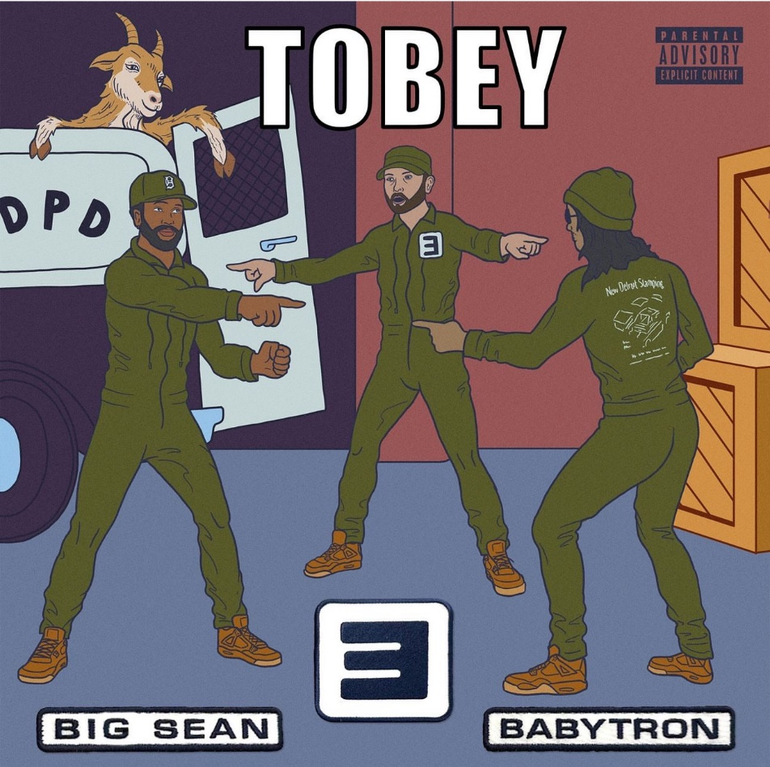

Los Angeles, CA – July 2, 2024 – Only a month after setting the world on fire with “Houdini,” the first single off his new album “The Death of Slim Shady (Coup De Grâce),” Eminem is back with the follow up. “Tobey.”

Featuring fellow Michigan hip-hop stalwarts BabyTron and Big Sean, “Tobey” showcases a different, yet equally familiar, side to Eminem than fans heard upon the release of “Houdini.” Layered over a sparse beat courtesy of producers Daniyel, Cole Bennett, John Nocito, Car!ton, and Marvy Ayy, the song features dizzying lyrical output by all three artists, showcasing their collective power and the potent musical landscape of Detroit area rap.

“Tobey” was first announced by Eminem via a short teaser video on his socials June 29 that showcases the return of the hockey-masked iteration of the Slim Shady persona…a snippet of the Cole Bennett directed video for the song which is planned for release this Friday, July 5. The new track is the second single from Eminem’s highly anticipated 12th album. “The Death of Slim Shady (Coup De Grâce)” was announced in late April, with the official release date of July 12 confirmed in a new teaser video released yesterday, July 1.

The album’s first single, “Houdini,” was released on May 31. An instantaneous global smash, the song entered the Billboard Global 200 and Streaming Songs charts at #1, and debuted at #2 on the Hot 100. The song currently sits in the top 20 of the Spotify Global and US charts, the Apple Music Global chart, and the Top 40 and Rhythmic radio charts. “Houdini” is Eminem’s highest charting single since 2013’s “The Monster” and also becomes his first charting single at the Rock radio format.

**For more on info contact** [**warren@chuffmedia.com**](mailto:warren@chuffmedia.com)