BENJAMIN FRANCIS LEFTWICH RELEASES NEW SONG ‘TINSEL IN THE RIVER’

THE SINGER-SONGWRITER’S CHRISTMAS SONG IS OUT NOW VIA DIRTY HIT

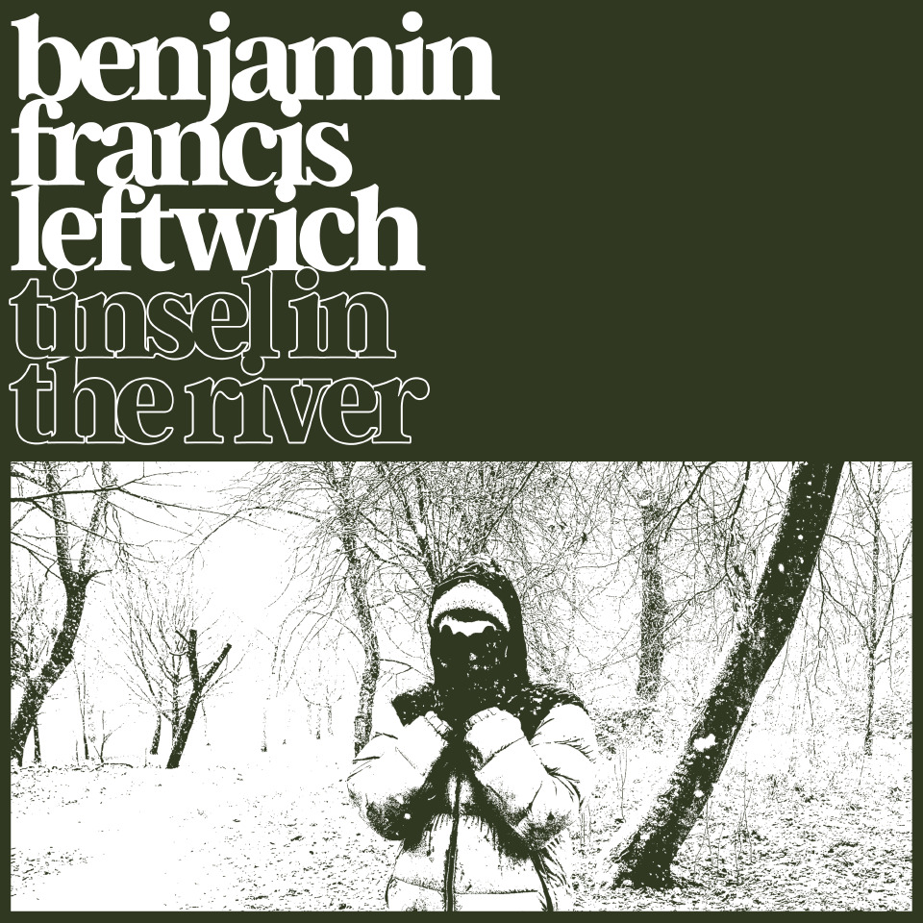
Cover art for ‘Tinsel In The River’/ All press assets available here

Listen to ‘Tinsel In The River’ here:
https://benleftwich.ffm.to/tinselintheriver

Benjamin Francis Leftwich has released his Christmas song entitled ‘Tinsel In The River’. Written and performed by Leftwich, it is out now via Dirty Hit.

Featuring his trademark acoustic guitar playing, intimate, honest vocals and lyrics with a heartbreaking perspective on the festive period, Benjamin says:

“‘Tinsel In The River’ is a song about sitting alone over the Christmas period and reflecting over the previous year of love, loss and what could have been - but flew out of one's hands. The song is set against the Christmas party season in the town in Yorkshire where I am from. The city comes alive with the party, the bag, loving fellowship - and also chaos.

To me the song is about that feeling of isolation, set against the backdrop of bright noisiness at that time of year and how the sparkle of it all can also be the trigger for the pain that was so nearly disappearing in the normal stillness of the town, which suddenly is turned upside down.”

‘Tinsel In The River’ follows Benjamin’s recent album ‘To Carry A Whale’, which was released to acclaim earlier this year. It was the fourth album released by Leftwich and his first made entirely sober. It was dubbed a “collection of sombre ballads, imbued with a fresh and genuine perspective on life” by Clash Magazine in their review.

Benjamin Francis Leftwich was the first artist signed to Dirty Hit Records, whereupon he released his acclaimed debut album ‘Last Smoke Before the Snowstorm’ in 2011. The album hit the top 40 in the UK and included the hit single ‘Shine’ which was remixed by tropical house king Kygo and named by Spotify their “most addictive song of 2014”; the song that was repeat-played most often that year.

He followed his debut album with 2016’s ‘After The Rain’, after a 5 year break, in part due to the death of his father. The record was met with critical acclaim, with The Guardian dubbing it “fragile, precious, oddly comforting” in their 4-star review of the album. He followed that with third album ‘Gratitude’ in 2019, which was deemed “graceful and honest” by DIY in their 4-star review.

Benjamin has also recently announced his 2022 tour, comprised of 26 dates across the UK and Ireland - tickets and details are available at benjaminfrancisleftwich.com.

Full tour schedule below -

FEBRUARY
01: Brighton, Komedia
02: London, Lafayette
04: Bodmin, St Petroc's Church
05: Lyme Regis, Marine Theatre
06: St Albans, The Horn
08: Birmingham, St Paul's Church
09: Newcastle, Wylam Brewery
10: Edinburgh, The Liquid Room
11: Aberdeen, The Lemon Tree
13: Dublin, Whelans
15: Bristol, St George's
16: Oxford, The Bullingdon
17: Cambridge, Junction 2
18: Colchester, Arts Centre
19: Ramsgate, Music Hall
21: Guildford, Boileroom
22: Nottingham, The Bodega
23: Manchester, Band On The Wall
24: Sheffield, The Foundry
25: York, The Citadel
26: Huddersfield, The Parish

For more information please contact warren@chuffmedia.com

