CELESTE RETURNS WITH BRAND NEW SINGLE
‘THIS IS WHO I AM’
LISTEN

DOWNLOAD ARTWORK
TITLE SONG FOR NEW SKY TV SERIES
THE DAY OF THE JACKAL
STARRING EDDIE REDMAYNE & LASHANA LYNCH
MAKES SCREEN DEBUT IN NEW STEVE MCQUEEN FILM BLITZ

CELESTE today (Nov 6th) makes her eagerly awaited return with the release of brand new single ‘This Is Who I Am’ via Polydor Records. Produced by Kendrick collaborators BEACH NOISE, the BRIT Award-winner and Oscar nominee CELESTE has held the song close for almost four years. Now, as she prepares to tell the next chapter of her story, the stirring ‘This Is Who I Am’ is less a reintroduction to Celeste’s music and more an act of self-actualisation, a complete creative distillation of her craft that sees her step with purpose into her new era.
‘This Is Who I Am’ is a track that finds drama in simplicity, as the artist’s velvety, old-world voice wraps around melancholy piano chords and cinematic strings that swell towards a belting crescendo. Speaking about the single, Celeste says "This song has existed for a long time, and it felt almost unjust that circumstances didn’t allow it to come out four years ago. Now, with everything aligning, this moment serves as a powerful acknowledgment of something that, back then, felt unresolved.”
‘This Is Who I Am’ is the title song for Sky’s new series The Day of the Jackal (also out today). An adaptation of the Frederick Forsyth novel of the same name, the track was selected for the show’s opening credits, handpicked by Eddie Redmayne, who plays the titular assassin, and his co-star Lashana Lynch.
A lot has happened since Celeste’s spell-binding performance of her breakout song ‘Strange’ at the BRIT Awards placed her firmly in the global spotlight. The British-Jamaican musician, who landed the prestigious double win of both the BRITs Rising Star Award and BBC Music’s Sound of 2020, achieved a No. 1 on the UK charts with her 2021 debut album Not Your Muse. That year also saw her earn a Mercury Prize nomination alongside Academy Award and Golden Globe nominations for ‘Hear My Voice’, her lead single from The Trial of the Chicago 7.
Since then, Celeste has taken a step back from the glare of mainstage spotlights to recalibrate and reconnect with herself, figuring out how to stay true to her vision and sense of authenticity in her work. It’s this mentality that led Celeste to collaborate with the Tate Modern for the launch of her 2022 single “To Love A Man”, release this year’s “Everyday” with a limited vinyl run and a live performance at record store Rough Trade in London.
Celeste cites her most recent work on Steve McQueen’s upcoming World War II drama Blitz as the most fulfilling, marking the first time the artist has acted on screen.
“Meeting Steve McQueen was one of the most inspiring and significant moments of my life in the last two years,” says Celeste. Witnessing the director’s uncompromising attention to detail on set, she explains, helped reaffirm her belief in artistic intuition, aligning with the core statement of ‘This Is Who I Am’ and her subsequent approach to writing music, reinstalling her confidence and sense of navigation.
All of which brings us back to “This Is Who I Am”. On the song, her warm, raspy voice asserting that “Only you can tell them this is who I am”, Celeste appears to address the person who is all knowing of who she is. Perhaps that was true at the time of writing. But after four years of introspection, it’s clear that this is an artist who knows herself better than anyone else and is giving others the voice and confidence to be who they are, bravely and boldly. The singer climbed to the summit of the music industry, took in the view and carefully traced the way back to her truth. Who is Celeste? She’s about to show you.
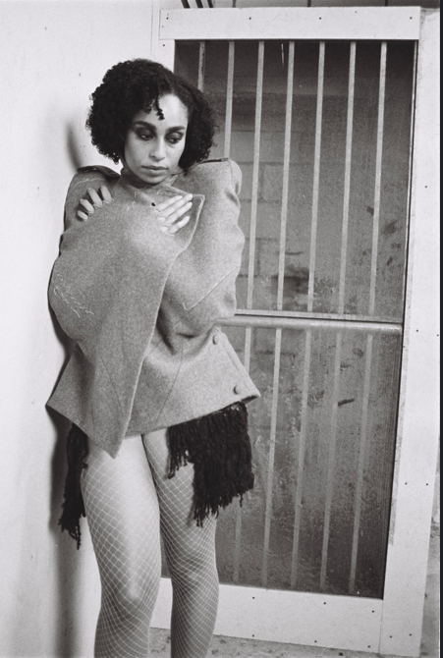
DOWNLOAD PRESS PHOTO (photo credit: Siam Coy)

For more on info contact warren@chuffmedia.com

