
SHARE NEW SONG ‘THIS IS THE SOUND OF YOUR VOICE’
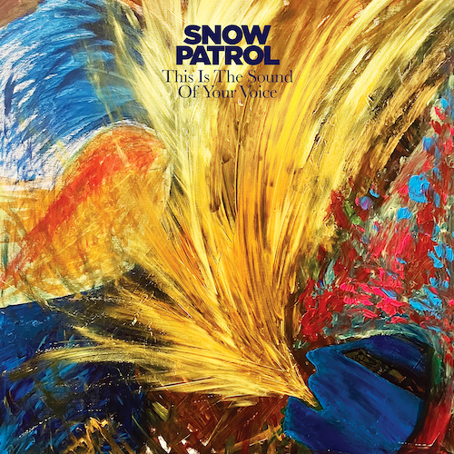
FROM FORTHCOMING NEW ALBUM ‘THE FOREST IS THE PATH’
SET FOR RELEASE SEPTEMBER 13TH 2024
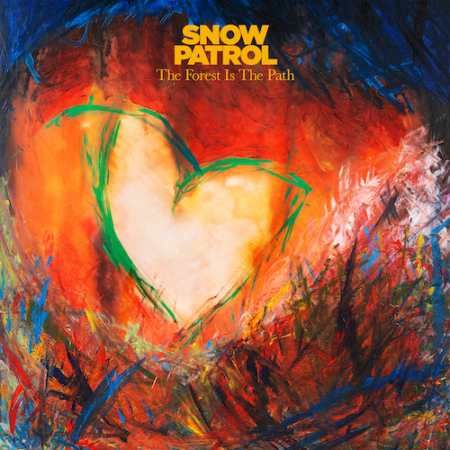
LISTEN
Pre-order album
SNOW PATROL today (July 5th) release new song ‘This Is The Sound Of Your Voice’ via Polydor Records. It is the second track to be shared from the Northern Irish band’s forthcoming new album ‘The Forest Is The Path’, which is set for release on September 13th and marks their eagerly awaited return after six years, following 2018’s ‘Wildness’. It is produced by Fraser T Smith (Adele/Dave/Stormzy) and the band. Now comprising the trio of Gary Lightbody, Nathan Connolly and Johnny McDaid, Snow Patrol offered the first taste of their extraordinary new album with recent single ‘The Beginning’.

After recently announcing details of an 8 date UK and Ireland Arena tour in 2025, Snow Patrol will kick off a summer of live performances today when they play Rock Werchter in Belgium. On July 12th they headline Thomond Park Stadium in Limerick where they will play to over 25,000 fans.

‘The Forest Is The Path’ was written by Gary Lightbody, Nathan Connolly and Johnny McDaid and features twelve tracks. Fraser T Smith, Will Reynolds, Roy Kerr and Troy Van Leeuwen (QOTSA) also contributed to the writing on some of the songs on the album. The album and single artwork features paintings by Gary Lightbody.

‘The Forest is the Path’ is an album rooted in reflection, introspection and interrogation. One of its key building blocks, says Gary, was the idea of love from the distance of time. “I haven’t been in a relationship for a very long time, 10 years or more, so love from a distance to me meant the way a relationship sits in your memory from a distance of, say, 10 years. That’s not something I’d previously thought about as away to write about love. So it’s like, when you’re in love, you’re standing in the lobby of the Empire State Building. When you’ve broken up with that person, you’re out in the street. You can still see the building, but you’re not in there anymore. And when it’s 10 years later, now you’re standing in Brooklyn looking at the Manhattan skyline.”

‘The Forest Is The Path’ tracklisting:
1. All
2. The Beginning
3. Everything’s Here And Nothing’s Lost
4. Your Heart Home
5. This Is The Sound Of Your Voice
6. Hold Me In The Fire
7. Years That Fall
8. Never Really Tire
9. These Lies
10. What If Nothing Breaks?
11. Talking About Hope
12. The Forest Is The Path

SNOW PATROL LIVE DATES
JULY
5th – Rock Werchter, Belgium
7th – Luxexpo, Luxembourg
12th – Thomond Park Stadium, Limerick
21st – Meo Mares Vivas Festival, Portugal
28th – Tramlines Festival, Sheffield
AUGUST
2nd – Y Not Festival, Derbyshire
16th – Hardwick Festival, Sedgefield
23rd – Victorious Festival, Portsmouth
25th – The Big Feastival

UK & Ireland Arena tour
Feb 15th London O2
Feb 16th Birmingham Resorts World Arena
Feb 18th Cardiff Utilita Arena
Feb 19th Hull Connexin Live
Feb 21st Glasgow OVO Hydro
Feb 22nd Manchester Co-op Live Arena
Feb 25th Dublin 3Arena
Feb 27th Belfast SSE Arena
-
LEAD PRESS PHOTO
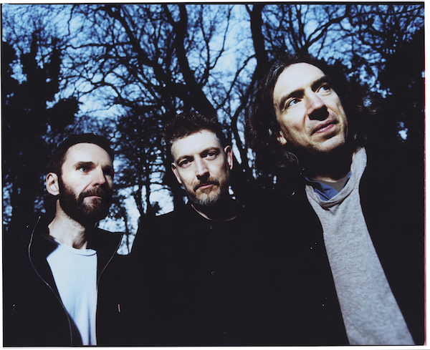
(Credit Tom Beard)
Connect with Snow Patrol
Facebook Instagram Twitter

For more on info contact warren@chuffmedia.com

