
ONLY THE POETS RELEASE NEW SINGLE “THINKING BOUT YOUR EX” LISTEN HERE
TAKEN FROM THE BAND’S DEBUT ALBUM, ‘AND I’D DO IT ALL AGAIN’ OUT JANUARY 30th 2026
ON TOUR IN OCTOBER/NOVEMBER WITH THE WOMBATS IN THE U.S

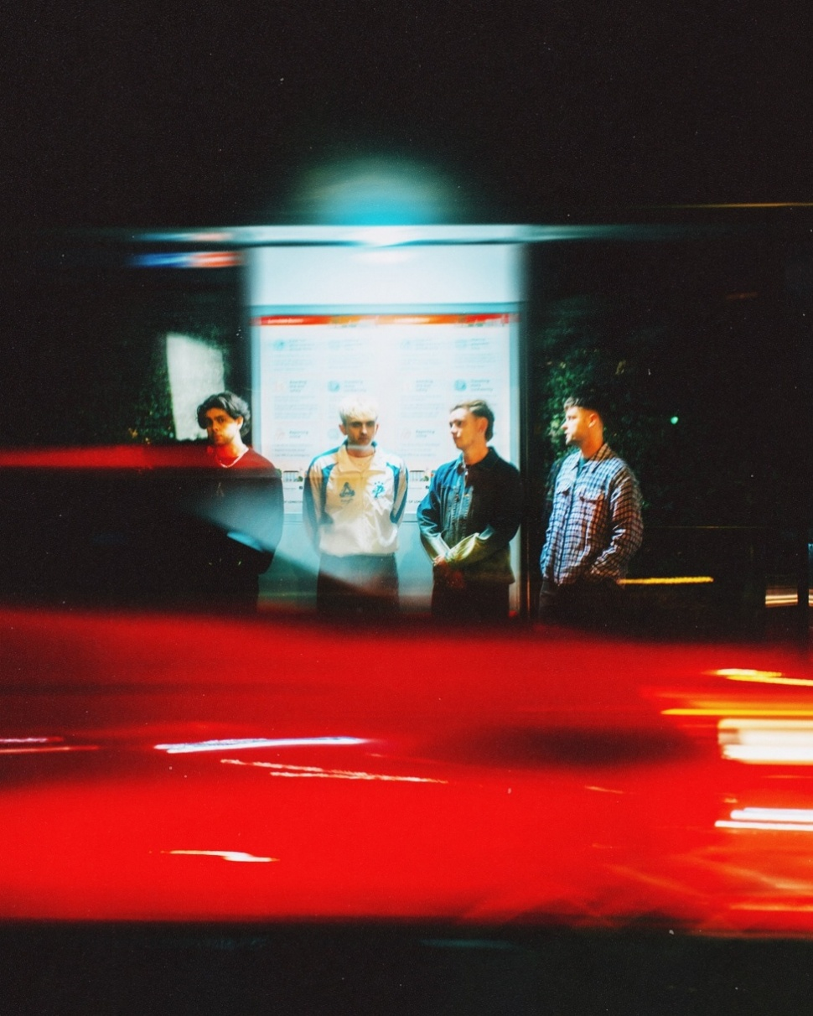

From selling out O₂ Academy Brixton in just ten minutes and making headlines with their historic £1 show, Only The Poets keep their unstoppable momentum rolling with the release of their latest single “Thinking Bout Your Ex” — a woozy, cinematic track that blends spacious 90s R&B textures with frontman Tommy Longhurst’s captivating vocals.

Built around a hypnotic groove and shimmering production, “Thinking Bout Your Ex” captures the uneasy spiral of comparison and jealousy that lingers in the aftermath of a break-up — “I’ve been thinking about your ex, it’s just jealousy I guess, running circles in my head.”
While the track’s sonics evoke late-night reflection and escape, its lyrics dig deeper — confronting insecurities that men rarely speak about and transforming them into something honest and cathartic.

The single marks another defining moment in what has been a landmark year for the Reading four-piece. Following their O₂ Brixton Academy sell-out, over 25,000 tickets sold across Europe, and the start of their 20-date US support tour with The Wombats, Only The Poets continue to build toward their highly anticipated debut album And I’d Do It Again, out January 30th 2026.

The band’s rapid ascent has been fuelled by a unique blend of emotional candour, infectious melodies, and a genuine connection with their fans, Their £1 Brixton show not only sold out instantly but also sparked a conversation around accessibility in live music for all , with proceeds supporting the LIVE Trust, the voice of UK live music.

For Only The Poets — Tommy Longhurst, Andrew “Roo” Burge, Clem Cherry, and Marcus Yates — music has always been about connection and honesty. With “Thinking Bout Your Ex”, they continue to turn raw emotion into widescreen sound, reaffirming their reputation as one of the UK’s most vital and emotionally resonant new bands.

Full list of U.S dates below.
OCT
Fri 17th McMenanmins Crystal Ballroom, Portland, OR
Sat 18th Commodore, Ballroom, Vancouver, BV
Mon 20th Regency Ballroom, San Francisco
Weds 22nd The Novo, Los Angeles, CA
Thurs 23rd The Depot, Salt Lake City, UT
Sat 25th Summit Music Hall, Denver, Col
Mon 27th Dallas, House of Blues,
Tues 28th Scoot Inn, Austin, TX
Thurs 30th The Filmore, Minneapolis

NOV
Thurs 1st The Vic Theatre, Chicago, Il
Mon 3rd St Andrew’s Hall, Detroit, Mi
Tues 4th Newport Music Hall, Columbus, OH
Thurs 6th Roxian Theatre, Chartiers, PA
Fri 7th Danforth Music Hall, Toronto
Sat 8th Danforth Music Hall, Toronto
Mon 10th Fillmore, Philadelphia
Tues 11th Anthem, Washington
Weds 12th Paramount, Brooklyn, NY
Fri 14th Paramount, Brooklyn, NY

ABOUT ONLY THE POETS
Only The Poets are one of the UK’s most exciting rising bands, known for their confessional songwriting, emotive storytelling, and electrifying live shows. The Reading four-piece have built their following from the ground up, growing a devoted fanbase through relentless touring, grassroots connection, and a string of powerful releases.
Their reputation as a must-see live act has been cemented through sold-out headline tours across Europe and the US, as well as support slots for YUNGBLUD, Bastille, and The Wombats. In 2025 alone, the band have sold over 25,000 tickets across Europe and made their US live debut with sold-out shows in New York, Los Angeles, and Boston.
With songs that speak openly about love, loss, mental health, and emotional resilience, Only The Poets have become a voice for a generation unafraid to feel deeply. Their lyrics are lived experiences — not just stories, but shared truths.

As they head toward their debut album, Only The Poets continue to carve their path through truth, connection, and unforgettable live moments.

OTP // INSTA // X // FB

For more information and press enquiries please contact
Jenny Entwistle
Jenny@chuffmedia.com

