Inhaler release brand new single These Are The Days
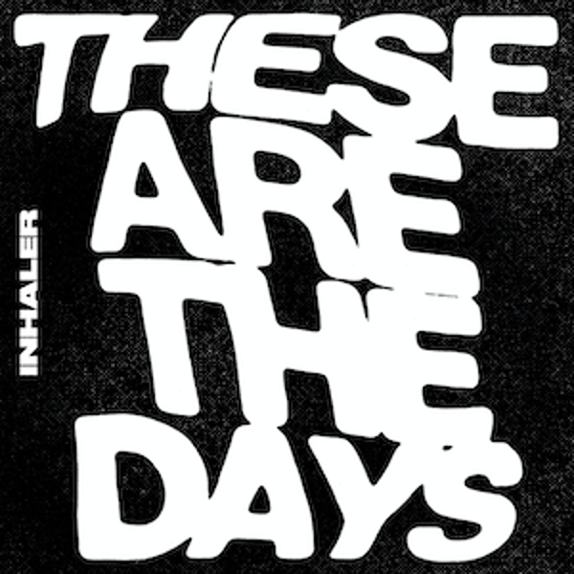

Stream - https://inhaler.lnk.to/TheseAreTheDays

Inhaler have announced details of a brand new single. One of the breakthrough bands of the past decade, the Dublin quartet return with These Are The Days, a widescreen indie-rock anthem and the group’s first new music since the release of their debut album It Won’t Always Be Like This in July 2021, a record that went to the top of the charts in both the UK and Ireland.

The group have a huge summer of festival dates lined up, including their first Glastonbury performance on the John Peel stage during Friday’s line-up plus appearances at Pinkpop, Nos Alive, BBK Live, Truck, Tramlines, Lollapalooza Chicago, Summer Sonic and a 5000 capacity headline show in Dublin. During the tour to support It Won’t Always Be Like This, Inhaler played to over 40,000 fans during US and European tours. The band will also support Arctic Monkeys across mainland Europe on the Sheffield group’s first live shows in three years.

Inhaler have now racked up over 140 million combined streams globally and their debut was a certified Brit Breakthrough that sold over 120,000 across the world. These Are The Days is the first track to emerge from sessions for Inhaler’s forthcoming second album. Stay tuned for more information on album two.

Inhaler UK tour dates:

June

11th – Summer Sessions, Dundee, Scotland (Noel Gallagher Support)
13th – Arena, Birmingham (Kings Of Leon Support)
22nd – Cambridge Junction, England
24th – Glastonbury Festival, England
26th – The SSE Arena, Belfast (Kings Of Leon Support)

July

5th – AO Arena, Manchester (Kings Of Leon Support)
23rd – Tramlines Festival, Sheffield, England
24th – Truck Festival, Oxfordshire, England

August
27th – Victorious Festival, Portsmouth, England

For more information and press enquiries please contact

Jenny Entwistle
Jenny@chuffmedia.com

