Another Sky Release ‘The Pain’

New Album Beach Day Out 1st March via Fiction Records

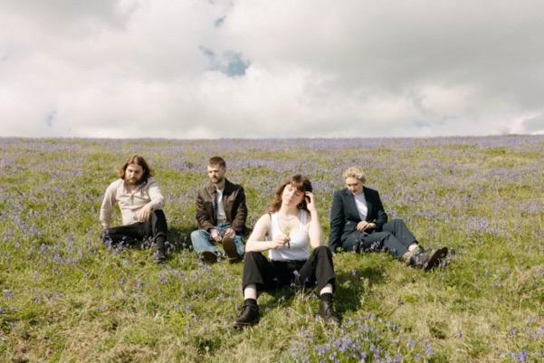
Credit – Darina
Download
Another Sky are excited to release ‘The Pain’, the new single from their upcoming second album Beach Day, due for release on 1st March via Fiction Records (world excl North America) & Republic Records (North America).

For the accompanying video, the band’s Art Director Darina had a lightbulb moment with an homage to the band’s favourite TV show ‘Severance’. All three of the band’s upcoming music videos play with the idea of multiple selves. The video sees the band working in an office as colleagues, unaware that in a parallel universe they may well be in a Crypt together, playing as a band.
Catrin explains “In the video Office Catrin is desperate to be liked by her fellow colleagues. But then she sees the version of herself she wishes she could be, Musician Catrin, which causes her to fully break down. It was a lot of fun to act out.”

Listen to ‘The Pain’ Here
Watch ‘The Pain’ Official Music Video Here

Up-and-coming visual artist Darina also captured the album artwork for the band’s sophomore album, ‘Beach Day’ on the South Coast of England, showing the band lost at sea, leaning on each other for comfort.

‘The Pain’ is the latest in a wave of hard-hitting and exciting comeback singles released over the last few months by the South London-based quartet.

“Psychopath” was a far more punchy and direct rock song than anything the band had previously released, and was followed up with ‘A Feeling’ which received strong support across BBC Radio 1 and 6 Music. Continuing the ferocious sentiments and instrumentation of the previous two singles, they swiftly followed with ‘Burn The Way’ and last month released ‘Uh Oh!’ which saw the South London quartet wrestling with their newly found creative zest, holding frustration and hindsight with both hands, and having a lot of fun with it too. The band announced Beach Day last month with a brand-new track which does not appear on Beach Day, ‘Aimee Caught A Moth’.

Vocalist Catrin Vincent has to say about the track –

“’The Pain’ is about looking back at your younger self with humour, compassion and fondness. It’s about missing the naivety of youth as well as embracing the wisdom of growing older, finally understanding why you’re drawn to people who hurt you. It’s an ode to living and thanking dramatic events for the lessons they teach you instead of wallowing in your mistakes.”

Pre-Order Beach Day Here

About Beach Day –

At this moment in time for Another Sky, there are maybe three certainties in this life: death, taxes, and rage. White-hot rage that takes you inwards, deeper into yourself, your fears, all the hidden truths you desperately tried to keep quiet while finding yourself.

With the band’s sophomore album Beach Day, that feeling opens a doorway to the most confident, fully formed and forthright version of Another Sky so far. Frontwoman Catrin Vincent points out the relationship between anger and freedom on this record. “If you don't move through anger, it'll calcify into bitterness, and it's not worth it,” she says, “but it’s about having the freedom to find and feel that anger. How can you move through something you don’t even know is there?”.

The album gave Vincent the opportunity to go more personal than ever – Another Sky has always supported and valued their front-woman’s vulnerability, but here it’s at its rawest. “Wait, why did I do this? Wait, why did I do this in the first place?” Vincent sings in the propulsive, almost euphoric climax of ‘Death of the Author’, one of many tracks on the album wrestling with a lack of control and surrender to the circumstances that great wreckage leave you with, whether you like it or not. The least you can do is make something of the rubble.

That rubble was rebuilt in the crypt of a church for Another Sky: the Covid years saw the band’s former studio flooded, as well as the painful consequences of a personal betrayal for all the band members (“all I had to do was be a good view as I fell from the sky you built for me,” Vincent spits on the explosive and impossibly direct lead single ‘Psychopath’). Both huge blows razed what you could perhaps call the first version of Another Sky to the ground. They needed a new space, and a new perspective, so they called out to their friends to help. “Does anyone know of any community spaces?”, they asked, and a Vicar, an avid Idles fan desperate to help some musicians, answered.

They built the crypt-based studio from scratch Another Sky, with help from guitarist Jack Gilbert’s builder Dad, where Gilbert produced much of the album himself – costing less and giving the band infinitely more freedom to take back control of their own narrative.

The anger and the fight is real, and it’s everything – but that doesn’t mean it always will be. Hold onto that feeling while it lasts: Another Sky are steadfast and galvanised to make you understand everything that got them here. How they survived. All you have to do is listen.

Track-Listing
- Beach Day
- The Pain
- A Feeling
- Uh Oh!
- I Never Had Control
- Death Of The Author
- Burn The Way
- Psychopath
- Playground
- City Drones
- I Caught On Fire
- Star Roaming
- Swirling Smoke

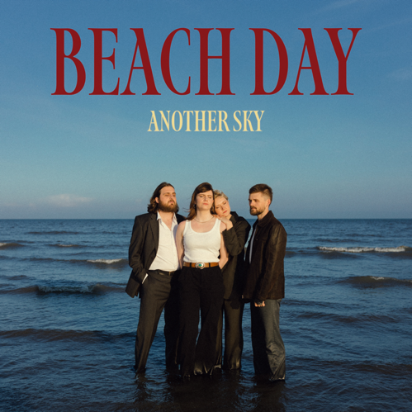
(Beach Day artwork // credit: Darina)
Download

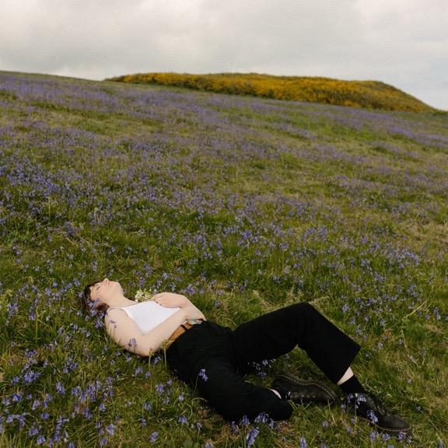
(Aimee Caught A Moth artwork // credit: Darina)
Download

For more on info contact warren@chuffmedia.com

