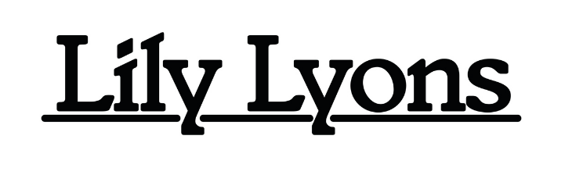**RELEASES NEW SINGLE ‘**[**THE ORANGE’**](https://youtu.be/gjGEmCFcKNs?si=djeb3WcQJkMlPoVm)

**SUPPORTING HARRISON STORM ACROSS THE UK NEXT MONTH**

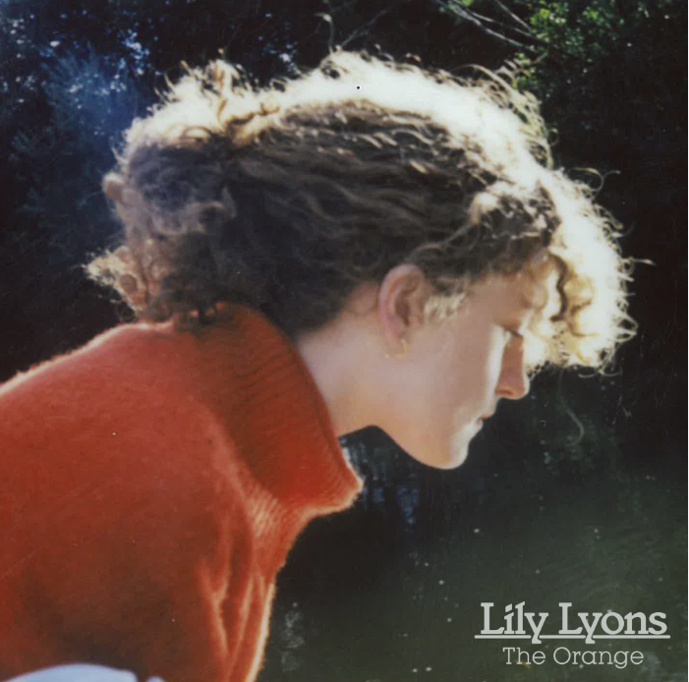

Lily Lyons has released her latest single 'The Orange' via Fiction Records.  The track has been accompanied by a beautiful live video, shot earlier this year at The Shelter in London. Watch [here](https://youtu.be/gjGEmCFcKNs?si=djeb3WcQJkMlPoVm).   
  
*"I wrote this song whilst spending a few weeks staying in Oxford; I had just read Wendy Cope’s poem The Orange for the first time and it had touched me deeply. Reading this poem broke me out of a cycle I had been in of becoming absorbed in the superficial and never finding peace due to looking in the wrong places. The song really poured out of me, a big “aha” moment, a reminder to continue to love the mundane. I always really connect with art that brings me back to the simple but brilliant."*  
  
Lily will be supporting Harrison Storm across the UK this November, along with a run of nearly sold-out headline shows at London’s Servant Jazz Quarters early next year.

**Lily Lyons UK Live Dates**  
  
17th Nov 2024 – Gullivers, Manchester (Harrison Storm Support)  
18th Nov 2024 – The Fleece, Bristol (Harrison Storm Support)  
27th Nov 2024 – Omeara, London (Harrison Storm Support)  
  
11th Feb 2025 – Headline show @ Servant Jazz Quarters – SOLD OUT  
12th Feb 2025 – Headline show @ Servant Jazz Quarters – SOLD OUT  
13th Feb 2025 – Headline show @ Servant Jazz Quarters

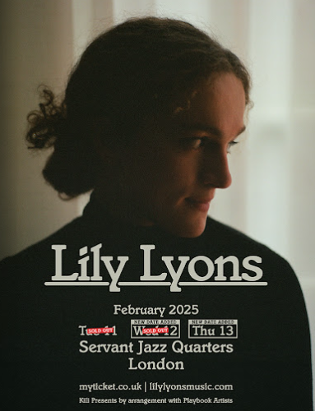

Follow Lily Lyons

[Spotify](https://open.spotify.com/artist/5YKAGYFz84gLEI7rAFpIpX?si=Di3evanETvmrtpdJrqDY6Q) | [Apple](https://music.apple.com/gb/artist/lily-lyons/1610727589) | [Instagram](https://www.instagram.com/lilylyonsmusic/?hl=en-gb) | [TikTok](https://www.tiktok.com/@lilylyonsmusic?lang=en)

**For more info contact Warren** [**warren@chuffmedia.com**](mailto:warren@chuffmedia.com)