Mumford & Sons

Share New Single, The Banjo Song

Listen HERE

The New Album Prizefighter Released 20th February 2026

Huge Summer Dates Set For London’s BST Hyde Park, Groningen, Rome + Berlin

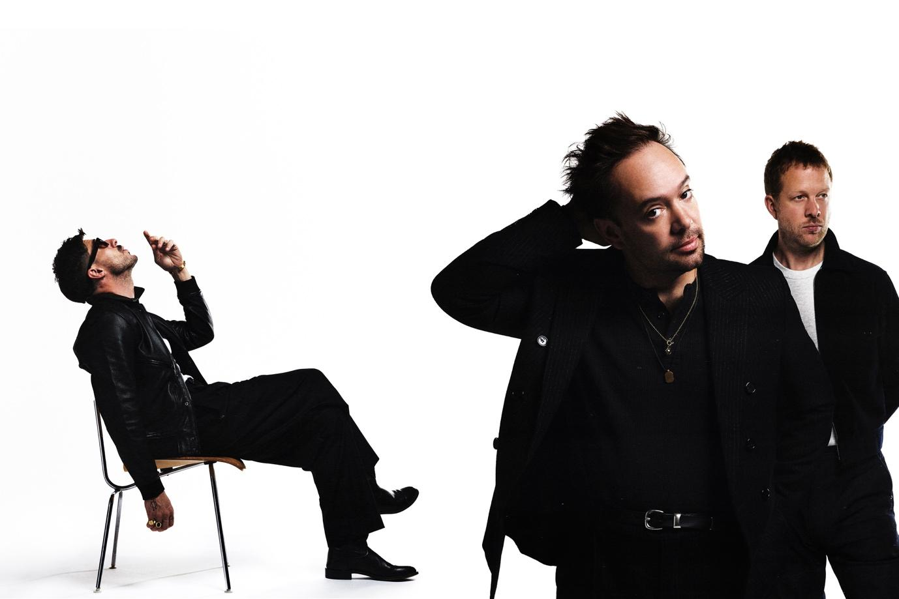
Image Credit: Conor Cunningham

Mumford & Sons are pleased to share a new track, The Banjo Song from their forthcoming sixth album, Prizefighter.

The new album is released 20th February 2026 via Island Records.

Listen to The Banjo Song HERE

The track was co-written with Aaron Dessner and Jon Bellion.

The Banjo Song follows the introductory tracks Rubber Band Man (with Hozier) and the new album’s title-track, as another taster to a record that vocalist Marcus Mumford has already described as the ‘most excited’ he’s been about a Mumford & Sons album. The Banjo Song makes for an excellent start to what promises to be a very hectic year for the band both on and off stage.

A mere seven months on from the arrival of RUSHMERE, the band’s long anticipated number one album in March 2025, Mumford & Sons take full advantage of a prolific period of songwriting with another full-length record in quick succession.

For a band whose unique sound has helped to both influence and inspire countless artists all around the globe, Prizefighter is Mumford & Sons’ finest example of precisely how and why they lead by example.

Co-produced and co-written with The National’s Aaron Dessner who the band previously worked with on their third record Wilder Mind, Prizefighter captures the band at their most open and instinctive. In just ten days, they’d written more than an album’s worth of songs, and a collection that feels both deeply personal, instinctive and unguardedly communal. Marcus Mumford’s lyrics grapple with resilience and striving, singing with a mix of confidence and urgency.

The album sessions were as much about rediscovery as recording. Days spent writing in Hudson cafés and nights spent around Long Pond’s kitchen table gave rise to songs that feel unpolished in the best sense—alive with first takes and the joy of simply making music together again. Re-energised, rejuvenated and in the form of their lives, Prizefighter embraces and reflects that full-strength energy and enthusiasm with 14 songs of light, shade and everything in-between.

That openness extended to the studio door too. Mumford & Sons welcomed collaborators into the studio, calling on the likes of Hozier, Gracie Abrams, Chris Stapleton, Gigi Perez, and Dessner himself. Their presence underscored the band’s commitment to community and connection.

Next Summer, Mumford & Sons will headline BST Hyde Park in London next July, with tickets on sale now. The show heralds the band’s first return to Hyde Park in a decade, with support from The War On Drugs. Huge outdoor Summer shows in Groningen, Rome, and Berlin are also on sale now.

Listen to the first track shared from the new record, Rubber Band Man (With Hozier), here.

Mumford & Sons Live:

4th July – BST Hyde Park, London w/The War On Drugs

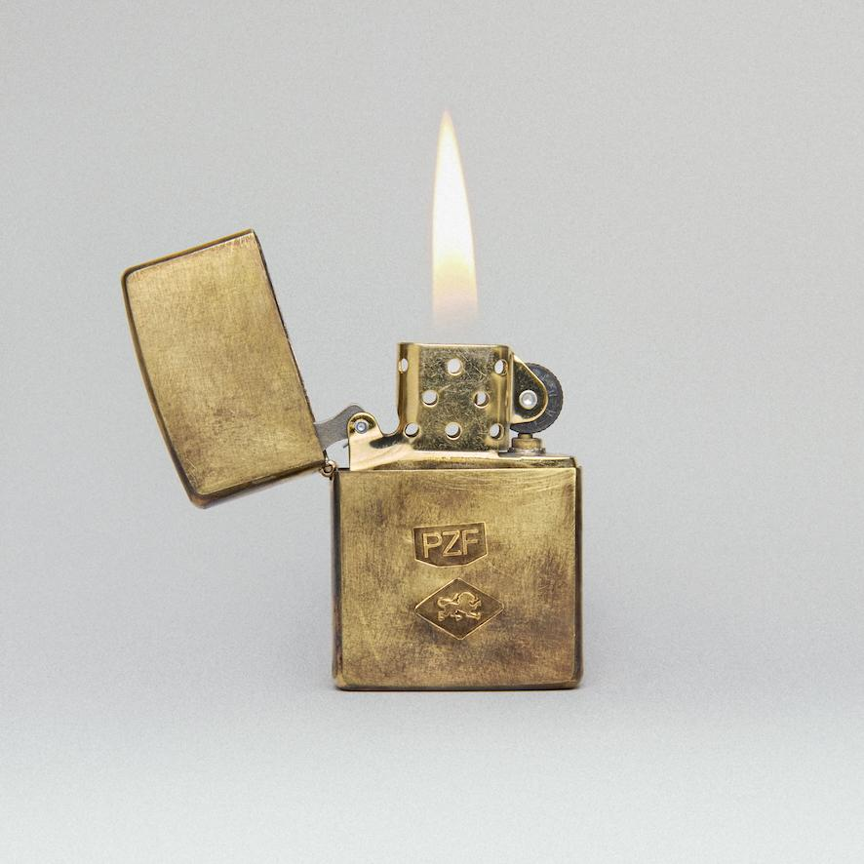
Prizefighter Album Artwork.

DISCOVER MUMFORD & SONS
Website | Facebook | Instagram | YouTube | Spotify

For more information and press enquiries please contact

warren@chuffmedia.com

