LUCY DACUS RELEASES NEW TRACK ‘TALK’

New Album Forever Is A Feeling Out March 28th

Forever Is A Feeling Tour Kicks Off April 16th, New Dates Added

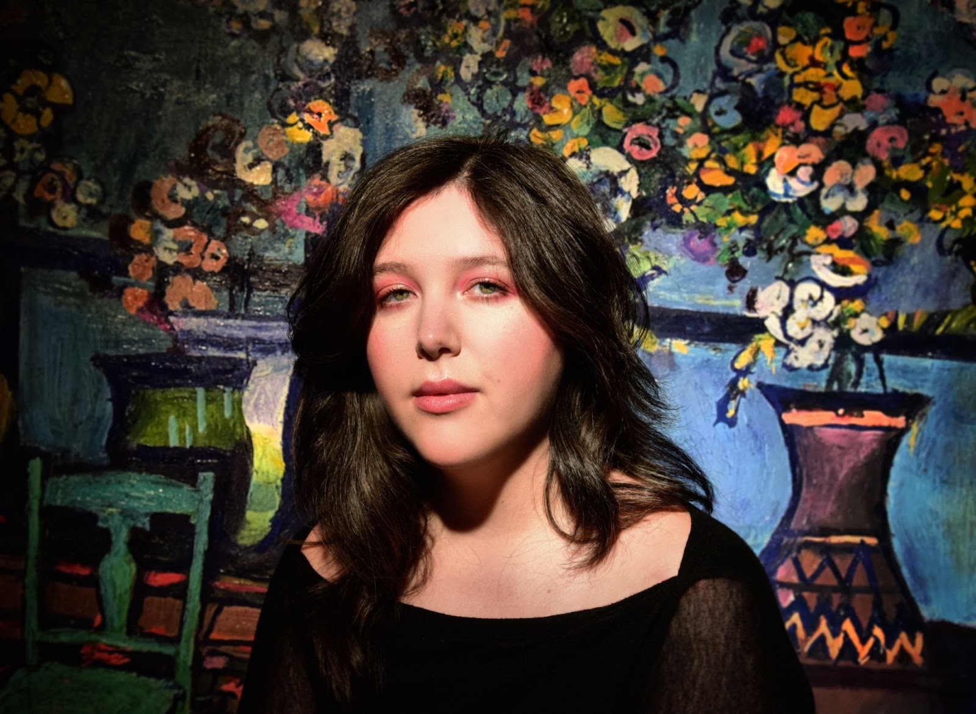
(Credit: Shervin Lainez. Download high res HERE)

Lucy Dacus has released ‘Talk’, the fourth track to be taken from her hotly anticipated new album Forever is a Feeling—out March 28th via Geffen Records/Polydor Label Group.

STREAM ‘TALK’ LYRIC VIDEO HERE

The song is the latest taste of her fourth solo album, following earlier released tracks ‘Ankles’, ‘Limerence’ and ‘Best Guess’. Dacus debuted ‘Ankles’ in a dazzling performance on The Tonight Show Starring Jimmy Fallon in January wearing custom Rodarte, a nod to the song’s Parisian music video in which she plays a painting that comes to life. ‘Ankles’ recently hit the top ten at AAA Radio in the U.S - marking Dacus’ first top ten radio hit as a solo artist.
On Monday, she unveiled the album’s full track listing before playing a sold out show in Paris’ stunning 16th century Saint-Eustache Church as part of her ‘An Evening With’ tour of museums and churches. Tracklist in full below.

Following the special run of intimate shows, Dacus’ Forever Is A Feeling Tour begins in Philadelphia on April 16th, with more dates already added due to demand. Support comes from special guest Katie Gavin (of MUNA) and jasmine.4.t.

WATCH VIDEO FOR ‘BEST GUESS’ HERE
WATCH VIDEO FOR ‘ANKLES’ HERE
STREAM ‘LIMERENCE’ HERE

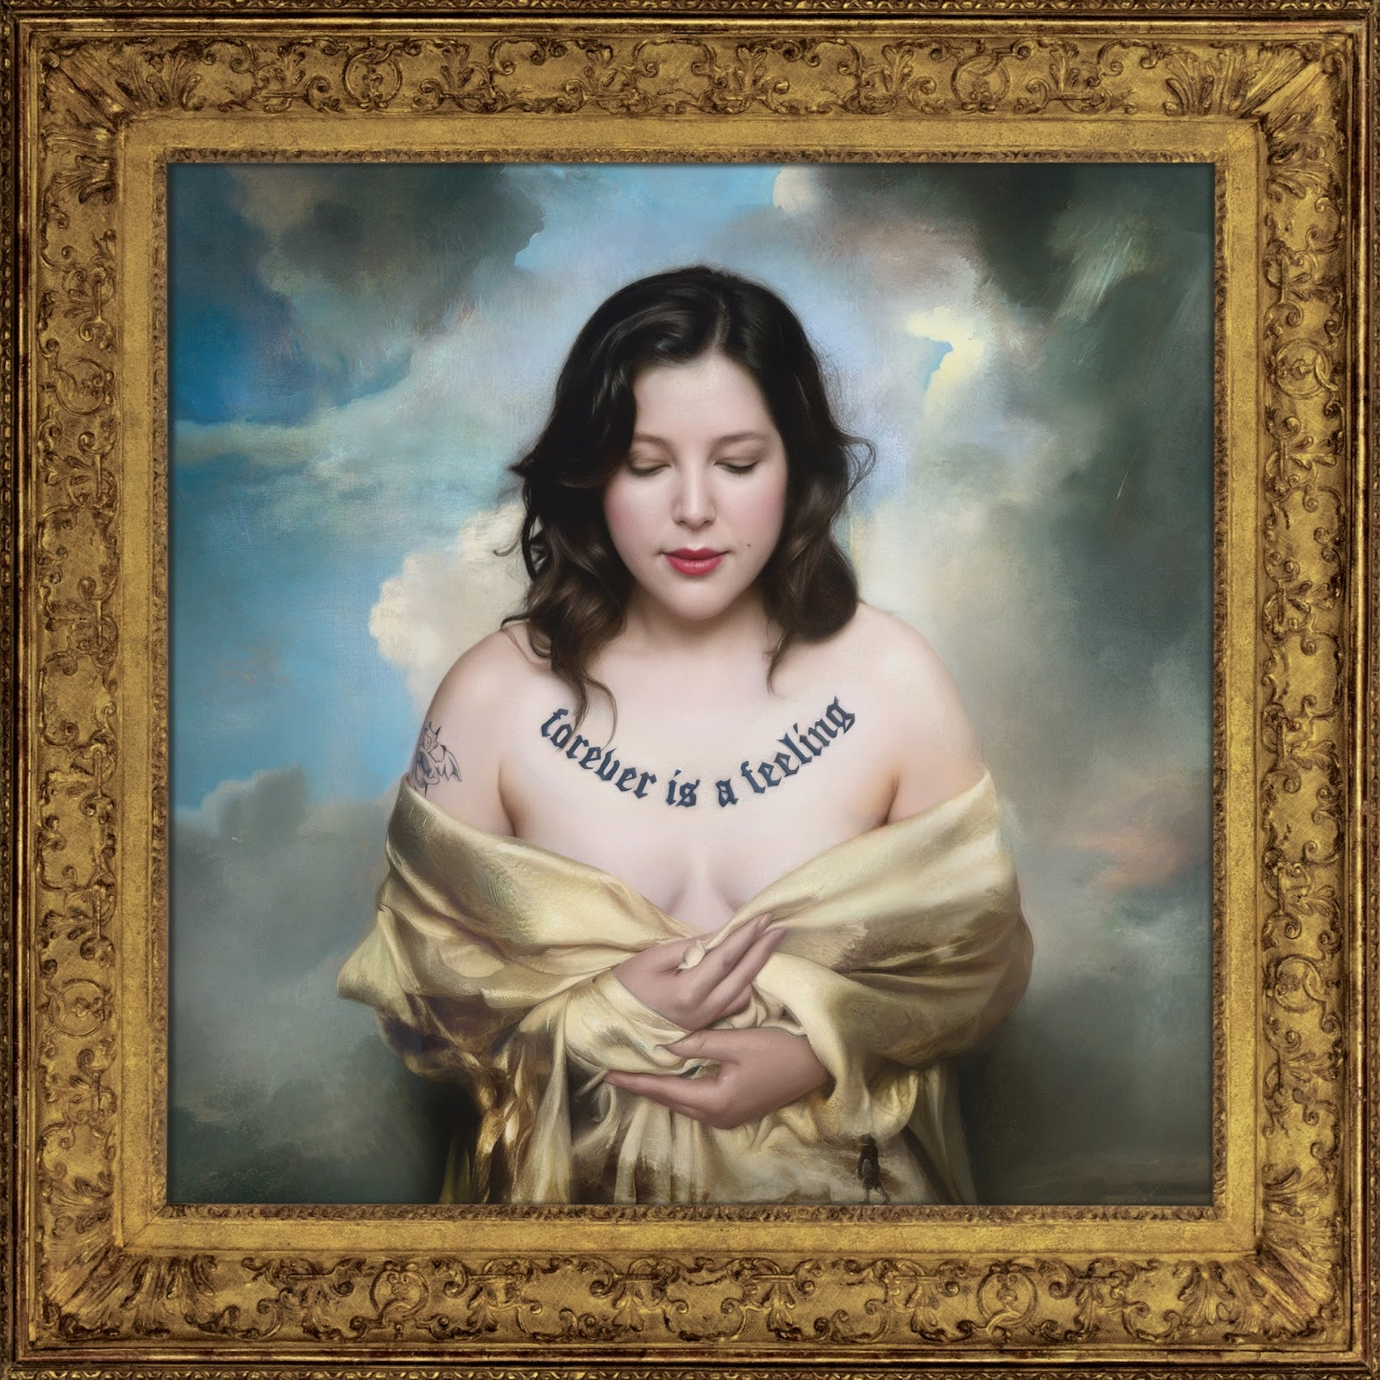
PRE-ORDER FOREVER IS A FEELING HERE

Forever Is A Feeling - Tracklist
- ‘Calliope Prelude’
- ‘Big Deal’
- ‘Ankles’
- ‘Limerence’
- ‘Modigliani’
- ‘Talk’
- ‘For Keeps’
- ‘Forever Is A Feeling’
- ‘Come Out’
- ‘Best Guess’
- ‘Bullseye’ ft. Hozier
- ‘Most Wanted Man’
- ‘Lost Time’

An Evening With Lucy Dacus:
March 12th - Vondelkerk, Amsterdam, NL *SOLD OUT*
March 14th - Säälchen at Haltzmarkt, Berlin, DE *SOLD OUT*
March 18th - Sir John Soane’s Museum, London, UK (early and late show) *SOLD OUT*

Forever Is A Feeling Tour:

April 16th - The Met - Philadelphia, PA - SOLD OUT #
April 18th - The Anthem - Washington, DC - SOLD OUT #
April 19th - The Anthem - Washington DC #
April 20th - MGM Music Hall - Boston, MA #
April 21st - MGM Music Hall - Boston, MA - SOLD OUT #
April 23rd - Radio City Music Hall - New York, NY - SOLD OUT #
April 24th - Radio City Music Hall - New York, NY - SOLD OUT #
April 25th - Massey Hall - Toronto, ON - SOLD OUT #
April 26th - Massey Hall - Toronto, ON #
April 29th - Ryman Auditorium - Nashville, TN - SOLD OUT #
April 30th - Ryman Auditorium - Nashville, TN - SOLD OUT #
May 1st - Chicago Theatre - Chicago, IL - SOLD OUT #
May 2nd - Chicago Theatre - Chicago, IL - SOLD OUT #
May 5th - Palace Theatre - St. Paul, MN - SOLD OUT #
May 6th - Palace Theatre - St. Paul, MN #
May 7th - Midland - Kansas City, MI #
May 9th - Winspear Opera House - Dallas, TX #
May 10th - Moody Amphitheatre - Austin, TX #
May 12th - Red Rocks Amphitheatre - Denver, CO #
May 14th - The Greek Theatre - Los Angeles, CA #
May 15th - The Greek Theatre - Los Angeles, CA #
Aug 1st - Osheaga Festival - Montreal, QC
Aug 2nd - Aug 3rd - Back Cove Music & Arts Festival - Portland, ME
Sep 21 st - Shaky Knees Festival - Atlanta, GA

UK & Europe

June 11th - Bergenfest - Bergen, NO
June 12th - Rockefeller - Oslo, NO
June 13th - 15th - Best Kept Secret Festival - Hilvarenbeek, NL
June 16th - Paradiso - Amsterdam, NL *SOLD OUT*
June 17th - Paradiso - Amsterdam, NL
June 18th - Astra - Berlin, DE
June 19th - Astra - Berlin, DE *SOLD OUT*
June 24th - Ancienne Belgique - Brussels, BE
June 25th - Trianon - Paris, FR
June 26th - Brixton Academy - London, UK *SOLD OUT*
June 28th - Glastonbury - Somerset, UK
June 30th - Usher Hall - Edinburgh, UK
July 1st - Barrowlands - Glasgow, UK
July 2nd - Academy - Manchester, UK *SOLD OUT*
July 3rd - Iveagh Gardens - Dublin, IE
July 5th - Roskilde Festival - Roskilde, DK

# with Katie Gavin and jasmine.4.t.

KEEP UP WITH LUCY DACUS:
Instagram | Tiktok | Website

For more information please contact jenny@chuffmedia.com

