BELLAH MAE
Returns With Sassy New Single “Sting” – A Confident, No-Holds-Barred Breakup Anthem
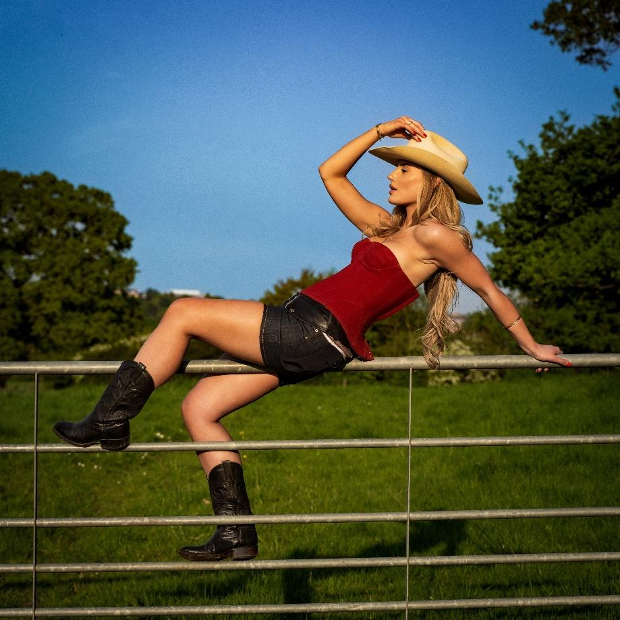
Listen Here
Catch Bellah live at the Tunes in the Dunes festival this Saturday 7th June in Cornwall.
Rising British pop powerhouse Bellah Mae is back — bolder, sharper, and more unapologetic than ever — with the release of her brand new single, “Sting” - the ultimate ex clapback! The track lands as a fiery follow-up to “Bad Day To Be My Ex,” and marks the next confident step for the Solihull-born singer-songwriter.
Written in Nashville by Bellah alongside collaborators Brett Truitt and Brigetta Truitt, “Sting” blends slick, country-tinged pop with the fierce storytelling flair Bellah has become known for. Laced with witty jabs and cutting lyricism, it’s a track that refuses to look back — an anthem for anyone who’s come out the other side stronger, hotter, and totally unbothered.
“I’ve really stepped into a new kind of confidence in both my personal life and songwriting and think you can really feel that within the new songs.” Bellah shares
“This song is a reminder that you’ll always be the hot ex.! It’s supposed to feel like a friends group chat cheering each other on, I want anyone hearing the song to feel empowered”
With lyrics like “I got hotter, sue me” and the now-iconic hook “Oh that’s gotta sting,” Bellah channels the energy of a woman fully in her power — part sweet, part savage, and served with a wink. The single’s razor-sharp wit and undeniable swagger are elevated by shimmering sassy production and an earworm melody destined to dominate playlists and pop culture alike.
“Sting” continues Bellah’s artistic evolution, showcasing the 23-year-old’s sharpened voice — both literally and figuratively — as she draws inspiration from '90s cultural icons like Pamela Anderson and Dolly Parton. Just like them, Bellah is reclaiming her narrative, one killer track at a time.
Following two sold-out UK tours, over 100K cumulative streams, and co-signs from major names like Tate McRae, Bellah Mae is carving out her space in the pop landscape — and “Sting” is a warning shot to anyone who’s underestimated her.
TikTok // Instagram // YouTube

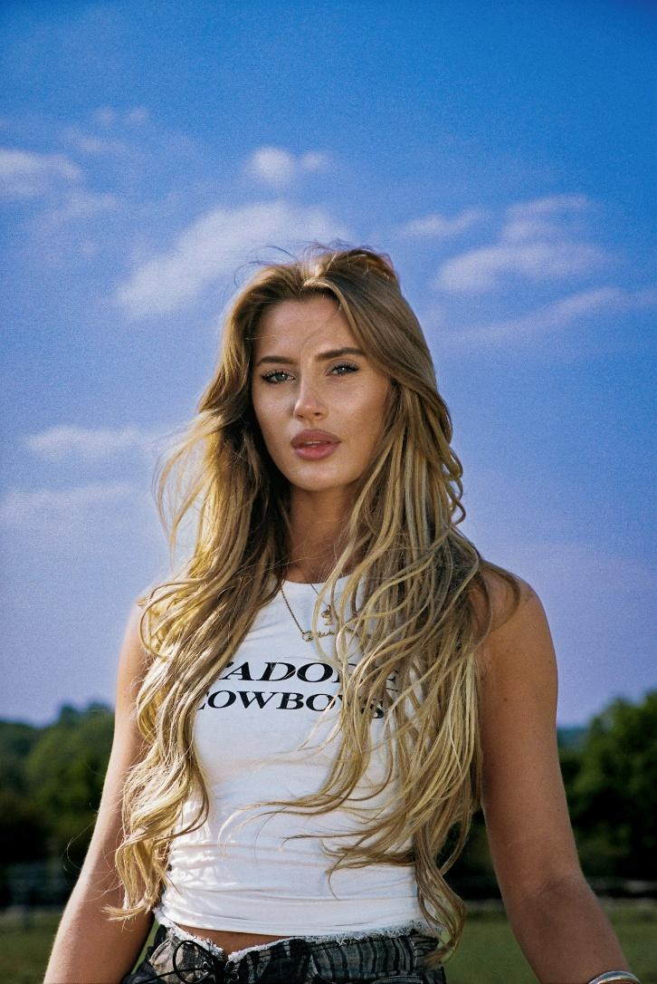

Warren Higgins
Warren@chuffmedia.com

