GOOD NEIGHBOURS

Share new single ‘Starry Eyed’
(Listen HERE)

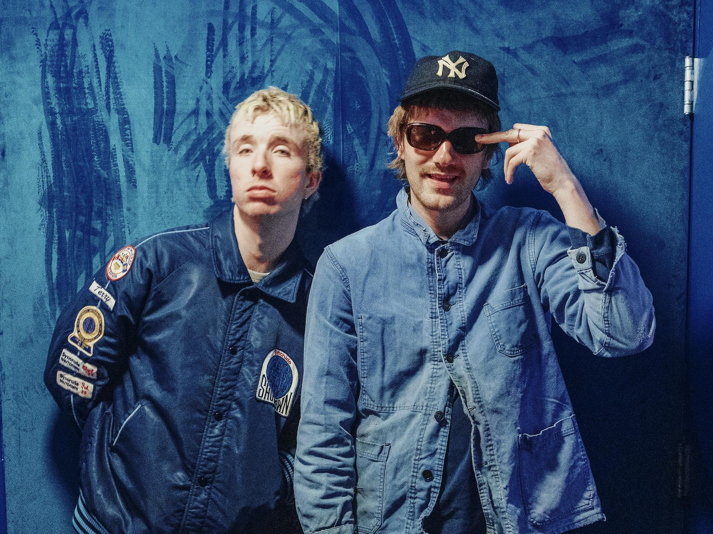
Photo Credit: Owen Hammel

Hot on the heels of their massive North American tour with Foster The People and ahead of their Adolescence Tour in the UK, Good Neighbours are back today with a brand-new track ‘Starry Eyed’, written by the duo in Los Angeles this January. Road testing the song while on tour, Scott and Oli immediately saw a response – both in the rooms and on social media. Following the insane fan-demand, and gathering online traction for the song, Good Neighbours have responded in kind. ‘Starry Eyed’ is out now.

Speaking about the track, Good Neighbours reveal, “We wrote Starry Eyed very off the cuff while we were stuck in LA. It’s about that star struck feeling that someone gives you the first time you meet them. There’s a vulnerability in that encounter that’s both scary and exciting, and we tried to capture the thrill that comes with it. We trialed playing it live on our recent tour with Foster The People, and it felt like something clicked. After fans were calling out for it to be played, it felt only right to put it out for everyone to hear with the same spontaneity and energy that the song was created in.”

The release of new music couldn’t be timelier, following the recent announcement of the band’s
Adolescence Tour, which officially kicks off in the UK April 2 through April 13, before returning to the U.S. on April 20. See below for full dates.

Speaking about the new tour, Good Neighbours explained, “There’s been a lot of bigggg mad moments in the last year, but as two boys from small towns, we realize we missed a couple stops. The adolescence tour is us making room for some places we haven’t yet been and letting us have some fun on the road.”

Earlier this year, Good Neighbours released ‘Ripple’, out now via Polydor Records alongside the band’s first official music video, directed by Alex Lockett. Watch HERE. Last month, Good Neighbours released their Apple Music Sessions EP, featuring a live version of ‘Ripple’ and a dreamy cover of Gracie Abrams’ ‘That’s so True’ (LISTEN). Earlier this month saw the release of a new soft version of ‘Ripple’. HERE

To say 2024 was something of a whirlwind for Good Neighbours is an understatement. ‘Home’, released in January of last year, recently was certified Platinum, making it the fastest and only RIAA Platinum debut released and certified in 2024. It has since amassed more than 500 million global streams, while TikTok videos using the song have amassed over 2 billion views. ‘Home’ entered the singles charts in 13 countries including the UK (#26) and the Billboard Hot 100 (for 11 weeks) and spent nearly 40 weeks in the Top 10 on Billboard’s Hot Rock Songs chart, along with impressive radio airplay on more than 200 stations in the U.S. across all formats, landing the song in both the Top 3 at AAA and in the Top 10 at Alternative Radio making it one of the most played songs of the year in both formats. Their latest single, ‘Ripple’ meanwhile is climbing the charts as well, currently sitting in the Top 20 at Alt Radio.

In addition, the band’s massive year included the release of their highly-anticipated, self-titled
debut EP (LISTEN), first UK and U.S. headline tours, during which time Good Neighbours made their television debut with a lively performance of ‘Home’ on Jimmy Kimmel Live! (WATCH), and a range of accolades including a Billboard Music Award nomination for Best Rock Duo/Group, VEVO naming the duo one of their VEVO DSCVR Artists To Watch for 2025, a shortlisting for a BRITS Rising Star, MTV Push UK 2025, and being added to BBC Sound Of 2025 longlist. Most recently, the band received a nomination for Best New Artist (Alternative & Rock) at the 2025 iHeart Radio Music Awards and were named one of Amazon Music UK’s 2025 Artists to Watch.

For a full list of tour dates and to purchase tickets, please visit www.wearegoodneighbours.com .

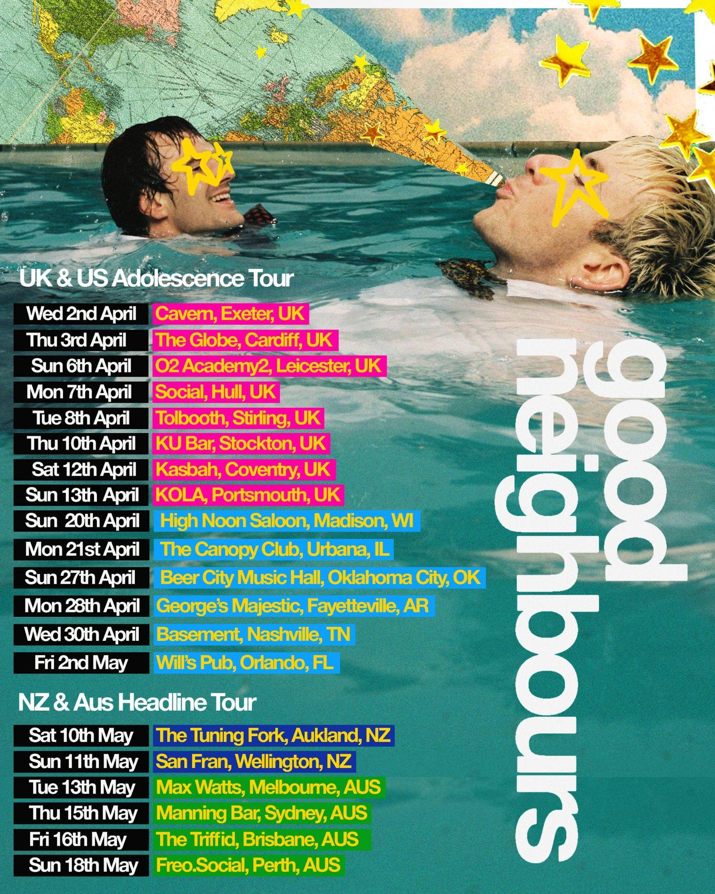

UK Adolescence Tour:

April 2 Cavern, Exeter
April 3 The Globe, Cardiff
April 6 02 Academy2, Leicester
April 7 Social, Hull
April 8 Tolbooth, Stirling
April 10 KU Bar, Stockton
April 12 Kasbah, Coventry
April 13 KOLA, Portsmouth

Following this spring run, Good Neighbours are so far confirmed for the following global summer festivals with more expected to be announced in due course:

June 21 Summerfest, Milwaukee, WI (US)
July 11 TRNSMT, Glasgow (UK)
Aug 1 Hinterland Music Festival, Saint Charles, IA (US)
Aug 2 Osheaga Festival, Montreal, QC (CA)
Aug 15 MS Dockville, Hamburg, Germany (EU)
Aug 22 Rock En Seine, Paris, France (EU)

Follow Good Neighbours
TIKTOK | INSTAGRAM | TWITTER/X | FACEBOOK | YOUTUBE

For more information and press enquiries please contact

Jenny Entwistle
Jenny@chuffmedia.com

