4X GRAMMY NOMINATED ARTIST JULIA MICHAELS RETURNS WITH LYRICAL PUNCH

RELEASES FIRST TASTE OF NEW MUSIC TO COME IN 2023

“SORRY TO ME TOO” OUT NOW

Listen to “Sorry To Me Too” HERE
Lyric video for “Sorry To Me Too” HERE

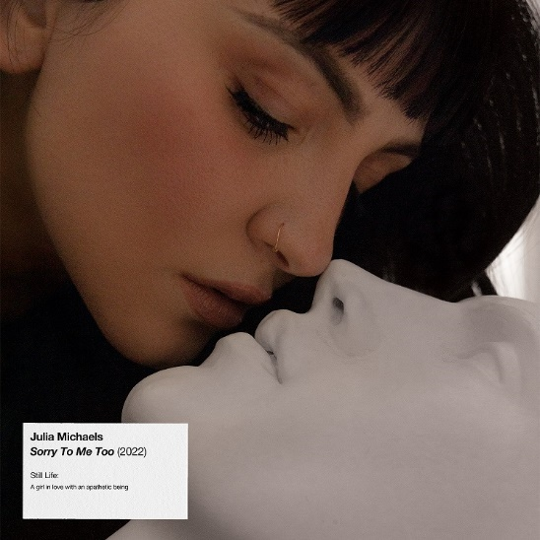
Primed for a massive 2023, 4x-GRAMMY® Award-nominated multiplatinum singer and songwriter JULIA MICHAELS returns with a brand-new song entitled “Sorry To Me Too” via Republic Records today. Listen to “Sorry To Me Too”—HERE.

The track’s upbeat production belies JULIA’s biting analysis of a breakup, before she issues an empowered apology to herself and moves on with her head held high. Once again, she takes a creative leap, leaning into a beat that’s as frenetic and anxious as it is danceable.

“The new music I have coming is me going through the grieving process of a breakup. You’ll hear me working out what happened, where it went wrong, trying not to blame myself, and getting back to life without this person who I thought would be in it for a really long time,” she says. ““Sorry To Me Too,” captures that disbelief and anger phase,” she adds. “Like, ‘You say you're sorry?’ Well, I'm sorry to me too for believing all your bullshit and in the promises that you gave me and told me that I clinged to—that I thought were real.”

Known for her lyrical vulnerability and prowess, the song reminds fans and critics alike why JULIA remains one of the industry’s top songwriters in a mostly male dominated field. An artist’s artist through and through, she continues to set the bar for herself and her peers, recently collaborating with Conan Gray, Sabrina Carpenter, Maren Morris, Ingrid Andress, Ellie Goulding, and more.

In other big news, her GRAMMY® Award-nominated smash “Issues” is currently approaching 6x-platinum status, while “What A Time” and “Heaven” were just certified platinum by the RIAA. Next up, she will pen original music for the upcoming Disney film, Wish, which stars Academy® Award winner Ariana DeBose and releases next November.

Stay tuned for more soon as “Sorry To Me Too” only paves the way for more music from Julia in 2023 and beyond.

ABOUT JULIA MICHAELS
Over the past few years, no songwriter has reshaped pop music more than 4x Grammy® Award-nominated and multiplatinum-selling artist Julia Michaels has. In 2017, she embarked on a solo career with her 5x-platinum selling debut single “Issues.” A year later, her peers recognized her stunning work with Grammy® Award nominations for “Best New Artist” and “Song of the Year.” She released a series of critically acclaimed EPs, including 2017’s fan-favorite Nervous System and 2019’s critically acclaimed Inner Monologue Part 1 and Inner Monologue Part 2. She also embarked on The Inner Monologue Tour, which marked her first-ever U.S. headline tour following an enviable run touring with Maroon 5, Keith Urban, Shawn Mendes, Niall Horan, and P!NK. 2021 saw Julia release her critically acclaimed full-length debut album, Not In Chronological Order, to critical acclaim. Her music continued to connect with songs like “What A Time” and “Heaven” going on to achieve Platinum status. To date, she has also notched 25 Billboard Hot 100 entries as a songwriter, including two number 1’s for Justin Bieber's "Sorry" and Selena Gomez's "Lose You to Love Me,” in addition to four top 10 hits. She received her third Grammy® Award nomination in the category of “Song Of The Year” for the hit song “If The World Was Ending” and her fourth Grammy® Award nomination for her work on H.E.R.’s album Back of My Mind. Next up, Julia will release “Sorry To Me Too” on November 11th, kicking off the next chapter for her solo artistry with a larger project arriving early 2023. What’s more, she has also been tapped to compose the original songs for Disney’s upcoming film “Wish” starring Oscar winner Ariana DeBose, which will arrive Nov 2023, with additional collaborations to extend her incredible songwriting legacy.
SOCIALS: OFFICIAL // FACEBOOK // TWITTER // INSTAGRAM

For more information and press enquiries please contact

Jenny Entwistle / Jenny@chuffmedia.com

