
SHARES NEW SONG
‘SOMEWHERE ONLY WE GO’
LISTEN HERE
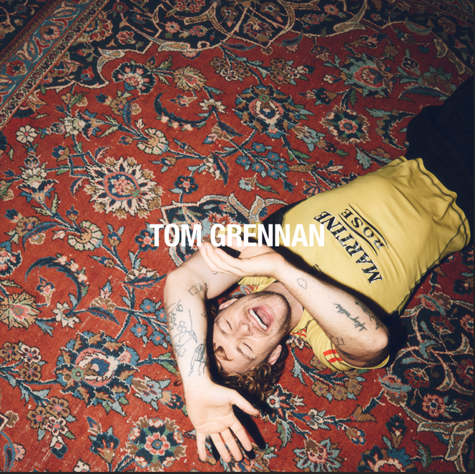
Download single artwork
FINAL TRACK SHARED AHEAD OF ALBUM RELEASE
‘EVERYWHERE I WENT LED ME TO WHERE I DIDN’T WANT TO BE’
OUT AUGUST 15th 2025

PRE-ORDER ALBUM HERE
TOM GRENNAN today (Aug 1st) releases new song ‘Somewhere Only We Go’, the sixth and final track to be shared from his upcoming album, ‘Everywhere I Went Led Me To Where I Didn't Want To Be’, which is released on August 15th via Insanity Records. After his wistful and captivating recent song ‘I Won’t Miss A Thing’, Tom majestically ups the ante with the electrifying ‘Somewhere Only We Go’, a rousing, stadium-sized singalong driven by an infectious hook to match its shimmering guitar lines and surging drums. It’s one of his most epic and bombastic songs yet.
Tom says, “Somewhere Only We Go” is a reflection on how people change, drift, and grow apart—sometimes for the right reasons, sometimes for the wrong ones. But no matter how much time passes, there are always moments, memories, and places that tie us to who we once were. This song is about honouring those connections, even when life moves on—because in the end, it moves too fast to leave the important things unsaid.”
As he readies himself for the release of his fourth album, Tom Grennan has announced a series of Record Store dates, running from 7th to 18th August, as well as an exclusive, one-off live fan event in Coventry. Tom will host a very special “Final Night Of Tour Rehearsals” show at the Exhibition Hall, Coventry Building Society Arena on Friday 29th August.
Fresh from a whirlwind of activity—launching his 'You About?' podcast with Roman Kemp, headlining Radio 1's Big Weekend, performing at the BAFTA Awards, and appearing with Chase & Status at the O2 - Tom recently joined Soccer Aid for the fifth time for their annual charity football match.
‘Somewhere Only We Go’ follows previous singles ‘I Won’t Miss A Thing’, ‘Full Attention’, ‘Higher’, ‘Shadowboxing’ and ‘Boys Don’t Cry’ and further showcases the thrilling evolution of one of UK’s most exciting talents at his creative best. Tom teamed up with producer Justin Tranter for his fourth album, creating a state-of-the-art pop record. The 15-track album is the multi-platinum-selling artist’s fourth and serves as the eagerly awaited follow-up to 2023’s ‘What Ifs & Maybes’. Coinciding with the album release, Tom Grennan will embark on his biggest UK & Ireland arena tour to date this September, with 11 dates announced for the GRENNAN '25 tour.
With two number one albums under his belt alongside multiple Brit and Ivor Novello nominations, countless airplay smashes, sold-out arena tours and an MTV Award for Best UK Act, Tom Grennan is already one of the country’s biggest artists. Last August saw the Bedford-born artist headline his biggest show to date to a capacity crowd of 25,000 at Gunnersbury Park.
Keen to explore a new sound, Tom enlisted the songwriter and producer behind hits for Dua Lipa and Chappell Roan and found in Tranter a collaborator who understood exactly what he wanted to say and what he wanted to sound like: George Michael, Prince, Freddie Mercury. “So much of the new music is uplifting — it makes you dance, makes you sing,” Tom says.
“It's about my fight with a side of me I have a lot of trouble with. It’s still a daily battle. But I’ve learned how to fight all these demons and I’m mentally and physically prepared now. I’m in athlete mode.”
While the title alludes to a time when Tom faced challenges with his mental health, ‘Everywhere I Went Led Me To Where I Didn't Want To Be’ is a positive album about self-belief and having the confidence to take risks. “This album is about me, revived. Now I'm at a place where I DO want to be. And I'm ready to blow people's heads off.”
It is set to be a stunning addition to Tom Grennan’s already-impressive discography, which has seen him accumulate over 1.5 million album sales and 2.5 billion streams across his gold-selling debut Lighting Matches (2018), his first UK Number One album Evering Road (2021) and What Ifs & Maybes (2023), another Number One and Tom’s third gold-selling album in a row. Tom Grennan’s recent Top 3 festive smash ‘It Can’t Be Christmas (Amazon Music Original)’ immediately gained silver certification in its first run at the Christmas title. Tom achieved his highest ever singles chart for a solo release and was only narrowly held off the top spot by Christmas titans Wham! and Mariah Carey.
The album tracklisting is:
- Full Attention
- Cool With That
- Shadowboxing
- Boys Don’t Cry
- Somewhere Only We Go
- Shadows on the Ceiling
- Celebrate
- Higher
- Certified
- Diamond
- Dirty Dishes
- Cinnamon
- Drama Queen
- I Won’t Miss A Thing
- Lonely Dancer
Album Release Record Store Dates
7-Aug-25 Liverpool Camp & Furnace with Jacaranda - Stripped back acoustic performance
7-Aug-25 Manchester HMV (Signing Only) 1pm
8-Aug-25 Hull The Welly with Crash Records - Stripped back acoustic performance
8-Aug-25 Leeds HMV (Signing Only) 1pm
9-Aug-25 Norwich UEA with HMV - Stripped back acoustic performance
10-Aug-25 Birmingham HMV Vault (Signing Only) 12pm
10-Aug-25 Trowbridge Civic with Sound Knowledge - Stripped back acoustic performance
11-Aug-25 Brighton Chalk with HMV - Stripped back acoustic performance
13-Aug-25 Bristol Prospect with Rough Trade - Stripped back acoustic performance
14-Aug-25 London HMV Oxford Street (Signing Only) 1pm
18-Aug-25 London Kingston Pryzm with Banquet Records - Stripped back acoustic performance

Final Night Of Tour Rehearsals Show
29-Aug-25 Coventry Exhibition Hall, Coventry Building Society Arena

GRENNAN ’25 UK Arena Tour
3-Sep-25 Bournemouth BIC
4-Sep-25 Birmingham Utilita Arena
6-Sep-25 London O2 Arena
9-Sep-25 Cardiff Utilita Arena
10-Sep-25 Nottingham Motorpoint Arena
11-Sep-25 Glasgow OVO Hydro
15-Sep-25 Aberdeen P&J Arena
16-Sep-25 Newcastle Utilita Arena
18-Sep-25 Leeds First Direct Arena
19-Sep-25 Manchester Co-Op Live

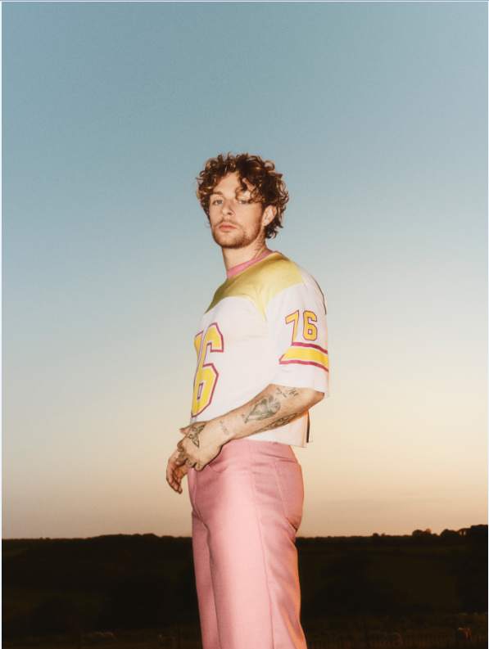
DOWNLOAD PRESS PHOTO
(credit: Ed Cooke)

DOWNLOAD ALBUM ARTWORK

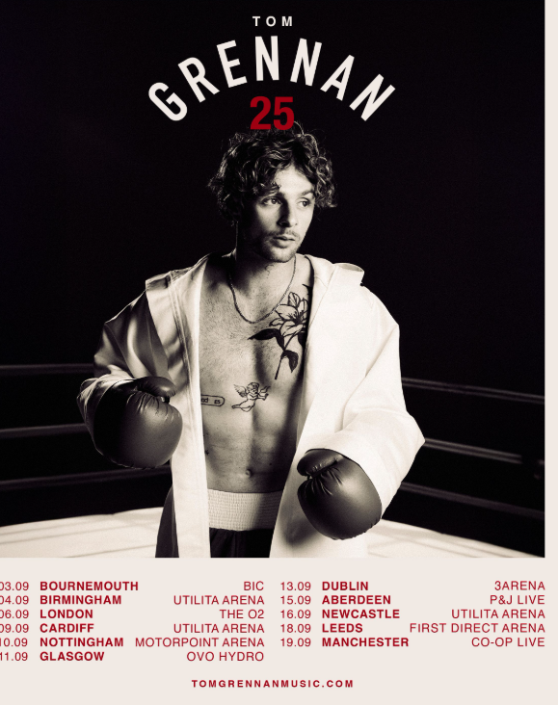

Connect with TOM GRENNAN

INSTAGRAM
TIK TOK
YOUTUBE
FACEBOOK
X

For more information and press enquiries for TOM GRENNAN please contact

Jenny Entwistle
Jenny@chuffmedia.com

