**GRAMMY® AWARD-WINNING ALESSIA CARA RELEASES NEW SINGLE “SLOW MOTION”**

**HIGHLY ANTICIPATED NEW ALBUM *LOVE & HYPERBOLE*ARRIVES ON VALENTINE’S DAY FEBRUARY 14th**

**LISTEN**[**HERE**](https://alessiacara.lnk.to/SlowMotion)**| WATCH**[**HERE**](https://alessiacara.lnk.to/SlowMotionlyricvid)

**PRE-SAVE/PRE-ORDER *LOVE & HYPERBOLE***[**HERE**](https://alessiacara.lnk.to/LoveandHyperbole)

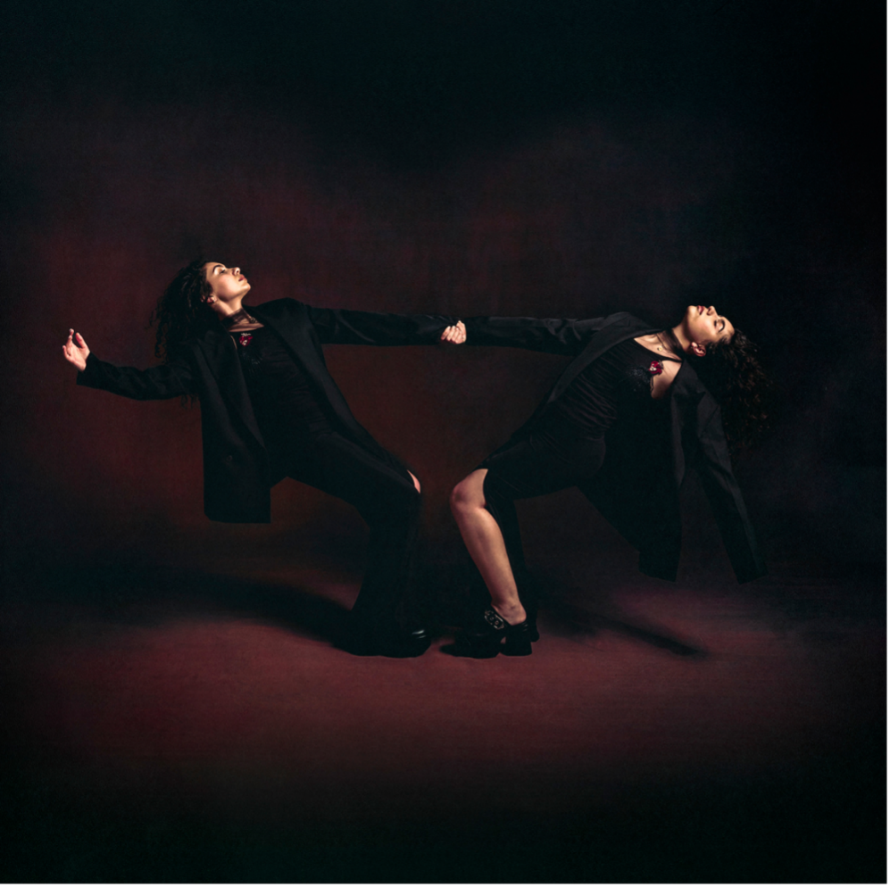

**January 24, 2025**– Opening up once again without filter, GRAMMY® Award-winning superstar **Alessia Cara** unveils a new single entitled **“Slow Motion”** Listen [**HERE**](https://alessiacara.lnk.to/SlowMotion) , taken from the new album ***Love & Hyperbole***, out **February 14, 2025**. Pre-save/pre-order [HERE](https://alessiacara.lnk.to/LoveandHyperbole).

**“Slow Motion”** produced by Mike Elizondo and Jake Gosling arrives on the heels of the standout track,  [**“(Isn’t It) Obvious,”**](https://www.youtube.com/watch?v=hmLnKnNh2ns) which has already generated millions of streams and counting in addition to earning critical praise.Not to mention, she delivered a showstopping performance of the track on Good Morning America. Watch her performance[HERE](https://www.goodmorningamerica.com/culture/video/alessia-cara-performs-isnt-obvious-gma-114982240).

***Love & Hyperbole*** showcases her evolution as a powerhouse vocalist, empathetic songwriter, and force of nature. Doubling down on the diary-like candor that’s always defined her music, ***Love & Hyperbole***begins with the self-aware reflection of a fitting starting point to the album’s journey from isolation and inertia to open-hearted connection. “For a long time I felt so lost and closed-off, to the point where I didn’t want to go outside,” says Alessia. “It’s me asking how I can ever be happy if I can’t even bring myself to be out in the world.” From there, Alessia documents her experience in “learning to let the light in,” taking care to share the many setbacks on her way to self-fulfillment. To that end, single,  [**Dead Man**](https://www.youtube.com/watch?v=IXjYdcYX7qk), ruminates on past relationships that left an indelible mark on her heart, unfolding as a hypnotic piece of soul-pop whose gloriously frenzied horn section features famed trombonist Roy Agee (a longtime member of Prince’s live band). “I feel like I’ve learned a lot from dealing with situations where the other person wasn’t capable of giving their full self,” says Alessia, who co-wrote “Dead Man” with Elizondo.

Over the course of *Love & Hyperbole*’s 14 spellbinding tracks, Alessia muses on everything from the blissed-out infatuation of new romance (on “**Slow Motion**”) to the excruciating anxiety that often accompanies falling in love and about “worrying if the person I love is going to leave me, because I’m not used to things being so good in a relationship,” says Alessia. “As soon as I tapped into that concept, I had a much better understanding of what I wanted this album to be.” Rooted in her most powerful vocal work to date, ***Love & Hyperbole*** closes out with the passionately sprawling celebration of letting go and looking ahead.

As she reflects on the making of ***Love & Hyperbole***, Alessia notes that the album served as a major turning point in solidifying her identity as an artist. “Every project so far has felt like a step in the right direction, but this album felt more like a leap,” she says. But despite bringing a greater level of confidence to every aspect of the process, she remains fully in tune with her more vulnerable side. “One of the things I hear most often from fans is that my music has helped them feel seen in some way,” she says. “The whole reason I started making music was that I didn’t always feel seen in my own life, so it’s really touching to know that expressing myself might help someone else feel understood. That’s always the goal with my music: to create something very specific and personal to me but also open enough so that everyone can see themselves in my songs.”

**Alessia Cara** has generated billions of streams, earned dozens of multi-platinum certifications around the world, and notably made history as *“the first Canadian to win ‘Best New Artist’* *at the GRAMMY® Awards*.*”*  
  
Welcome to her next chapter and get ready for ***Love & Hyperbole***!

  
**ABOUT ALESSIA CARA:**Since catapulting to stardom with quintessential loner anthem “Here” in 2015, the singer/songwriter has matured alongside her audience, capturing the highs and lows of adolescence and young adulthood with camera-like clarity. In many ways, Cara’s new era is a snapshot of an artist finally processing her meteoric rise in the music industry. The Grammy winner’s debut single, “Here,” peaked at No. 5 on the Billboard Hot 100 and went on to sell three million copies. Her platinum-selling debut album, Know-It-All, delivered another smash hit with “Scars to Your Beautiful” and she memorably contributed “How Far I’ll Go” to the Moana soundtrack. She then added further platinum plaques to her collection with “Stay,” a dizzying club collaboration with Zedd, and an unforgettable feature on Logic’s “1-800-273-8255.” The Brampton, Ontario, native returned in 2018 with *The Pains of Growing*, which won a Juno Award for Best Album and Songwriter of the Year cemented Cara as one of her generation’s foremost singer/songwriters. Her last album, *In The Meantime*, that featured hit singles “Best Days” and “Sweet Dream.” The album was met with critical acclaim from [Pitchfork](https://defjam.us13.list-manage.com/track/click?u=b52e78ece97447e472590f343&id=fbd8e1bf76&e=0005104402), [NME](https://www.nme.com/reviews/album/alessia-cara-in-the-meantime-review-3053259), [Billboard](https://defjam.us13.list-manage.com/track/click?u=b52e78ece97447e472590f343&id=4a7337d16d&e=0005104402), [Rolling Stone,](https://defjam.us13.list-manage.com/track/click?u=b52e78ece97447e472590f343&id=de907f5c62&e=0005104402) with [The New York Times](https://defjam.us13.list-manage.com/track/click?u=b52e78ece97447e472590f343&id=03937f976b&e=0005104402) calling it *“Incisive and introspective as ever. Cara continues to position herself as both pop star and therapist.”*

**FOLLOW ALESSIA CARA:**[**TIKTOK**](https://defjam.us13.list-manage.com/track/click?u=b52e78ece97447e472590f343&id=143a554819&e=0005104402)**|**[**YOUTUBE**](https://defjam.us13.list-manage.com/track/click?u=b52e78ece97447e472590f343&id=9df25bfd9b&e=0005104402)**|**[**INSTAGRAM**](https://defjam.us13.list-manage.com/track/click?u=b52e78ece97447e472590f343&id=5d1bf849ee&e=0005104402)

**For more info contact** [**warren@chuffmedia.com**](mailto:warren@chuffmedia.com)