THE LAST DINNER PARTY SHARE NEW SINGLE, ‘SINNER’

WATCH LIVE PERFORMANCE VIDEO HERE

+ UK HEADLINE TOUR ANNOUNCED FOR AUTUMN 2023
LONDON SELLS OUT IN TWO HOURS, SECOND NIGHT ADDED

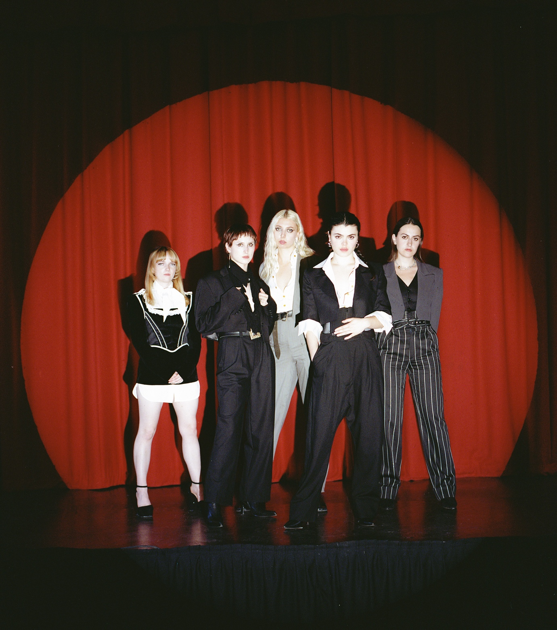
Credit: Cal McIntyre

BAND KICK OFF FESTIVAL SEASON WITH STUNNING DEBUT PERFORMANCE AT GLASTONBURY

The Last Dinner Party are excited to share details of their second single, Sinner.

Sinner is streaming now and produced by James Ford. It follows the London five-piece’s scintillating debut single, Nothing Matters, which provoked an instantaneous reaction of acclaim across the board.

Sinner launches today with a live performance video directed by The Last Dinner Party and Balan Evans. Watch the video HERE

Guitarist Lizzie Mayland on Sinner: “Sinner is a story of self-acceptance, and the longing for the past and present self to become one.

Born from a breakbeat drum sample, Sinner is punctuated by ripping guitar lines and harmony-filled vocal breakdowns.”

The band have spent much of the Spring and early Summer out on the road which is where they’re due to remain for the rest of 2023. They made their debut at Glastonbury last weekend, playing to a near capacity crowd at Woodsies in the Saturday breakfast slot, and converting hundreds of curious passers-by into bonafide fans with 45 minutes of impassioned, electric live performance.

The Last Dinner Party are set to repeat that same compelling trick in the coming weeks with early slots at the likes of Green Man, End of the Road, Latitude and Reading & Leeds. They’ll follow their Summer of festivals with a new UK headline tour in the Autumn. The eight date run kicks off at Blackpool’s Central Library on the 8th October, concluding at The Fleece in Bristol on 22nd October. A show at London’s EartH venue on 17th October follows a recent run of hometown sell-out dates at Moth Club, Camden Assembly, and Oslo. Tickets for the headline dates are on sale now via https://www.thelastdinnerparty.co.uk/live/

The band follow their Autumn headline tour with an arena tour of Europe and UK in support of Hozier.

All 46 live dates are listed below.

The Last Dinner Party Live:

3rd July – Montreux Jazz Festival, Montreux Switzerland
8th July – Bilbao BBK Live, Bilbao
20th July – Hare & Hounds, Birmingham SOLD OUT
21st July – Latitude Festival, Southwold
22nd July – Bodega Social, Nottingham SOLD OUT
23rd July - Truck Festival, Stevenage
27th July – Headrow House. Leeds SOLD OUT
28th July – The Deaf Institute, Manchester SOLD OUT
29th July – Y Not Festival, Derbyshire
4th August – Smukfest, Skanderborg
12th August – Boardmasters, Newquay
14th August – O2 Academy, Liverpool (w/ First Aid Kit)
15th August – O2 Academy, Liverpool (w/ First Aid Kit)
16th August – O2 Academy, Edinburgh (w/ First Aid Kit)
18th August – Paredes De Coura, Coura Portugal
20th August – Green Man, Brecon Beacons
25th August – Reading Festival
26th August – Leeds Festival
31st August – End of the Road Festival, Salisbury
1st September – 3rd September – Electric Picnic, Stradbelly
8th October – Blackpool Central Library
9th October – King Tut’s, Glasgow
10th October – The Cluny, Newcastle
12th October – Academy 2, Manchester
14th October – Live at Leeds
15th October – The Welly, Hull
17th October – EartH, London SOLD OUT
18th October – EartH, London
19th October – Portland Arms, Cambridge
20th – 22nd October – Sŵn Festival, Cardiff
22nd October – Fleece, Bristol
27th October – London Calling Festival, Amsterdam
26th November – Avicii Arena, Stockholm (w/ Hozier)
28th November – Ziggo Dome, Amsterdam (w/ Hozier)
29th November – Zenith, Paris (w/ Hozier)
2nd December – Velodrome, Berlin (w/ Hozier)
3rd December – Wiener Stadthalle, Vienna (w/ Hozier)
5th December – Sporthall, Hamburg (w/ Hozier)
6th December – Sportovni Hala Fortuna, Prague (w/ Hozier)
8th December – Forest National, Brussels (w/ Hozier)
10th December – M&S Bank Arena, Liverpool (w/ Hozier)
11th December – OVO Hydro, Glasgow (w/ Hozier)
13th December – Resorts World Arena, Birmingham (w/ Hozier)
15th December – OVO Wembley Arena, London (w/ Hozier)
17th December – SSE Arena, Belfast (w/ Hozier)
19th December – 3Arena, Dublin (w/ Hozier)

For more information and press enquiries please contact

Warren Higgins
warren@chuffmedia.com

