TWO-TIMES BRIT AWARD WINNER SHARES HER NEW SINGLE
‘SIDE EFFECTS’

LISTEN HERE / WATCH THE VIDEO HERE

MAJOR SUMMER FESTIVALS INCLUDE GLASTONBURY, CREAMFIELDS,
RADIO 1’S BIG WEEKEND, PARKLIFE & READING AND LEEDS

Download high-res photo by Simon Emmett HERE

The two-times BRIT Award winner BECKY HILL, who has amassed over 7 billion streams to date and a growing catalogue of classic chart hits, today enters an exciting new chapter in her career with ‘Side Effects’, her first new release of 2023.

‘Side Effects’ is a real statement of intent for the year ahead. Becky’s powerhouse soulful vocals provide the star quality to a song which heightens her huge talent for uniting instantly addictive pop hooks with electrifying dance electronica. The song’s lyrics add a layer of relatability as it captures the ‘side effects’ of being held back by the ghosts of an old relationship when all you want to do is move on.

Becky wrote and releases ‘Side Effects’ with friend and key collaborator, Lewis Thompson with whom she has a prolific creative partnership (the pair previously co-writing Becky’s huge hits with David Guetta ‘Remember’ and ‘Crazy What Love Can Do’ also with David Guetta and Ella Henderson) plus producer Jon Shave and long-term collaborators, Karen Poole and MNEK, who also provides backing vocals.

‘Side Effects’ is accompanied by a stunning official video, which was directed by KC Locke (Stormzy, Ed Sheeran, David Guetta). It follows Becky as she embarks upon an epic journey of escape from the lingering side effects of a toxic relationship.

Becky says, “I haven’t released a solo record in over a year, so coming out the door after a second BRIT win feels very exciting! I’m playing the UK’s best festivals this year and I can’t wait for people to have a new song to sing along with me. ‘Side Effects’ has been made with my favourite people in the industry and this one really feels like the beginning of my new chapter in my artistry. Album two here we come.”

Becky’s summer schedule calls at the biggest events of the UK summer festival schedule, with all currently confirmed shows listed below. In addition, she will kick off her YOU / ME / US residency with Ibiza Rocks on May 30th which runs through to late July. Please see HERE for tickets and HERE for a documentary filmed during last year’s residency.

MAY
26th - Creamfields South
28th - Radio 1 Big Weekend

JUNE
11th - Parklife Festival
25th - Glastonbury

JULY
9th - TRNSMT

AUGUST
25th - Leeds Festival
26th - Creamfields North
27th - Reading Festival

With an irrefutable aptitude for writing chart-smashing pop songs and a reputation as a trailblazer in the electronic music scene, Becky Hill has gone from strength-to-strength since first coming to attention as the voice of Wilkinson’s ‘Afterglow’. She has constantly returned to the Top 10 with hits including ‘Gecko (Overdrive)’ with Oliver Heldens (#1), ‘Wish You Well’ with Sigala (#8), ‘Remember’ with David Guetta (#3) and ‘Crazy What Love Can Do’ with David Guetta and Ella Henderson (#5) - plus another six Top 20 singles. She has collaborated with a who’s who of global talent, with other big names such as Joel Corry, Galantis, Sigala, MK, Jonas Blue and Tiesto.

Her 2021 debut album ‘Only Honest On The Weekend’ debuted at #7 and was certified Gold, adding to a career which has already achieved four double-Platinum singles. In addition to her two BRIT Awards, Becky has also won two ASCAP London Music Awards for ‘False Alarm’ and ‘Lose Control’, plus Best Female Artist at the 2022 O2 Silver Clef Awards. Her international success reached new heights in 2022 with four #1 hits at US dance radio in the shape of ‘Run’ with Galantis’, ‘Crazy What Love Can Do’ with David Guetta and Ella Henderson, ‘History’ with Joel Corry’, and ‘Words’.

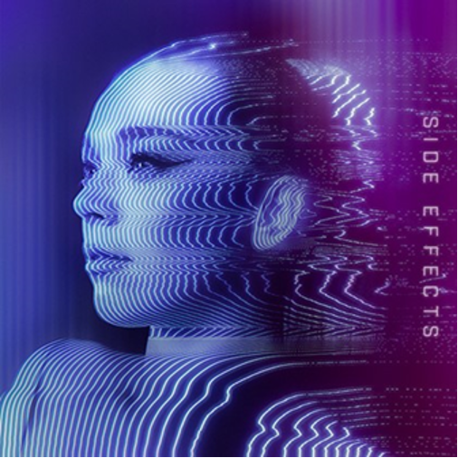

high-res artwork HERE

Follow Becky Hill:
Spotify | Apple Music | YouTube | TikTok | Instagram | Facebook | Twitter | Website

For more information & media enquiries, please contact Warren
warren@chuffmedia.com

