PALACE
RELEASE NEW SINGLE AND LIVE VIDEO
“SHAME ON YOU”
NEW ALBUM ‘SHOALS’ OUT 21ST JANUARY
2022 UK, EUROPEAN AND US TOURS
PLAY O2 ACADEMY BRIXTON FEBRUARY 11TH

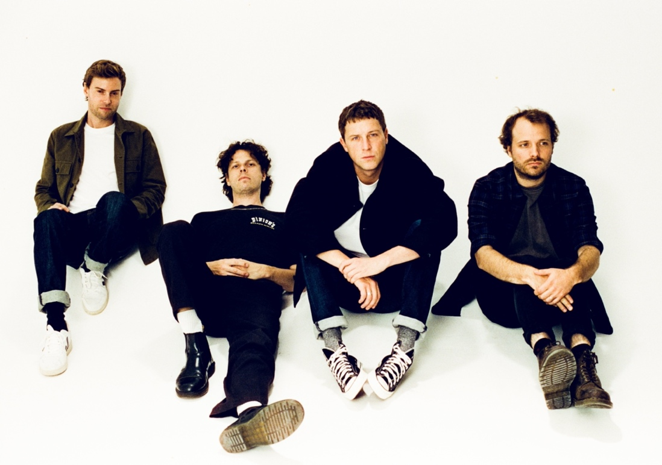
Credit – Daniel Harris

MOJO ****
“a more pure and intense sound” – DIY Magazine 3.5*
“Not many bands do better emotionally literate, melancholic indie at the moment” – The Observer

With just two weeks until the release of their spellbinding third album ‘Shoals’ on January 21st, London band Palace have released their latest single, ‘Shame On You”, via Fiction. The single release is accompanied by a new live music video, shot in a jet engine testing facility and directed by acclaimed filmmaker and photographer David J. East, who has worked with the likes of Foals and The Japanese House.

WATCH THE LIVE VIDEO FOR ‘SHAME ON YOU’ HERE
‘Shoals’ is a profound and pensive album, boldly exploring some of life’s greatest questions over its 12 mesmerising tracks. The album deftly explores the interplay of three central existential dilemmas against a broader backdrop of wonder at the vastness and power of the ocean, concluding its arc with the stunning opus ‘Where Sky Becomes Sea’. Through diving into themes of the subconscious, dreams and existentialism, ‘Shoals’ is broadly a record about living with and processing fear. As frontman Leo Wyndham explains:

“‘Shoals’ is a record about confronting our own fears and anxieties. Through the pandemic we were confronted more than ever with ourselves with little distraction, suddenly seeing who we are in the rawest of forms. It held a mirror up to our flaws and imperfections and forced us to see the real 'us'.

The record symbolises how our minds can have beautiful yet dangerous depths, like the ocean, and how our fears and thoughts are like shoals of fish that move and shift constantly from place to place; chaotic, often untameable and unpredictable.”

‘Shoals’ is comprised of 12 tracks, and in addition to ‘Shame On You’ the album will include the brilliant singles, ‘Where Sky Becomes Sea’, ‘Fade’, ‘Lover (Don’t Let Me Down)’ and ‘Gravity’ released in 2021.
Following the release of the album, Palace will embark upon their biggest tour yet, with dates across the UK, Europe, and the US, including a not-to-be-missed show at the O2 Brixton Academy on 11th February.

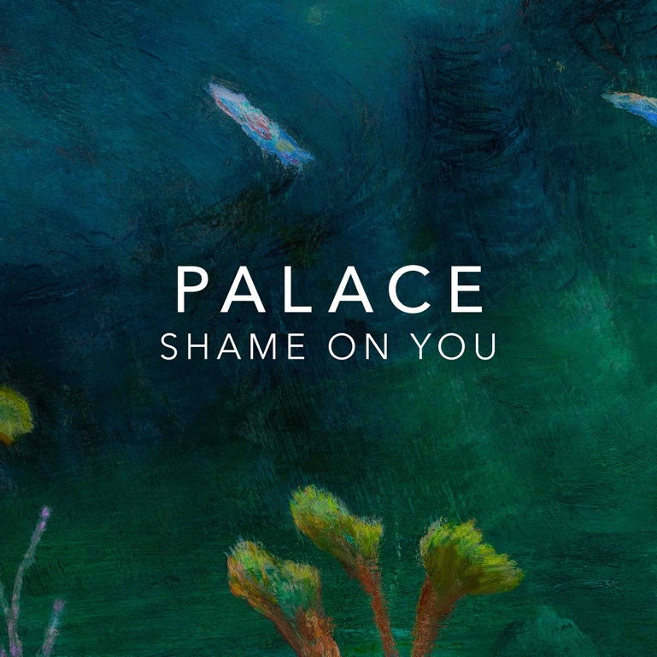
Leo Wyndham, Matt Hodges and Rupert Turner released their acclaimed debut EP ‘Lost In The Night’ in 2014, followed by the ‘Chase The Light’ EP the following year, their debut album ‘So Long Forever’ in 2016 and sophomore album ‘Life After’ in 2019.

PRE ORDER / PRE-SAVE ‘SHOALS’ HERE

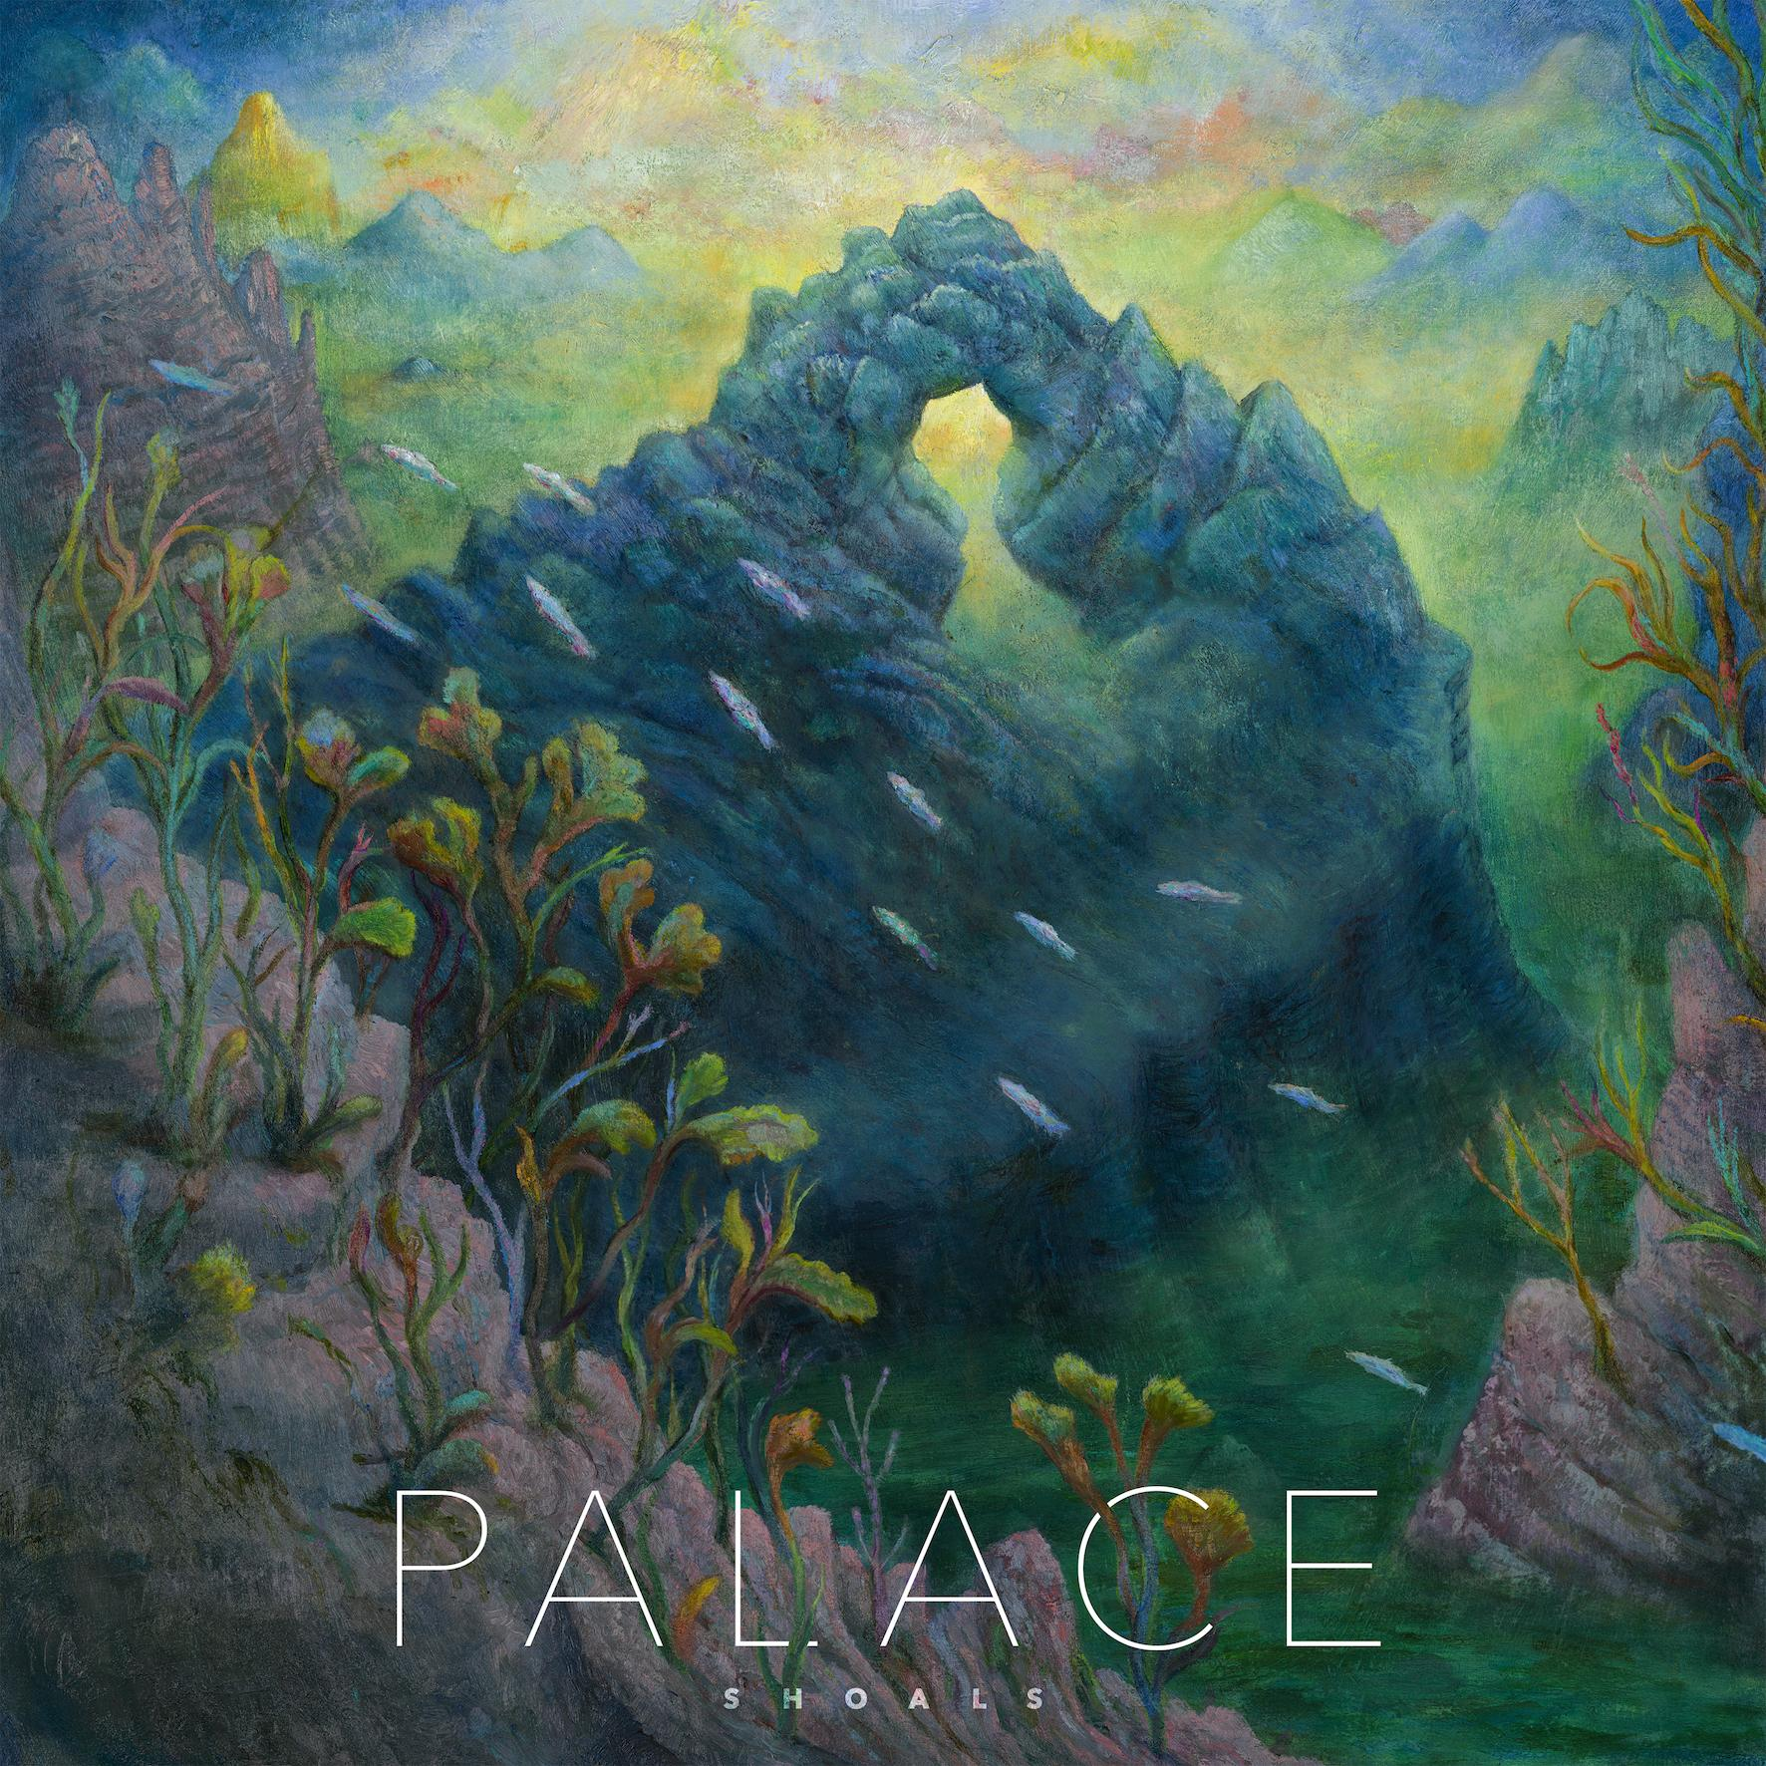
‘Shoals’ artwork

‘Shoals’ Tracklisting
- Never Said It Was Easy
- Shame On You
- Fade
- Gravity
- Give Me The Rain
- Friends Forever
- Killer Whale
- Lover (Don’t Let Me Down)
- Sleeper
- Salt
- Shoals
- Where Sky Becomes Sea

UK & IRELAND TOUR 2022
February 3rd, Glasgow, SWG3
February 4th, Manchester, O2 Ritz
February 5th, Bristol, O2 Academy
February 6th, Leeds, University Stylus
February 8th, Dublin, Vicar St
February 10th, Nottingham, Rock City
February 11th, London, O2 Academy Brixton

EUROPEAN TOUR 2022
February 17th, France, Paris, La Maroquinerie
February 18th, Belgium, Ghent, Vooruit Balzaal
February 19th, Germany, Cologne, Luxor
February 20th, Switzerland, Zurich, Mascotte
February 22nd, Italy, Milan, Magnolia
February 24th, Austria, Vienna, Arena
February 25th, Germany, Munich, Strom
February 26th, Czech Republic, Prague, Café V Lese
February 27th, Hungary, Budapest, Durer Kert
March 1st, Poland, Warsaw, Hydrozagadka
March 2nd, Germany, Berlin, Heimathafen
March 4th, Denmark, Copenhagen, VEGA small hall
March 5th, Germany, Hamburg, Mojo
March 6th, Netherlands, Amsterdam, Paradiso

US/CAN TOUR 2022
April 22nd, Dallas, TX, Club Dada
April 23rd, Austin, TX, Parish
April 24th, Houston, TX, Studio @ Warehouse Live
April 26th, Orlando, FL, The Social
April 27th, Atlanta, GA, Terminal West
April 29th, Durham, NC, Motorco Music Hall
April 30th, Washington DC, 9:30 Club
May 1st, Philadelphia, PA, Foundry
May 3rd, Boston, MA, Paradise
May 5th, New York, NY, Webster Hall
May 7th, Montreal, QC, Club Soda
May 9th, Toronto, ON, Danforth
May 10th, Cleveland, OH, Beachland Ballroom
May 11th, Columbus, OH, A&R Bar
May 13th, Detroit, MI, Shelter
May 14th, Chicago, IL, Thalia Hall
May 16th, Denver, CO, The Gothic Theatre
May 17th, Salt Lake City, UT, The Complex
May 19th, Los Angeles, CA, The Fonda
May 21st, San Francisco, CA, The Fillmore

Instagram | Facebook | Twitter | Website

For more information & media enquiries please contact Jenny Entwistle
jenny@chuffmedia.com

