DRUG STORE ROMEOS
SHARE NEW SINGLE & VIDEO ‘SECRET PLAN’
DEBUT ALBUM THE WORLD WITHIN OUR BEDROOMS - OUT 25 JUNE ON FICTION RECORDS
BIGGEST HEADLINE SHOW TO DATE @ LONDON’S SCALA 17 NOV
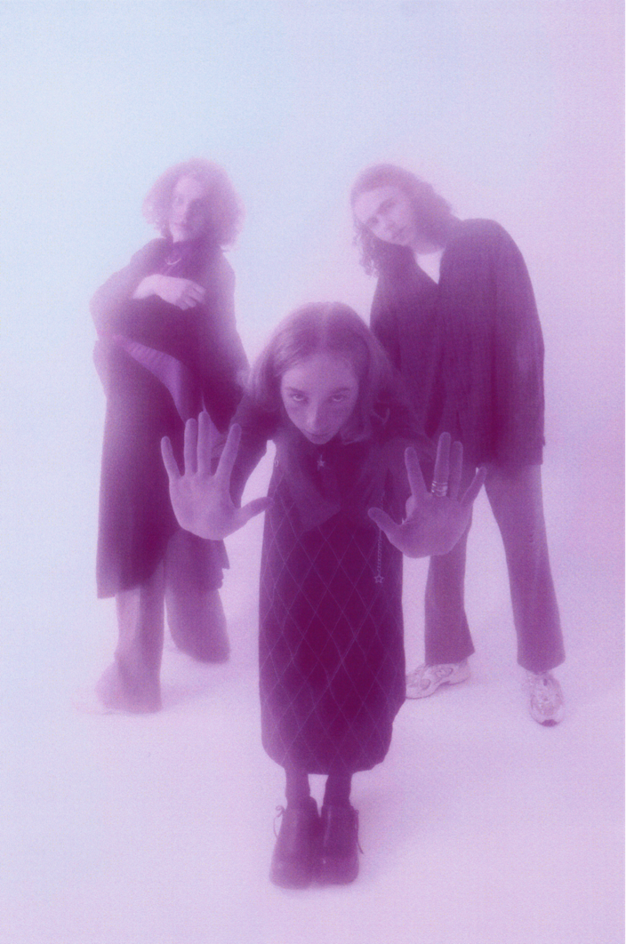
Photo credit: Neelam Khan Vela
“Drug Store Romeos, a.k.a. British teens Charlie, Jonny, and Sarah, craft intricate and intoxicating indie rock soundscapes that belie their tender years.” The FADER
“A web of spectral dream pop wonder... the trio’s propensity for cosmic, beguilingly escapist melodies remains an unshakeable draw” - The Line Of Best Fit
“Every bit the head-rushed encompass from dream-pop-come-cosmos-crusaders Drug Store Romeos... a crystalline sound-bath adorned with a top layer of stardust” - So Young
“A dreamy, hazy oasis in a sea of loud, demanding nonsense” - Dork

Listen to ‘Secret Plan’ HERE
Hampshire trio Drug Store Romeos have today shared their new single and video ‘Secret Plan’, taken from their upcoming debut album The world within our bedrooms - out 25 June via Fiction Records (preorder HERE).
Previous single ‘What’s On Your Mind’ was lauded by the likes of The Line Of Best Fit (where it was crowned Song Of The Day), So Young, Dork, and Gigwise as well as being playlisted at the Independent, Notion, NME, and Coup de Main. Drug Store Romeos were also recently tipped in The FADER’s longstanding tastemaker series GEN F and by blog icons Pigeons & Planes as one of their 15 New and Rising Bands You Should Listen to in 2021. Drug Store Romeos will play their biggest headline show to date at London’s Scala on 17 November – tickets are available HERE.
Speaking about the new single, with its accompanying video by ---, the band commented: “‘Secret Plan’ was written during the first lockdown when the only time I could write was between 2am-7am because I live with 12 very noisy people. It was partly inspired by the surrealist quote “bathed everyday reality in magic light”, and we wanted it to feel personal yet transportative.”
Recorded at London’s Eastcote Studios with regular producer George Murphy, The world within our bedrooms is a testament to youth and adventure; an escape from mundanity and proof that art will always open a door for those looking to escape. The band explain: “The album is a journey of emotions and colour schemes. A lot of bands have a consistent emotion across their whole album but we wanted to reflect the ever changing nature of someone’s mental state over a period of time. We always wanted to create our own world, and as a three we have this force field around us.”
With their beloved Stereolab, Broadcast, and Mild High Club acting as guiding lights, the band sought to shake things up and push beyond the walls of their bedroom. Vocalist Sarah scoured vintage magazines for lyrical inspiration - inspired by Dadaist poet Hugo Ball - and hung a print of transcendentalist artist Agnes Pelton’s 1934 piece ‘Orbits’ in the vocal booth. “When I look at that painting it’s where I want my voice to exist,” she says of the work by an artist renowned for her abstract approach to depicting stillness, “I would sing and try to immerse myself in that.”
***
Drug Store Romeos formed at college in nearby Farnborough when childhood friends Jonny and Charlie pinned an ad about finding a bassist for their new band to the school’s notice board - Sarah replied and quickly proved herself a better vocalist than either of them. Sharing affections for Suburban Lawns and Tom Tom Club, Drug Store Romeos cut their teeth playing live at college, Guildford Boiler Room and Aldershot West End Centre, rather than the familiarly trodden paths in London - although they did frequent the city as often as three times a week at one point; carrying all of their equipment back to Fleet by train as none of the band were old enough to drive.
While the band have since moved to London, by the time they came to record The world within our bedrooms, all three members were keen to hold onto that wide-eyed energy for as long as possible. Those 3am walks home from Fleet station, with amps and flight cases slung over their shoulders, would become a rite of passage; the quiet countryside influencing their hushed atmospheric sound and nocturnal leanings, the tight bonds formed back home buoying their hypnotic and delicate blend of dream pop and synth-led explorations.
Having built an identity away from the London music scene in the otherworldly and isolated suburbs of Hampshire, Drug Store Romeos are emerging from their cocoon with a purpose, a direction and a fresh lease of life.
***
See Drug Store Romeos live in 2021:
27 May | YES, Manchester (SOLD OUT)
29 July | SET, London (SOLD OUT)
2-5 Sep | End Of The Road Festival
25-26 Sep | Dot to Dot Festival
9 Oct | Are You Listening? Festival
13 Nov | Stag & Dagger Festival, Glasgow
14 Nov | Stag & Dagger Festival, Edinburgh
17 Nov | Scala, London
Drug Store Romeos - The world within our bedrooms - out 25/06/2021 via Fiction
1. Building Song
2. Secret Plan
3. Bow Wow
4. Elevator
5. Walking Talking Marathon 6. Frame Of Reference
7. Feedback Loop
8. What’s On Your Mind
9. No Placing
10. Vibrate
11. Electric Silence
12. Kites
13. Put Me On The Finish Line 14. Cycle Of Life
15. Adult Glamour

For more information and press enquiries please contact

Jenny Entwistle
Jenny@chuffmedia.com

