**SHARE THE NEW TRACK ‘SAVE ME’ – LISTEN HERE**

**FROM THE DEBUT ALBUM ‘FEAR LIFE FOR A LIFETIME’, OUT JULY 12TH**

**PRE-ORDER / PRE-SAVE HERE**

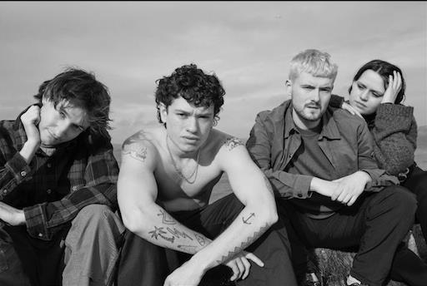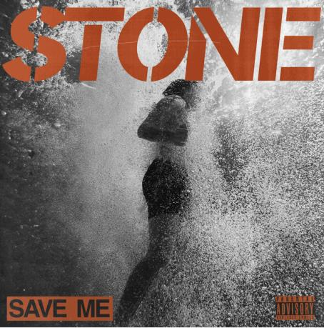*“This is the step forward that they’ve been building in their heads... It’s safe to say that STONE are ready to establish themselves with ‘Fear Life’.”* - **DORK***“A musical mishmash of punk, garage rock and subtle electronica that you’ll be unable to peel your ears and, if you’veseen them live, eyes away from.”* - **Rolling Stone***“The band explore their own identity while treading a path towards the big time.”* - **NME** *“When STONE hit the stage, you simply can’t take your eyes off them.”* - **Kerrang!** *“An uncanny ability to draw huge choruses out of thin air.”* - **DIY***“A force to be reckoned with.”* - **The Line of Best Fit**

DOWNLOAD ARTWORK **HERE** & PRESS PIC **HERE –** CREDIT IS **CLAUDIA LEGGE**

The rise of new wave indie-rock icons **STONE** reached new heights with the news that they will release their debut album **‘Fear Life For A Lifetime’** on **July 12th**. The news was supported by an A-Z of tastemakers including **DORK**, **DIY**, **Kerrang!**, **NME** and **The Line of Best Fit**, while the lead single **‘My Thoughts Go’** received **Radio 1** airplay from **Sian Eleri** and **Alyx Holcombe** as well as being added to **Spotify’s** global **MARROW** playlist. Now **STONE** further amplify excitement for the album by sharing the new track **‘Save Me’.**

Coming from the more explosive end of **STONE’s** sonic spectrum, **‘Save Me’** erupts into a blistering volley of serrated riffs and battering ram rhythms as **Fin Power** delivers each lyric with the panicked urgency of a man at breaking point. Which is entirely apt, as his words tap into the psyche of someone who can only escape heartbreak by throwing themselves into a pit of substance abuse. It’s a prime example of how **STONE** are beguiling a growing following - this song, like many of their others, shares an unguarded vulnerability and truth that mirrors the experiences of many of their fans.

**Fin** says, *"Save Me is a vulnerable track that lashes out in the face of bad habits and self destructive tendencies. It's hard hitting and we can't wait to deliver it live this festival season."*

As with the rest of their upcoming debut album, **‘Save Me’** was written by **STONE** and was recorded during sessions with **Rich Costey** (**Sam Fender**, **HAIM**, **Biffy Clyro**) in **Brattleboro**, **Vermont**.

Completed by **Elliot Gill** (guitar), **Sarah Surrage** (bass) and **Alex Smith** (drums), the **STONE** story dates back a decade when Fin promised Elliot that their band would make it somehow. Led by the wildly charismatic Fin, STONE have star quality and easygoing relatability in equal measure. As seen with shows with **Sam Fender, Yungblud**, **Inhaler**, **The Wombats** and **DMA’s**, you can’t take your eyes away from their on-stage antics - yet they always take the time to ensure that every fan who wants to meet them after a show will have their moment.

It’s an ethos which is building a powerful community around them, especially when combined with the post-punk poetry and snapshots of young adult life that emerge from their lyrics. Sonically they bounce between hooky indie-pop and full- throttle alt-rock with an undercurrent of hip-hop swagger, and their genre agnostic approach was further underlined when **Fin f**eatured on **While She Sleeps’** recent album **‘SELF HELL’**. They have the songs, the personality, the attitude and the ambition - **STONE’s** time is now.

**‘Fear Life For A Lifetime’** is available to pre-order **HERE**.

**STONE** will celebrate the release of **‘Fear Life For A Lifetime’** by embarking upon an instore tour and the big question is - how will their famously explosive live experience translate to the confines of a record store? Let’s just say expect the unexpected. Tickets for the dates, listed below, are available **HERE**.

**STONE** have also recently been announced as main support to **Jake Bugg** on his forthcoming headline UK tour this Autumn. Tickets for the dates, listed below, are available **HERE**.

**JULY  
12th - London, Rough Trade East**

**13th - Birmingham, HMV Vault**

**16th - Leeds, The Vinyl Whistle**

**17th - Liverpool, Jacaranda Baltic**

**NOVEMBER (Supporting Jake Bugg)  
18th – Leeds, o2 Academy  
19th – London, Roundhouse  
21st – Dublin, National Stadium  
23rd – Glasgow, Barrowland Ballroom  
26th – Manchester, o2 Victoria Warehouse**

**Follow STONE:**[**YouTube**](https://www.youtube.com/channel/UCy2UjknL3o-JILuB4h2KDCw) **|** [**Instagram**](https://www.instagram.com/stoneliverpool/) **|** [**TikTok**](https://www.tiktok.com/@stoneliverpool?lang=en) **|** [**Website**](https://www.stone.band/)

**For more information please contact**

**Warren@chuffmedia.com on 07762 130 510**