RELEASES NEW SINGLE ‘RUNAWAY’
WATCH THE VIDEO HERE
LISTEN HERE

TAKEN FROM UPCOMING NEW ALBUM ‘HOLD FAST’
RELEASED ON 18TH JUNE 2021

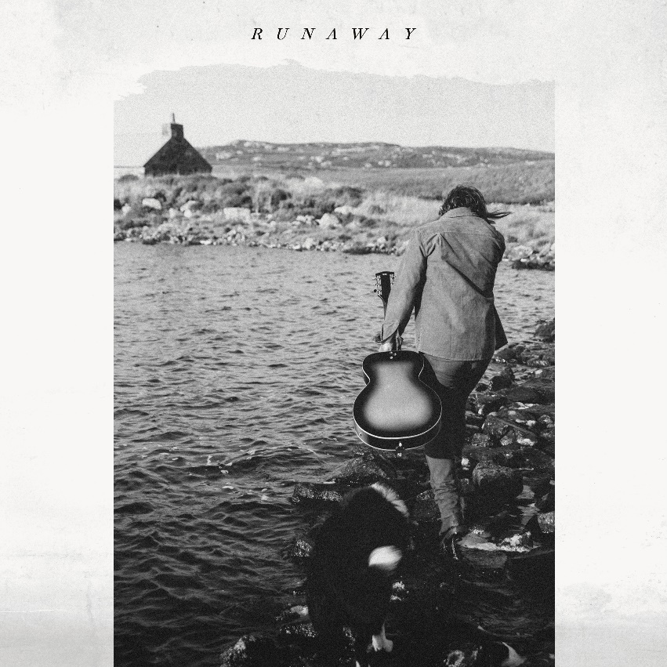

Colin Macleod has released ‘Runaway’, the latest single from his eagerly anticipated new album ‘Hold Fast’, out on 18th June 2021 on SO Recordings. (Available to pre-save here.)

The driving, propulsive track is emblematic of Macleod’s Hebridean take on Americana, with its widescreen, Springsteen-style folk-rock.
‘Runaway’ shows a further side to ‘Hold Fast’, alongside previously released singles ‘Old Soul’ (which features Sheryl Crow), a melancholic folk track that Clash hailed as showing ‘Songwriting of real depth and character’, and the country-stomper of ‘Warning Signs’.

Colin Macleod lives an intriguing dual existence from his home on the Isle of Lewis in the Outer Hebrides where he has lived most of his life. When he is not on tour with the likes of Sheryl Crow, Robert Plant or Roger Waters, he is at home on the island raising a flock of sheep, crofting ( a form of traditional farming), or working as a gillie ( a type of fisherman).

This dual-life informs Macleod’s music, and the tradition, community and the rugged ways of island life all soaks into ‘Hold Fast’.

Colin Macleod first left the Isle of Lewis in 2009. He was spotted playing a gig in an Aberdeen pub by an A&R from Universal, which culminated in the release of the ‘Fireplace’ album under the moniker The Boy Who Trapped The Sun in 2010. Homesick and burned out by the experience, he returned to the island and eventually had a realisation: stories of life in this remote part of the world gave him something fascinating and unique to write about. It was a style that resonated throughout his debut album ‘Bloodlines’.

Official website
Spotify
Apple Music
YouTube
Instagram
Facebook
Twitter

For all media enquiries contact warren@chuffmedia.com on 07762 130510

