MUMFORD & SONS AND HOZIER COMBINE ON NEW SINGLE, RUBBER BAND MAN

LISTEN/WATCH VIDEO TO RUBBER BAND MAN (WITH HOZIER) HERE

TRACK WAS PRODUCED ALONGSIDE THE NATIONAL’S AARON DESSNER AND PRECEDES MUMFORD & SONS’ SOLD-OUT UK + EUROPEAN ARENA TOUR IN NOVEMBER/DECEMBER

RUBBER BAND MAN FOLLOWS THE BAND’S NUMBER 1 FIFTH STUDIO ALBUM, RUSHMERE, EARLIER THIS YEAR.

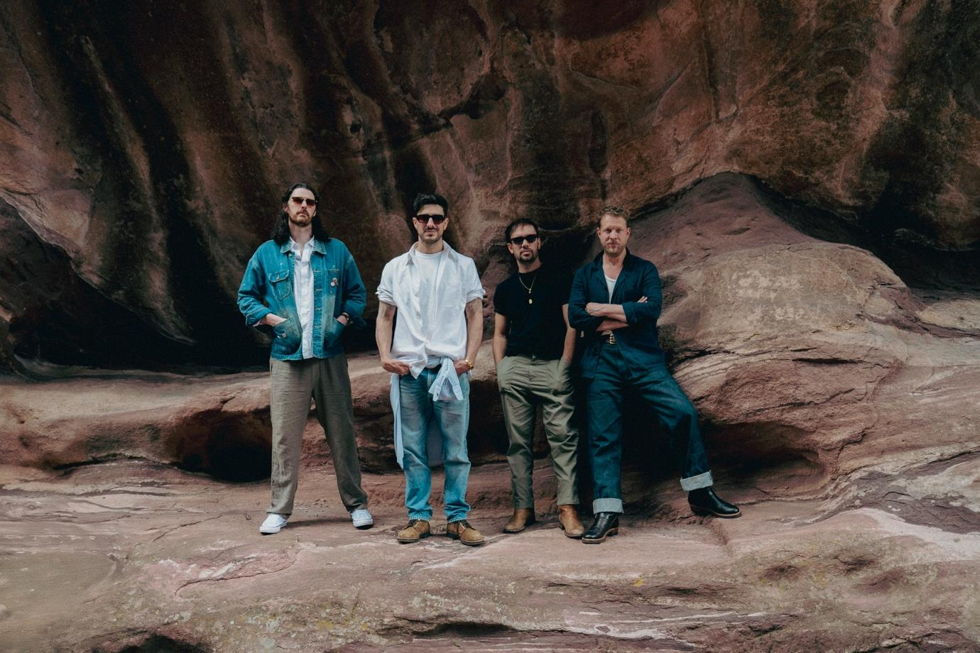
Credit: Jay Sansone

Mumford & Sons are pleased to share a brand new single, Rubber Band Man (With Hozier) is streaming now. Listen/watch video here.

Arriving just seven months after debuting their fifth album RUSHMERE at number 1 in the UK, Rubber Band Man was recorded at Long Pond Studios in upstate New York alongside producer Aaron Dessner. Dessner has previously worked with the band on their third album Wilder Mind that debuted at 1 on both sides of the Atlantic.

Hozier’s involvement stems from a friendship with the band that stretches back to 2017 when he joined Mumford & Sons on stage to cover The Beatles’ A Little Help From My Friends when the British band headlined the Longitude Festival in 2017. He also guested with them at the Austin City Limits Festival in Texas in 2023.
Rubber Band Man is a confident next step for Mumford & Sons who have been busy on and off the road over the past twelve months, with RUSHMERE merely the starting point. With more songs than they’ve known quite what to do with, the band left the studio door open at Long Pond. Hozier here makes the first meaningful connection of many studio collaborations, and his distinguishable, rich baritone compliments Marcus’ vocal beautifully.

Since RUSHMERE’s release, Mumford & Sons have largely been out on the road across the US, interspersing a string of sold-out arena dates with a return to a tour they initially started over a decade ago out on the US railroad, joined this time by the likes of Maggie Rogers and Noah Kahan. The band follow this new single’s release by returning to the UK and Europe for a 22-date run that concludes with two hometown shows at London’s O2 Arena. Any remaining tickets for the European leg of the tour are on sale now via www.mumfordandsons.com

Mumford & Sons Live (2025/26):
29th November – Utilita Arena, Newcastle (w/ Sierra Ferrell) SOLD OUT
30th November – First Direct Arena, Leeds (w/ Sierra Ferrell) SOLD OUT
2nd December – OVO Hydro, Glasgow (w/ Sierra Ferrell) SOLD OUT
3rd December – Co-op Live, Manchester (w/ Sierra Ferrell) SOLD OUT
5th December - Utilita Arena, Sheffield (w/ Sierra Ferrell) SOLD OUT
7th December - Utilita Arena, Birmingham (w/ Sierra Ferrell) SOLD OUT
8th December - Utilita Arena, Cardiff (w/ Sierra Ferrell) SOLD OUT
10th December – The O2, London (w/ Sierra Ferrell) SOLD OUT
11th December – The O2, London (w/ Sierra Ferrell) SOLD OUT

FOLLOW MUMFORD & SONS
Website | Instagram | YouTube | TikTok | Facebook | X | Spotify | Apple Music | Soundcloud

For more information and press enquiries please contact

warren@chuffmedia.com

