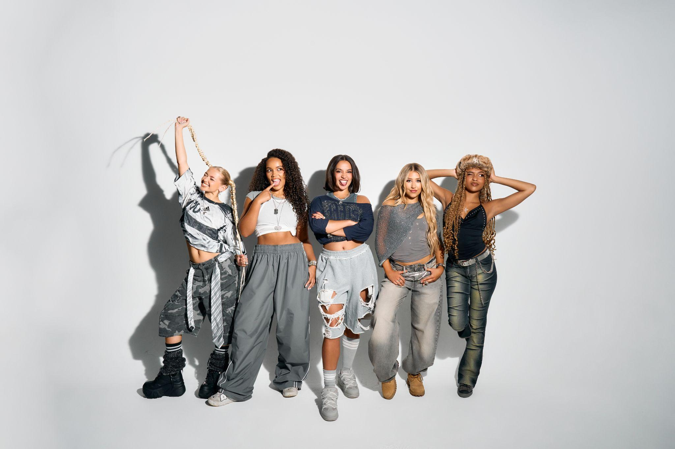
L-R: Zoe, Summer, Reanna, Emmy, Shali

XO share new track/video, ‘Real Friends’

“A titanic debut single…breaking through pop boundaries, XO are doing it their way” - CLASH
“Bolshy Y2K production…pop girlies, assemble” - Sunday Times Style
“Electrifying…XO’s unapologetic take on girl power, and it lands with impact” - Wonderland
“You’re gonna want to keep an eye on this lot” - Official Charts

Listen/Watch ‘Real Friends’: https://xo.lnk.to/RealFriends
Listen/Watch debut single, ‘Lovesick’: https://XO.lnk.to/lovesick

XO have today shared ‘Real Friends’, which is out now on Polydor Label Group. This follows hot on the heels of acclaimed debut single ‘Lovesick’, which introduced the UK’s essential new girlband ahead of much more to follow this year.

‘Real Friends’ is a swaggering and empowered electro-pop anthem that champions those who will always be by your side. Written by GRAMMY and Brit award-winning superstar Charli xcx, Sabrina Carpenter collaborator John Ryan and Sweden’s legendary Mattias Larsson, XO’s own first co-write gives this affirmation a down-to-earth, distinctly British twist. “We’re not quite Hollywood Hills yet,” offers Zoe. “I’m definitely on the double decker bus.”

The self-confessed “most chaotic girlband you’ve ever bet in your life”, XO are force-of-nature five-piece Emmy, Reanna, Shali, Summer and Zoe. In sound and spirit they evoke that classic lineage of world-class British groups, but with a contemporary and cutting-edge twist: think the unstoppable UK energy of Spice Girls as raised on the global pop-girls (Tate McRae), plus that new wave of all-choreo and all-conquering acts like Katseye. Yet XO strive for something more imperfect and unapologetic in their firebrand of Pop - a thoroughly Gen Z vision of Girl Power.

‘Real Friends’ is testament, too, to the growing XO world and all who enter it. Having only formed in autumn 2024, the band draw on their individual differences - members hail from Essex, London, Liverpool, Derbyshire and Hong Kong - as much as the values (and vocals) that bind them together. It’s all there in the name XO, itself. Always keen to avoid the ‘girls’ or ‘babes’ route - “everyone is conscious of being included, and can present how they want to”, states Shali - the band quickly shoot down the idea of it meaning anything as cute as “hugs and kisses. XO is an energy for us, like an aura.”

On just their second release the XO word is spreading, with ‘Lovesick’ landing early support across Radio 1, BBC Introducing, and their first ever TV performance on Saturday Mashup! (where they performed their DIY fan-fave, ‘Ponytail’). The band are earning their stripes up and down the country on an adventurous schools-tour, quickly amassing an ardent audience with their bangers and their message. Asked what their hopes are for this first chapter, XO’s answers are as suitably unique to each girl as they are shared by ‘Real Friends’ “To set the tone,” says Summer, keen to stay in the moment. Zoe, however, simply states: “World Domination.” You really wouldn’t put it past XO, the next, best British girlband we’ve all been waiting for.

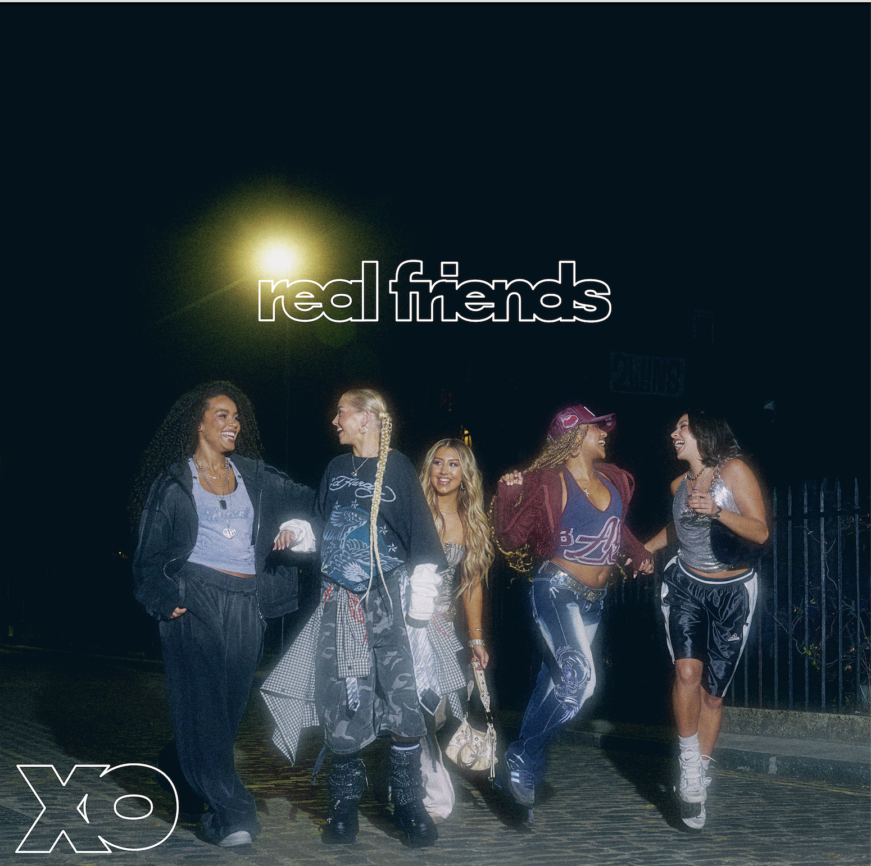
‘Real Friends’ artwork

FOLLOW XO!
Instagram || Tiktok || Official Site || Youtube

For more on info contact warren@chuffmedia.com

