Release New Track ‘Ready For Something’
New Album How Will I Know If Heaven Will Find Me?
Out September 2nd 2022 on Fiction Records
October UK Headline Tour Announced
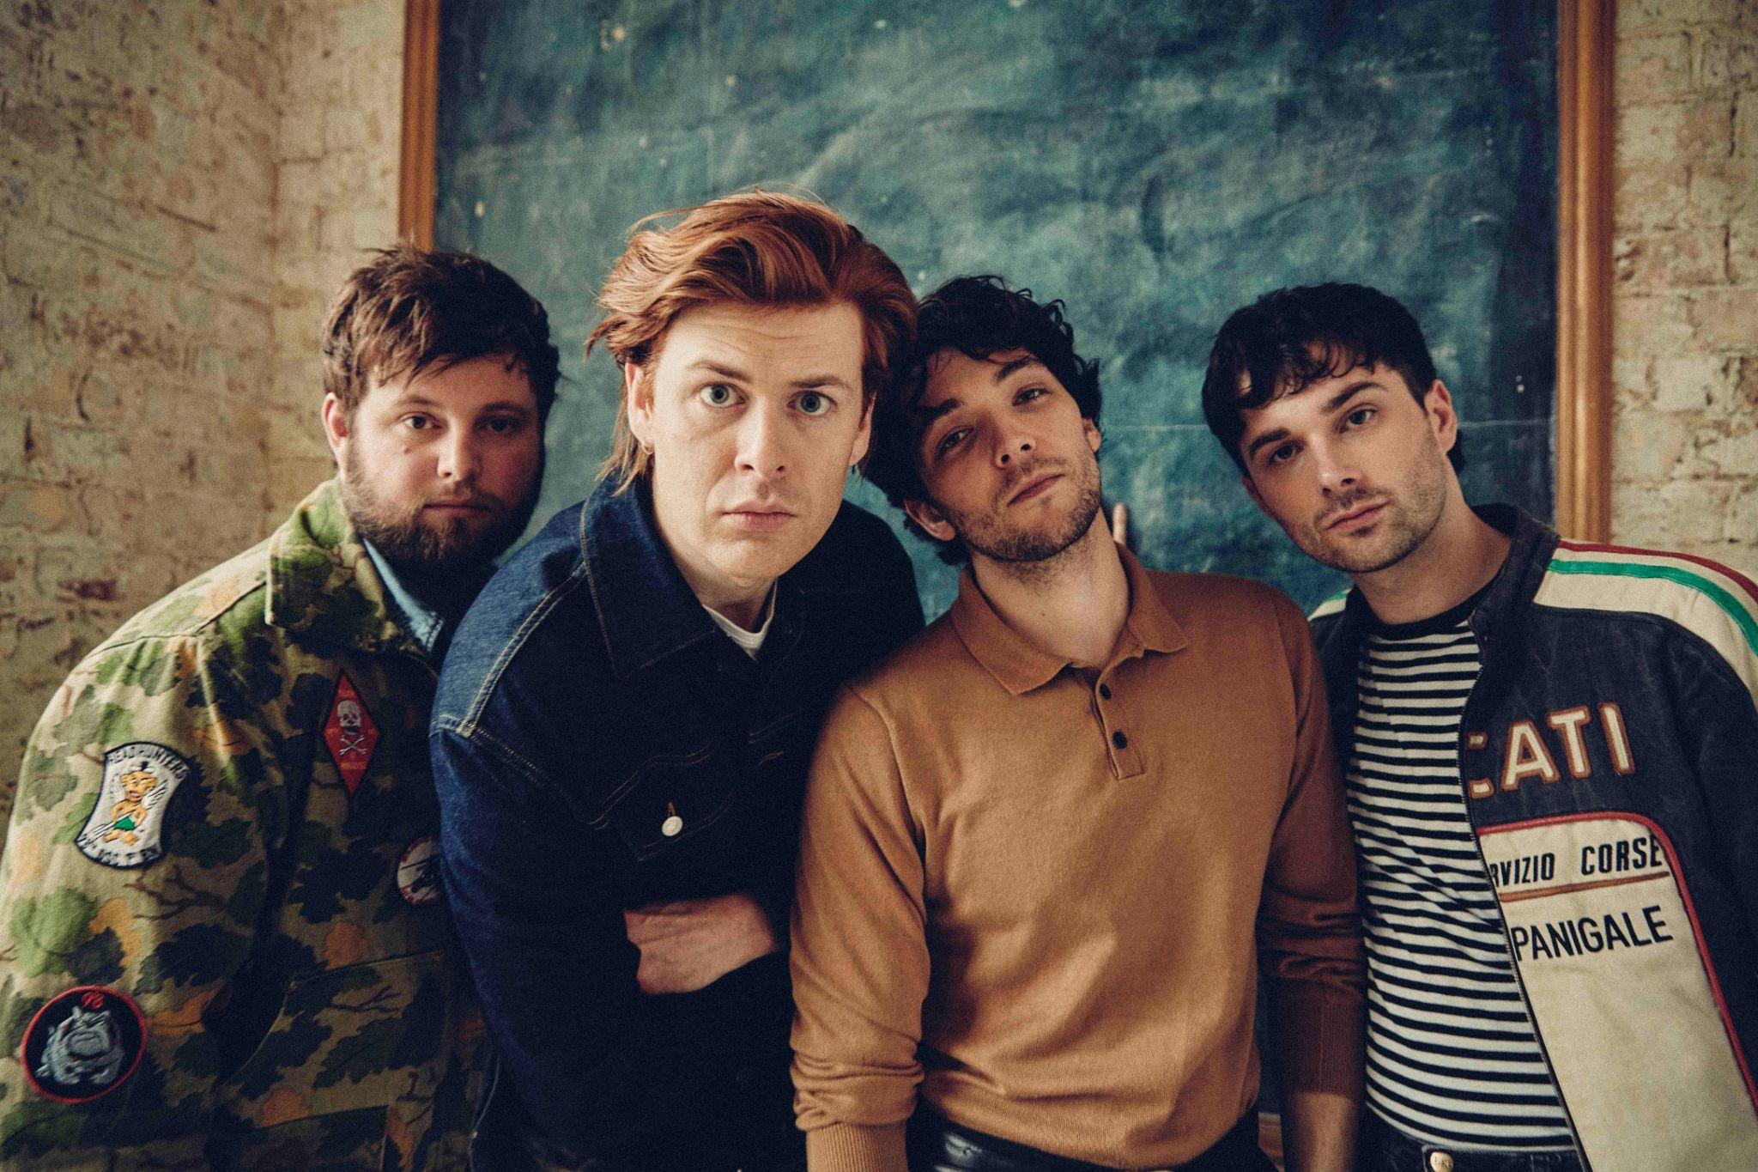
Following the release of their anthemic single ‘Bloodrush’, The Amazons have dropped their blistering new track ‘Ready For Something.’ The track is the second taste of new music from the band’s forthcoming album How Will I Know If Heaven Will Find Me? - out September 2nd 2022 on Fiction Records.
An unshackled, guitar-driven rock banger, packed to the brim with heavy riffs, ‘Ready For Something’ is one of the standout songs from the record. “‘Ready For Something’ is a scratching at the walls kind of song,’ lead singer Matt Thomson said of the track. ‘You’ve been in the cage for far too long and you are ready. Ready to live, ready to experience, ready to make mistakes. Anything.” Listen to ‘Ready For Something’ HERE.
How Will I Know If Heaven Will Find Me? is both a love letter and a rallying cry. Expansive, uplifting, sun-drenched singalongs produced by Jim Abbiss (Bombay Bicycle Club, Arctic Monkeys, Adele), and featuring co-writing collaborations with the likes of Maggie Rogers & Jamie Hartman, find the Reading four-piece emerging from the darkness of 2019’s Future Dust full of lust for life and post-pandemic hope.
The boys continue to tour the UK with a string of summer festivals and a huge newly-announced UK tour in October, which will see the band headline London’s Roundhouse. Tickets available HERE.
SUMMER FESTIVAL DATES
June
Thu 9th Milan, I-Days Festival
Sat 18th Isle Of Wight Festival
July
Sat 9th Cheltenham, 2000 Trees Festival
August
Fri 5th Bingley Weekender
Fri 12th Leicestershire, 110 Above Festival

HEADLINE TOUR
October
Thu 6th Belfast, Limelight 2
Sat 8th Manchester, Academy
Sun 9th Nottingham, Rock City
Tue 11th Southampton, O2 Guildhall
Wed 12th Bristol, O2 Academy
Thu13th Leeds, O2 Academy
Sat 15th Birmingham, O2 Institute
Sun 16th Glasgow, SWG3 Galvanisers
Mon 17th Newcastle, Boilershop
Wed 19th Norwich, UEA
Thu 20th London, Roundhouse

Pre-Order the album HERE
The Amazons are Matt Thomson, Chris Alderton, Elliot Briggs and Josef Emmett.
theamazons.co.uk
Instagram // Twitter // Facebook

For more info contact Warren@chuffmedia.com

