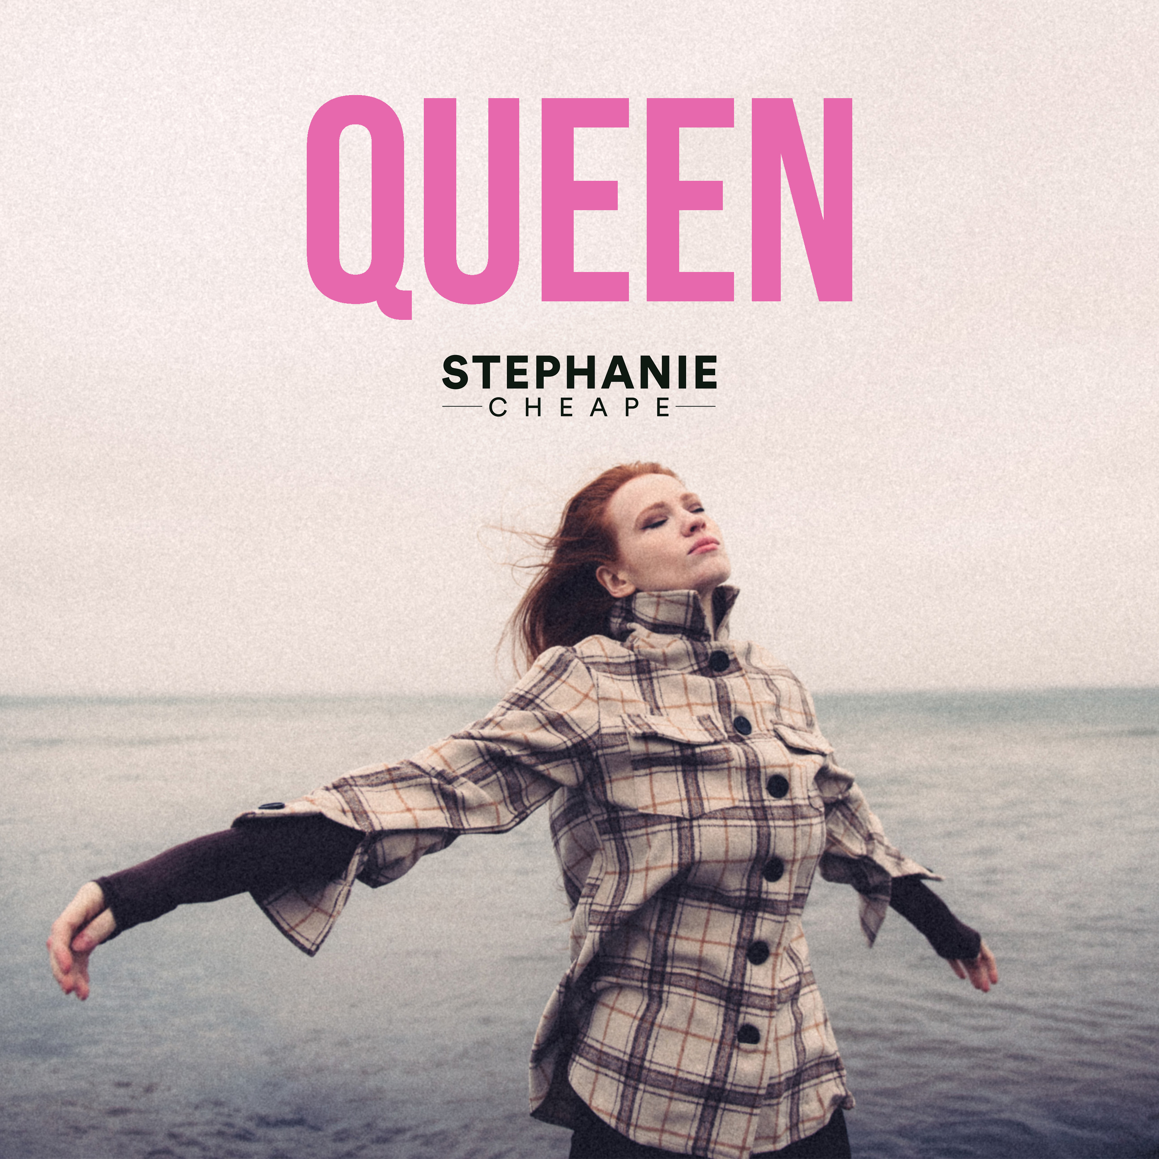
STEPHANIE CHEAPE
New single, Queen, out on April 9

Since picking up her first Nordoff Robbins award three years back, Stephanie Cheape’s been nothing but busy. Well, until the world stopped turning in 2020, she was.

She toured the UK supporting Barns Courtney, played Belladrum (twice), TRNSMT (twice), Party at the Palace, sold out King Tut's, headlined the Torchlight Procession to 40,000 people and played at Edinburgh’s Hogmanay the next night and then settled into 2020 for what looked to be an amazing year ahead. We now know what happened…

She's been writing constantly during lockdown - by herself, plus co-writing with some of Scotland's finest, like Sam McTrusty and Ross McNae from Twin Atlantic, and Lewis Gardiner formerly of Prides fame. “Writing is absolute escapism. I’m not very good at articulating how I feel about much in reality so writing became a method of communication for me as a person to process whatever I was feeling or seeing around my life at that particular time but also just to experiment with how I think as an artist and how that influences me as a writer.

“I definitely have struggled with lockdown, the isolation alone was brutal for me although it has led to some great opportunities in my writing. If I’m being brutally honest - I’ve hated it. I can’t wait to be in the atmosphere of live people enjoying life.”
New single, Queen, out on April 9 is a co-write with Sam and Ross and produced by Lewis, it’s the result of some of Scotland’s finest talents hooking

“Queen is unpredictable, it’s all about Self love. Absolute acceptance. Confidence in every gender. As Cher famously said. “I am a rich man”.

For more on Stephanie Cheape contact warren@chuffmedia.com

