Another Sky Return With Electrifying New Sound

New Single “Psychopath” + B-Side “Watching Basinski” Out Now

Listen Here

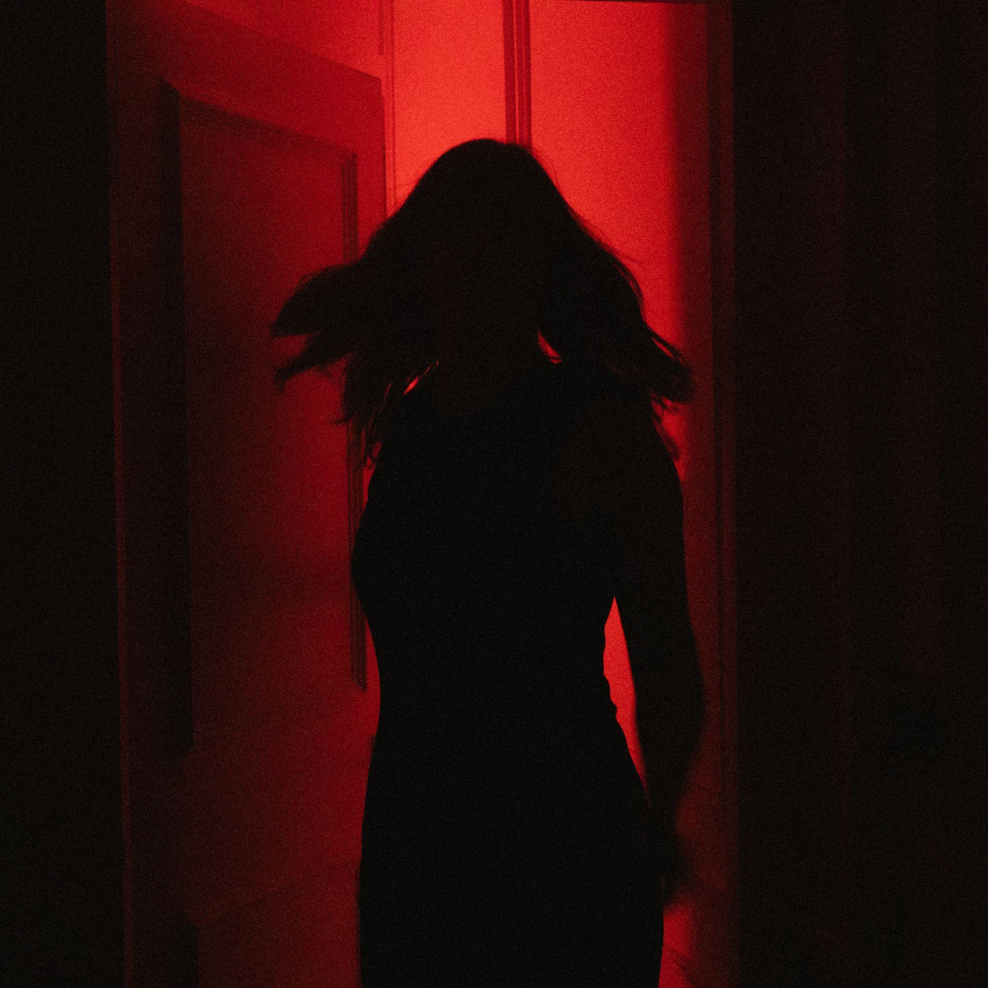
Credit - Darina
Download

Alt-rock darlings Another Sky return after a three-year absence from the spotlight. Their long-awaited single “Psychopath” is a far more punchy and direct rock song than anything from their 2020 debut record, “I Slept On The Floor”. The new track comes served with a raw acoustic B-Side “Watching Basinski”, recorded in their bedrooms during lockdown.

Listen To “Psychopath” and “Watching Basinski” Here
“Most of our upcoming music is pretty influenced by music from the late 90s and early 00s. So releasing an A-Side and B-Side felt like a good way of paying homage to the era we grew up in.” says lead singer Catrin Vincent.
On the songs themselves, Vincent comments “They reflect a really personal journey. I usually hate writing lyrics about myself, but during lockdown, it was the only thing I had to write about. I was so surprised to find multitudes of grief and sadness disguised as anger. Psychopath captures the angriest I’ve ever felt. For years, I felt like that rage could never be voiced.
On the B-Side Catrin adds “Watching Basinski captures the grief that lies underneath that anger. That’s what our new music is trying to convey; the human journey from fear and anger through to love and acceptance.”
In their three year absence, the band (Vincent, Jack Gilbert, Naomi Le Dune & Max Doohan) have not only been writing and producing new music, but have built a brand new studio from scratch in the crypt of a Church. More info to follow on that new music soon.
The news of their return came with an announcement of their signing to Republic Records in the US. “Who knew a song in 5/4 timing would get you signed to a US major label?” quips Vincent. The band continues to work with Fiction Records in the rest of the world.

Credit - Darina
Download

For more on info contact warren@chuffmedia.com

