ONLY THE POETS ANNOUNCE NEW SINGLE ‘ONE MORE NIGHT’ + UK TOUR
LISTEN HERE
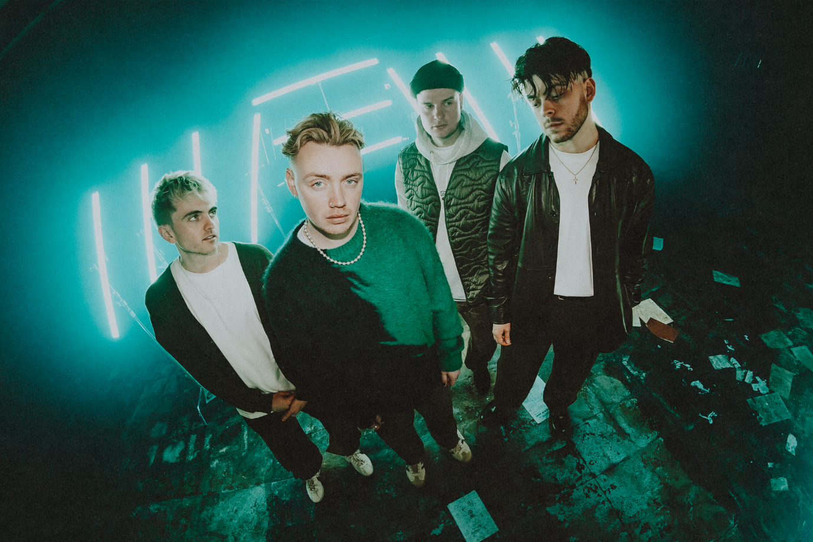
SOLD OUT EU TOUR KICKS OFF THIS MONTH
“Their respect and appreciation for their fans feels genuine, and it’s never more apparent than when they share the room together” – CLASH
Today, alt-pop four-piece Only The Poets share euphoric new single ‘One More Night’, which sees frontman Tommy Longhurst reminiscing lost summer evenings over soaring guitars and pulsating synths. It’s a yearning banger about good times gone-by,
Tommy says, ‘It’s a track about living in the moment. Remembering those nights where nothing else matters and everything felt like it was going to be okay. Those nights, that unknown to you at the time, turned out to be one of the best moments of your life.”
The release follows a stellar year for the Reading band, having played to 20,000 people across 50 shows in 10 different countries, racked up 10 million streams just on Spotify and 150k Shazams worldwide, as well as selling out their UK headline tour (which culminated in an epic gig at Shepherd’s Bush Empire. Due to demand, the band then also played a small ‘Homecoming’ tour, taking in Glasgow, Newcastle, Leeds, Manchester, Bristol and London – all dates sold out. At the festivals, the bands drew the biggest set at the BBC Introducing stage at Reading Festival following the ongoing Radio 1 support.

Only The Poets, comprising of Tommy Longhurst, bassist Andy “Roo” Burge, guitarist Clem Cherry and drummer Marcus Yates, have established themselves in just a few short years as one of the UK’s biggest emerging live acts. Unsigned until the beginning of 2023, the band’s DIY ethos saw them build things from the ground up, from playing student house parties, pub circuits and small venues to selling out 1,600-capacity venues in the UK and across Europe last year.
Alongside releasing their heartbreak anthem ‘Looking At You’ back in September last year, the band also announced a massive run of 2024 dates for their ‘One More Night’ European tour. Kicking off in Paris on the 6th February 2024, the 22-date tour will see the band play in venues across the continent including Milan, Krakow, Berlin, Prague, Oslo and Krakow, ending in Lille on the 11th April. See the full list of dates below…

UK Tour dates
Wed 5 June 2024 – London, KOKO
Fri 7 June 2024 – Birmingham, O2 Academy 2
Sat 8 June 2024 – Oxford, O2 Academy 2
Mon 10 June 2024 – Glasgow, Saint Lukes
Tues 11 June 2024 – Manchester, Gorilla
Wed 12 June 2024 – Bristol, Thekla
Thurs 13 June 2024 – Southampton, Engine Rooms

See ‘One More Night’ EU Tour 2024
Tue 6 Feb 2024 – Paris, Le Trabendo
Wed 7 Feb 2024 – Antwerp, Trix
Thu 8 Feb 2024 - Utrecht, TivoliVredenburg – Ronda
Fri 9 Feb 2024 – Luxembourg, Den Atelier
Sun 11 Feb 2024 – Hannover, Capitol
Mon 12 Feb 2024 – Stuttgart, Im Wizemann Club
Tue 13 Feb 2024 – Zurich, Dynamo
Thu 15 Feb 2024 – Milan, Santeria Toscana 31
Fri 16 Feb 2024 - Vienna, Flex
Sun 18 Feb 2024 – Kraków, Klub Studio
Mon 19 Feb 2024 – Poznan, TAMA
Tue 20 Feb 2024 – Berlin, Kesselhaus
Sun 24 Mar 2024 – Frankfurt, Zoom
Mon 25 Mar 2024 – Prague, MEETFACTORY
Tue 26 Mar 2024 – Munich, Technikum
Wed 27 Mar 2024 – Strasbourg, La Laiterie (Club)
Fri 29 Mar 2024 - Heerlen, Nieuwe Nor
Mon 1 Apr 2024 – Copenhagen, DR Koncerthuset, Studio 2
Wed 3 Apr 2024 – Stockholm, Fryshuset (Klubben)
Thu 4 Apr 2024 - Oslo, Vulkan Arena
Sat 6 Apr 2024 - Hamburg, Gruenspan
Mon 8 Apr 2024 – Leipzig, Taubchenthal
Tue 9 Apr 2024 - Cologne, Kantine
Wed 9 April - Cologne, Kantine
Thu 11 Apr 2024 – Lille, The Black Lab

OTP // INSTA // TWITTER // FB

For more information and press enquiries please contact
Jenny Entwistle
Jenny@chuffmedia.com

