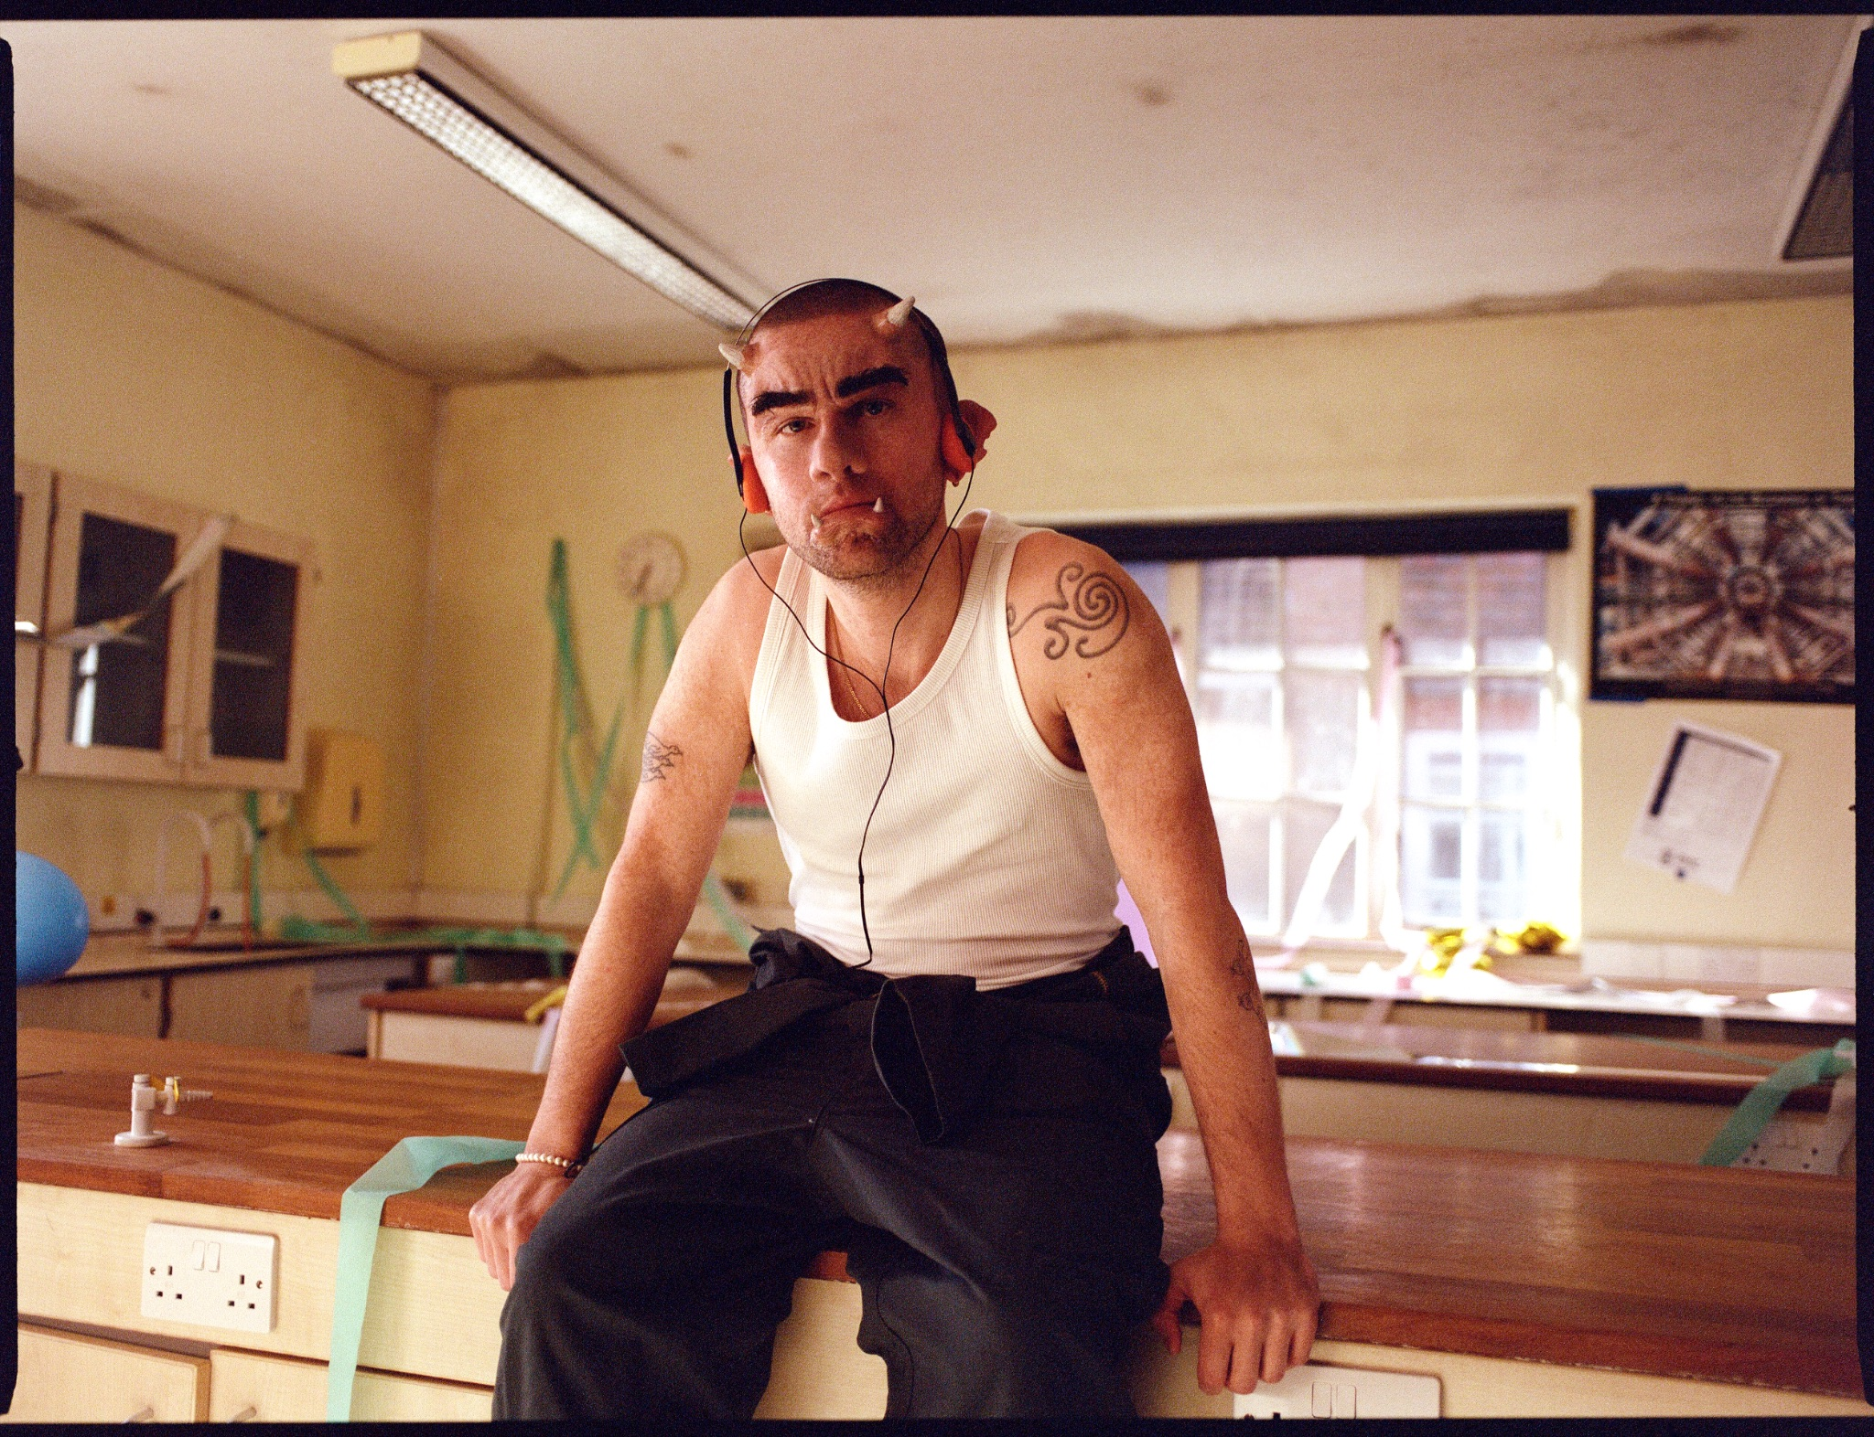

hard life share new track/video, ‘OGRE’

UK Headline tour & summer festivals also announced
New album - onion - released July 18th on Island EMI
“Something as frivolous as a name change can’t halt the ascent of a band this charismatic and resilient” - NME ⭐⭐⭐⭐
“Raucous, fun and full of lyrical sleights of hand - The Times ⭐⭐⭐⭐
“Indefinable…imagine what would happen if Alex Turner, Kaytranada and Loyle Carner collaborated, and you’ll get something fairly close” - GQ
"A more refined, authentic musical project...sounds hungrier than ever" - Wonderland

Listen/Watch ‘OGRE’: https://hardlife.lnk.to/OGRE
Listen to first single, ‘othello’: https://HardLife.lnk.to/othello
Watch the ‘othello’ video: https://www.youtube.com/watch?v=QC_Tp2u7l40
Photo/Artwork: https://umusic.box.com/s/uz8r34xyhuo2pk3b21r4k9ksiyjagur9

hard life share brand new track and video ‘OGRE’, the second layer of new album onion (released July 18th on Island EMI), which was introduced recently by acclaimed first single ‘othello’. Today’s release also comes alongside news of a UK headline tour to follow hard life’s live return over the festival season this summer, taking in BBC Radio 1 Big Weekend, Truck Festival, Y NOT & Boardmasters. These newly announced headline dates see the band return to some of the UK’s most iconic venues including London’s O2 Academy Brixton. See the full run of dates below.

‘OGRE’ is hard life’s own, weirded-out twist on the classic breakup-ballad. Setting heartfelt acoustics over quickfire rap akin to the oversharing of a voice-note, its offbeat production - and nerdish nod to ‘Shrek’ - sees Murray Matravers channel the lowest of lows into new songwriting heights. Full of pathos and surreal humour, the ‘OGRE’ video, starring Murray as a janitor after the party’s over, brings to life this sense of the monster within.

“OGRE’ is about a situation where nobody’s done anything wrong, but that almost makes things worse,” Murray comments. “Sometimes relationships are more complicated because they lack an antagonist, and someone to hate: I’ll be your ‘OGRE’, if that gives us a clean break. This was one of the first songs I wrote for the album with Taka, and this image of onions - partly inspired by ‘Shrek’ - became central to the record. Onions are so universally recognisable, and I liked the idea of something simple yet complex.”

‘OGRE’ continues the grand farewell turned creative rebirth of hard life. Straddling pop accessibility with genre-disruptive playfulness, it’s a totem of personal growth born out of melancholy, self-awareness, but also the courage to come back swinging. The album emerged after - of all things - a long haul flight: disillusioned with his work and having effectively quit music, Murray booked a spontaneous trip to Japan, wishing to fully immerse himself in the fashion, food and local culture that had fascinated him since touring four years ago. He was also, as ‘OGRE’ confesses, running away from an unbroken streak of breakups (romantically, within the hard life band, and from the life once lived). Seeking solace in Tokyo, Murray met another wandering stranger, Taka, and started making music again spontaneously in Shirokane’s local studio, named onion.

What emerged within a matter of weeks - to the surprise of even Murray himself - was a new hard life album: songs hardened by experience, but also compassionate, confident, and care-free. First single ‘othello’, for instance, is about making peace with chaos unfolding, when there is no “black or white”, tragedy or comedy to rage against. The album’s musical curiosity and main-character energy harnesses this period of loss into an unexpected opportunity for growth. It’s a messy chapter that closes, too, on a homecoming: Murray returned to Leicester in December 2024, reconnecting with the wider hard life live band ahead of their full-circle return to the live stage this summer.

onion follows 2022’s MAYBE IN ANOTHER LIFE…, which charted at number 2 (Murray Matravers’ second consecutive album to do so) and reached stages ranging from London’s Alexandra Palace to Glastonbury’s Pyramid. Accompanied by a raw but refined cinematic aesthetic, onion is as much a welcome return, then, as an exhilarating fresh start: the kind only possible, perhaps, when your life blows up. Having spent his young career matching unsteady circumstances with unvarnished positivity, amidst breakups and breakthroughs - and for legal reasons, all things easy and hard - life seemingly has a way of disrupting Murray Matravers’ best laid plans. Here is British pop’s underdog, with added bite.

HARD LIFE – 2025 UK HEADLINE TOUR
Tue 28 Oct – Leeds – O2 Academy
Wed 29 Oct – Bristol – O2 Academy
Thu 30 Oct – London – O2 Academy Brixton
Mon 3 Nov – Newcastle upon Tyne – The Boiler Shop
Tue 4 Nov – Glasgow – SWG3 Galvanizers
Thu 6 Nov – Manchester – Manchester Academy
Mon 10 Nov – Nottingham – Rock City
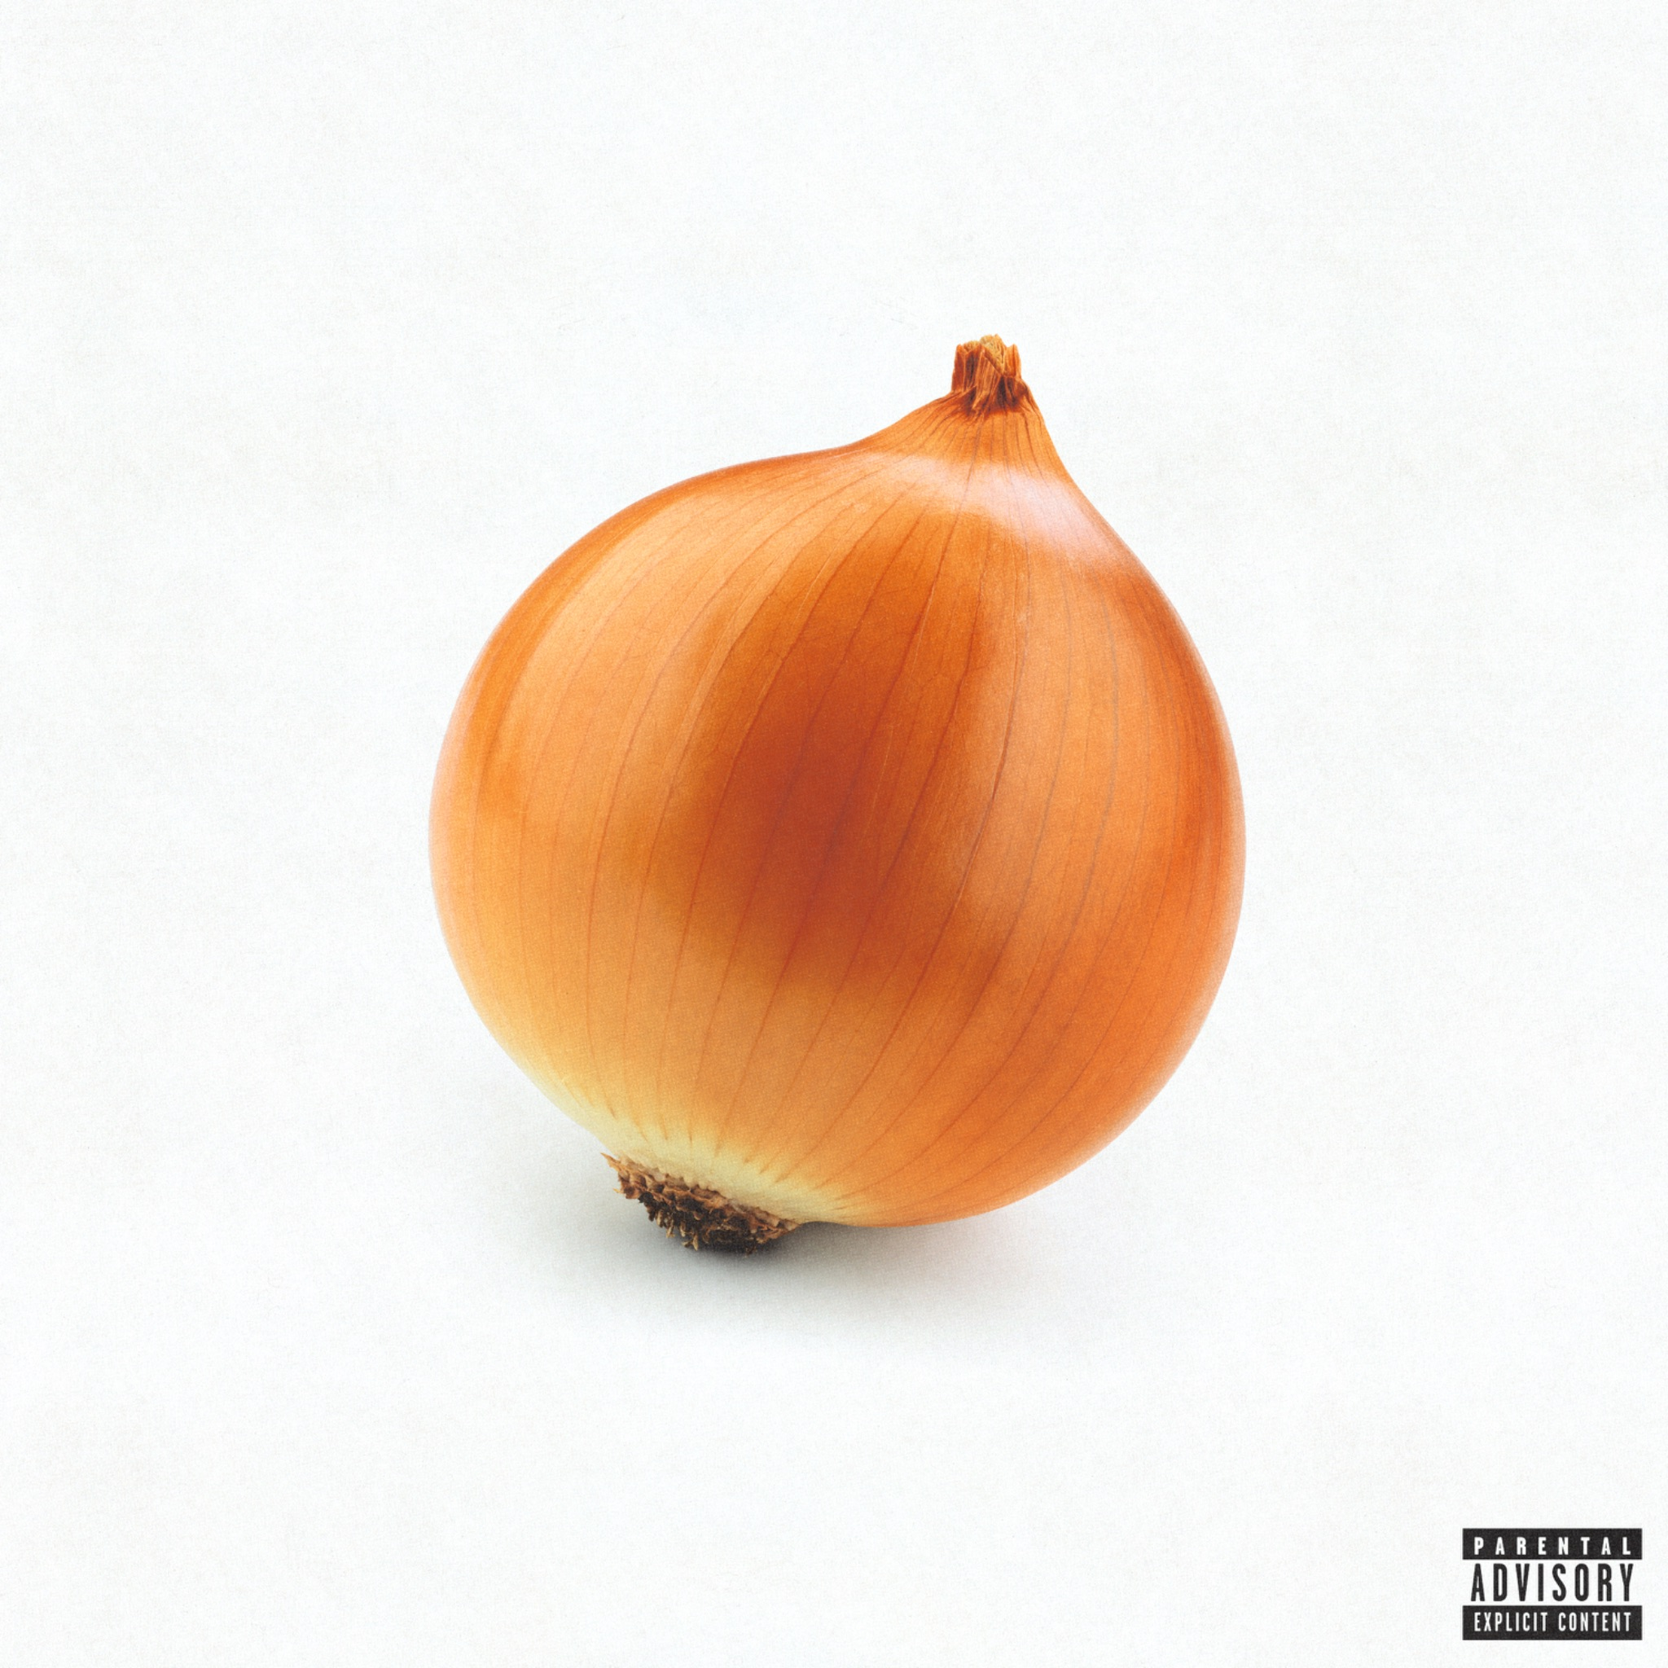
‘onion’ - album artwork

For more information contact warren@chuffmedia.com

