KAETO RELEASES NEW SINGLE ‘NO BODY’
LISTEN HERE
SHARES MESMERISING VIDEO DIRECTED BY GERMAN FILMMAKER PAULA ROMY
OCTOBER 11th 2023
ANNOUNCES RESIDENCY AT LONDON’S LAYLOW
LEAD PRESS PHOTO (credit: Maisy Banks)
KAETO will release her new single ‘No Body’ via Polydor Records on October 11th. ‘No Body’ is Kaeto’s first release for Polydor and follows last year’s astonishing debut ‘Good Morning’. It comes with production by Brendan Grieve and a stunning video directed by German filmmaker Paula Romy.
Built around a rolling, psychedelic-pop groove and the singer-songwriter’s hypnotic, reverb-heavy vocals, it’s a euphoric gem from a startlingly talented new artist. “Why are we all watching ourselves,” she asks on the track, exploring themes of smartphone obsessions and modern vanity. “I’m not trying to be preachy,” Kaeto says. “I’m exploring these things because I’m doing them and I can’t stop.”
“I really enjoyed making No Body and I love performing it,” she says. “I don’t want to say too much about what it means as it can ruin what other people might interpret and I think that is more interesting and fun! I don’t want to impress my experience onto other people. For me, the music is more fun that the words I can sum up to describe it.”
It’s the culmination of a period of sonic self-discovery for the Scottish-born, London-based artist. It was back in 2019 that Kaeto first entered the studio with outside producers and began building a sound that would be all her own, but the route she’s taken since is a mark of her maverick and inventive approach to music. One such diversion was enrolling in Clown School, a move designed to throw herself into something creative and spontaneous and shake off the mundanity of modern life. It's why Kaeto’s music has such a free-spirited, loose-limbed sense of adventure about it. “I’m so unashamed of myself,” she says, “but music is where I go to explore these things.” As anyone who saw Kaeto’s brilliant support with Haim at All Points East recently can attest, it’s going to be a fun ride.
KAETO has announced she will play a series of shows at Laylow. The mesmerising newcomer will kick things off with a performance at the West London venue on September 28th, following up with two further shows on October 12th and 26th. Following that, KAETO will open for ELIZA at Kentish Town Forum on 17th November.
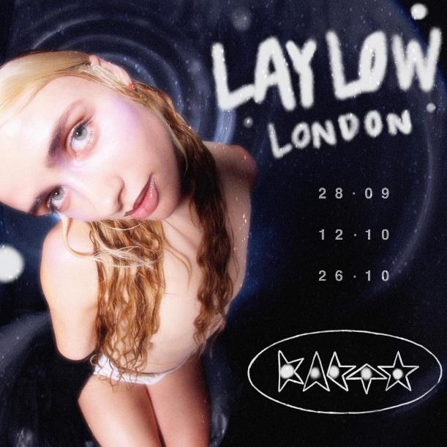
DOWNLOAD ‘NO BODY’ ARTWORK
FOLLOW KAETO Instagram | YouTube

For more on info contact warren@chuffmedia.com

