

SHARES NEW SINGLE ‘NEVER BE ALONE’ WITH SONNY FODERA LISTEN HERE / WATCH THE VIDEO HERE

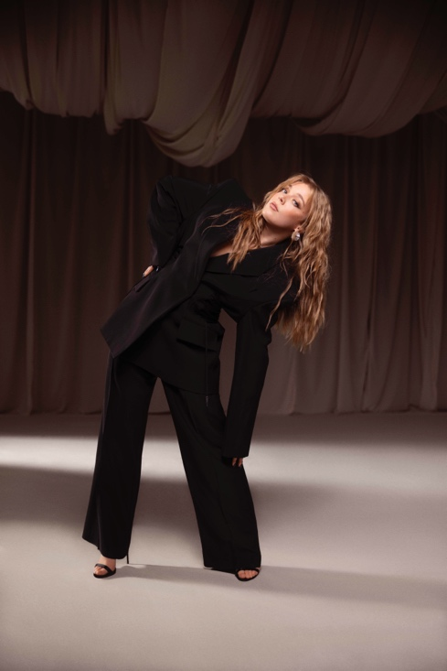

Becky Hill’s status as a two-time BRIT Award winner with 10 billion streams and seven UK Top 10 hits to her name has continued to build with her recent singles. First ‘Side Effects’ (with Lewis Thompson) hit the Radio 1 playlist on its way to becoming a #1 airplay hit, before her Chase & Status collab ‘Disconnect’ peaked at #6 on the OCC and was certified Gold bringing her to a total of 7.4 million sales as a lead artist in the UK to date. Now Becky Hill propels that stellar form into 2024 as she heightens anticipation for her upcoming second album by unveiling her latest track ‘NEVER BE ALONE’ with fellow dance music trailblazer Sonny Fodera.

‘Never Be Alone’ draws upon Becky’s influences from deep within the world of club culture. Her dancefloor diva topline mixed with Sonny Fodera’s production provides an intoxicating rush of heavyweight dub bass, pounding beats, luminous synths and atmospheric breakdowns which allows the drops to hit hard.

Becky says, “‘Never Be Alone’ was born out of a post lockdown world where isolation & distance were forced upon the world. With my partner & I both being in music, we really felt the full force of an imposed lockdown on the events industry. Our entire careers were in jeopardy and I really felt the downward spiral of someone I loved, who’d worked his entire adult life curating line ups for festivals and clubs. I wrote this song with my long time collaborator Karen Poole (‘Remember’, ‘History’ and ‘Disconnect’) drawing on inspiration from the time we lived apart, feeling helpless with his despair.

What I love about this single is that it has transcended lockdown and feels so relevant still in a time when we need to be there for each other now more than ever. I’ve been playing it in my live sets this summer and it has been a joy watching the crowd’s reaction, but I’m excited to show people what Sonny Fodera has added to this anthem; he’s one of the only people left in the dance space I haven’t collaborated with yet and I can’t wait to release this record alongside him.”

The song’s blissed out intensity is amplified by its striking video. Directed by Remi Laudat and filmed in the barren natural beauty of Morocco’s Agafay Desert just outside of Marrakesh, Becky cuts a beguiling, magnetic figure as she moves from daylight to dusk, while the song is further intensified by a burning ring of fire.

London-based artist Sonny Fodera’s flair for powerful house music with palpable emotions has made him “one of the biggest draws in house” (Mixmag). The strength of his original productions and remixes have made him a go-to collaborator with world-renowned artists including Tiesto, Diplo, MK and 21 Savage, while his DJ sets pack venues the world over with UK headline shows at Alexandra Palace and the Mayfield Depot in Manchester as well as international festivals from Coachella and Tomorrowland to Glastonbury and EDC Vegas.

‘Never Be Alone’ follows a remarkable 2023 for Becky. The year was bookended with two prestigious music awards: the BRIT Award for Best Dance Act (her second year in a row) and Best Vocalist at the Drum & Bass Arena Awards. And in-between, the year delivered highlight-after-highlight: a killer Glastonbury set, a summer YOU/ME/US residency in Ibiza, exceeding a billion domestic career streams and winning Attitude Magazine's Music Award. She also kickstarted the second series of her critically acclaimed podcast The Art of Rave with dream guest Fatboy Slim, after its initial series had featured influential names such as Roni Size, Fabio & Grooverider, Sister Bliss, Andy C and Pete Tong.

On the live front, immense demand for Becky’s autumn UK and Ireland arena tour saw 80,000 of its 130,000 tickets sell-out in just three days, leading to the addition of a series of outdoor summer shows alongside select festival dates. Currently on tour in Australia and New Zealand, she will also play her debut headline tour of mainland Europe in April, which hits seven countries. Her upcoming UK and Ireland shows are listed below, please see HERE for remaining tickets and a list of all scheduled international dates.

JUNE
13th - Cheshire, Delamere Forest
14th - Cork, Musgrave Park
15th - Belfast, Belsonic

JULY
12th - Derby, Summer Sessions

AUGUST
7th-11th - Newquay, Boardmasters
9th - Newmarket, Racecourse
16th - Durham, Hardwick Festival
18th - Edinburgh, Summer Sessions
24th - Cardiff, The Bay Series
25th - Portsmouth, Victorious Festival
29th - Scarborough, Open Air Theatre
30th - Sheffield, Rock ‘n’ Roll Circus
31st - Margate, Dreamland

OCTOBER
12th - Glasgow, OVO Hydro
13th - Newcastle, Utilita Arena
15th - Nottingham, Motorpoint Arena
16th - Leeds, First Direct Arena
18th - Exeter, Westpoint Arena (SOLD OUT)
19th - Birmingham, Utilita Arena (SOLD OUT)
20th - Manchester, AO Arena
22nd - Cardiff, Utilita Arena (SOLD OUT)
24th - London, OVO Arena Wembley

Follow Becky Hill:
Spotify | Apple Music | YouTube | TikTok | Instagram | Facebook | Twitter | Website

more on info contact warren@chuffmedia.com

