DECLAN MCKENNA SHARES NEW TRACK, “MULHOLLAND’S DINNER AND WINE”

LISTEN HERE

LIFTED FROM FORTHCOMING NEW ALBUM, WHAT HAPPENED TO THE BEACH?, OUT 9TH FEBRUARY 2024

16-DATE UK TOUR KICKS OFF 23RD MARCH IN CARDIFF – ON SALE NOW

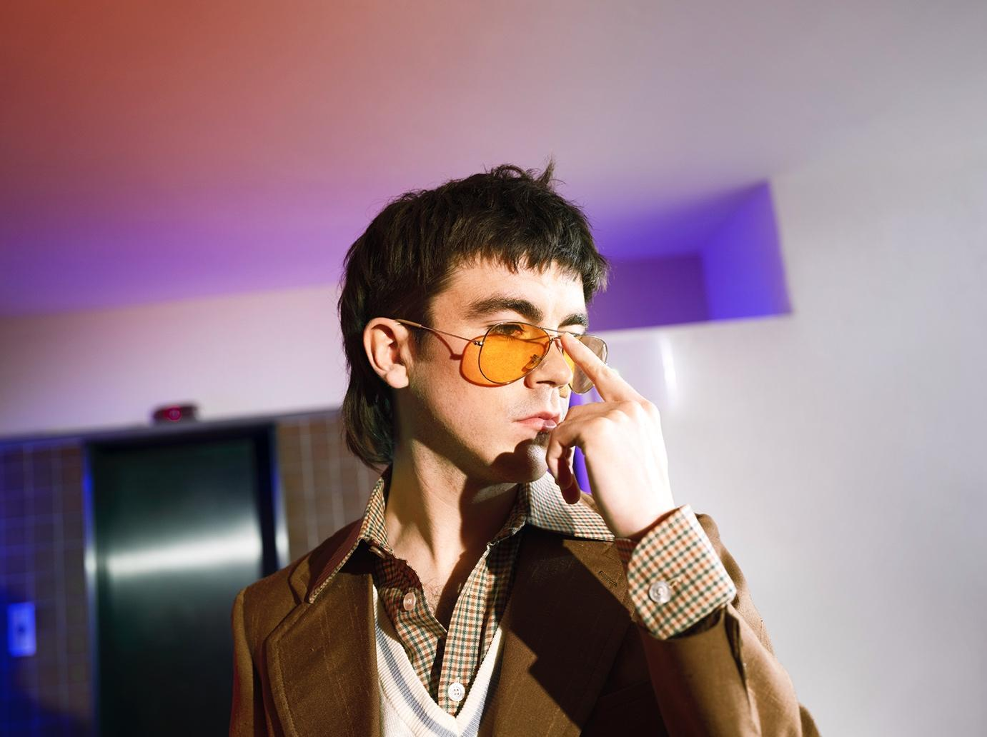
Credit: Henry Pearce

Declan McKenna is excited to share the next track to be lifted from his forthcoming album, What Happened To The Beach?, out 9th February via Columbia Records. Listen to Mulholland’s Dinner and Wine HERE

If we’ve learned anything from the smattering of tracks shared from Declan’s third LP so far, it’s that this one resolutely refuses to be categorised. No second guessing. Mulholland’s Dinner and Wine operates on another plain to Sympathy’s indie-rock leanings, the Beck-esque calypso groove of Elevator Hum, and the restless euphoria of Nothing Works. It’s a simmering, sunshine swagger that evokes almost prime psychedelic-era Tame Impala. Produced by Gianluca Buccellati out in LA, this new song radiates joy, as though they set the studio up outdoors and let the mood take them wherever it wanted. It’s a glorious few minutes of sound.

Declan McKenna: “Mulholland’s Dinner and Wine was written with Gianluca Buccellati as a kind of weird, warped story about a cartoon-y criminal duo, and the origins of the title come from an off-licence in the UK, but it became entangled with Mulholland drive in LA. The lyrics came from observations driving around the hills there and conversations at strange, hip parties.”

Following extensive US touring throughout the year, playing to over 60,000 fans, Declan recently announced his UK/Ireland tour for the Spring, with additional dates since added in both Dublin and Glasgow. Remaining tickets are on sale now, including the last few at London’s Alexandra Palace, Declan’s biggest headline show to date in April. A European run follows suit, ahead of a predictably busy run of festival performances. Since its initial announcement, additional live dates have been added in Glasgow, Dublin and Liverpool due to demand.

Listen to recent single Elevator Hum

What Happened To The Beach? Is the follow up to Declan’s acclaimed second album, Zeros, which debuted in the UK album chart at number 2 and with much critical acclaim.

PRE-ORDER THE ALBUM HERE

Declan McKenna Live:

23rd March – Great Hall, Cardiff University SOLD OUT
24th March – UEA, Norwich SOLD OUT
25th March – O2 City Hall, Newcastle SOLD OUT
27th March – O2 Academy, Glasgow SOLD OUT
28 March - O2 Academy, Glasgow NEW DATE
29th March – The Octagon, Sheffield SOLD OUT
1st April – Ulster Hall, Belfast
2nd April – 3Olympia Theatre, Dublin SOLD OUT
3rd April - 3Olympia Theatre, Dublin NEW DATE
5th April – O2 Apollo, Manchester SOLD OUT
6th April – Liverpool University (Mountford Hall), Liverpool NEW DATE
8th April – De Montfort Hall, Leicester
9th April – Beacon, Bristol
10th April – The Halls, Wolverhampton
12th April – Alexandra Palace, London
13th April – Brighton Centre, Brighton
14th April – O2 Academy, Bournemouth
16th April – Ancienne Belgique, Brussels
17th April – Paradiso, Amsterdam
18th April – Tivoliredenburg Ronda, Utrecht
21st April – Kantine, Cologne
22nd April – Uebel & Gefährlich, Hamburg
23rd April – Astra, Berlin
25th April – Stodola, Warsaw
26th April – Kwadrat, Krakow
27th April – SaSaZu, Prague
29th April – Le Transbordeur, Lyon
30th April – Rock School Barbey, Bordeaux
2nd May – Le MeM, Rennes
3rd May – La Cigale, Paris
25th May – Live At Leeds, In The Park
12th July – TRNSMT Festival, Glasgow

www.declanmckenna.net

For more information and press enquiries please contact

Jenny Entwistle
Jenny@chuffmedia.com

