**THE HORRORS**

**RELEASE NEW SINGLE “MORE THAN LIFE”**

**NEW ALBUM ‘NIGHT LIFE’ OUT MARCH 21ST**

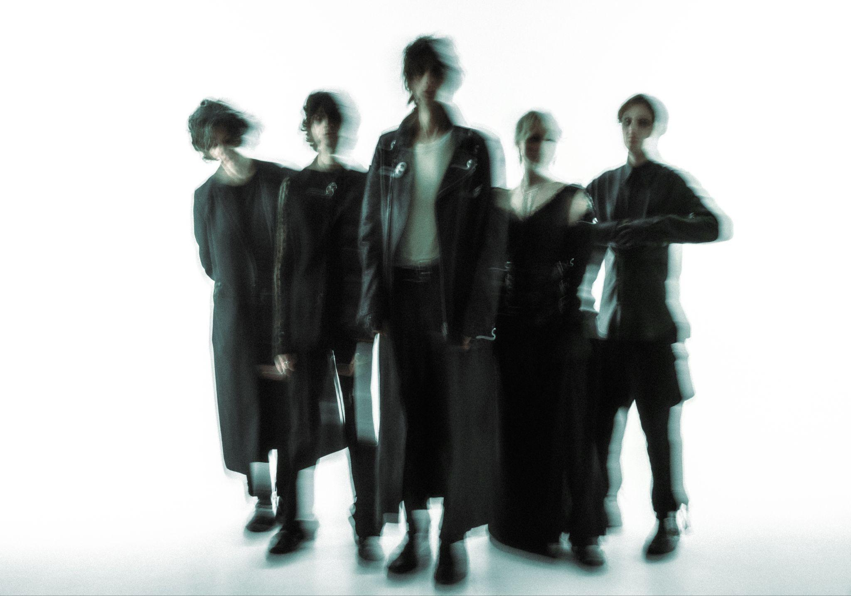

Credit: Vessel Video (Paris Seawell)

The Horrors today release an anthemic new single ‘More Than Life’, the fourth track to be taken from their forthcoming sixth studio album ‘Night Life’, out March 21st via Fiction Records. The single follows a sold-out run of UK dates to close out 2024, including a blistering show at London’s ICA.

[**LISTEN TO “MORE THAN LIFE” HERE**](https://thehorrors.lnk.to/MoreThanLifePR)

*“”More Than Life” has a different type of intensity to our recent singles, it’s more driving and direct. It was written in the middle of Canary Wharf, which looks more like Blade Runner everyday. It’s such a strange place to do anything creative as the surroundings feel particularly stark.”* explains the band.

*“We still needed a couple more songs for the album before going to LA to record at Yves’ studio, and we were in that insular part of the process where it feels like the outside world doesn’t exist. The song is basically about the question of what matters to you and by that point we were definitely clear on where we were heading.”*

As The Horrors approach their 20th anniversary as a band, ‘Night Life’ sees them shapeshift into a new form, with a new sonic outlook and a new line up centred around the core duo of vocalist Faris Badwan and bassist Rhys Webb, now joined by Amelia Kidd on keys and Telegram’s Jordan Cook on drums, making the new album the band’s first to not feature all 5 original members. While demos began modestly in Webb’s basement flat in North London with the pair thriving on the immediacy of, as Faris describes, *“shortening the distance between having an idea and expressing it”*, the record truly took shape in LA under the guidance of producer Yves Rothman (Yves Tumor, Blondshell) before finishing touches were applied back in London along with guitarist Josh Hayward, with Kidd bouncing parts and production ideas remotely from Glasgow.

The resulting album is a record of weight and space, of melancholy and euphoria; a record that has the ability to make bedfellows of seemingly disparate ideas as only The Horrors can. The ‘Night Life’ here is not the vim and vigour of pubs and clubs. It’s the thoughts that happen under the cover of darkness; the places your mind takes you when the rest of the world is asleep. A record born out of a desire to revive the raw, instinctive spirit of the band’s early work.

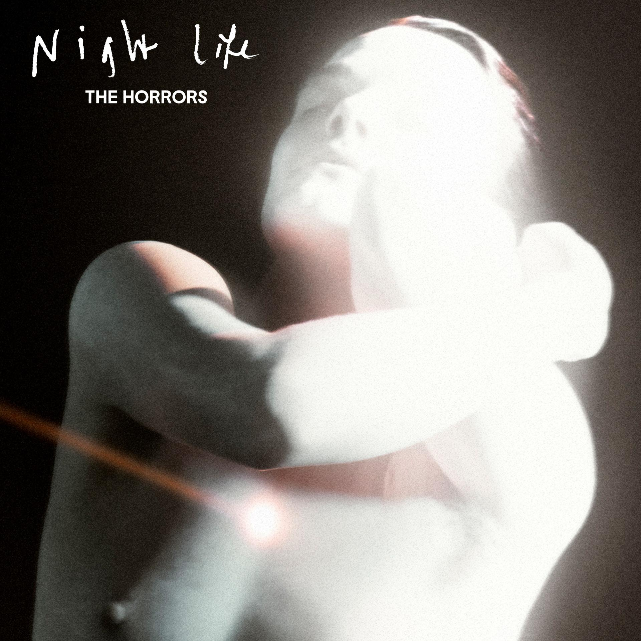

**‘Night Life’ artwork**

After nearly 20 years making music, there are few bands who’ve created a canon as determinedly innovative and consistently critically-acclaimed as The Horrors. Emerging as zeitgeist-shaking garage-goths on their 2007 debut ‘Strange House’, before taking a sharp left turn for their Mercury-nominated follow up ‘Primary Colours’, since the beginning they’ve roamed freely between genres. 2011’s ‘Skying’ won the NME Award for Best Album; ‘V’ was heralded as “a triumph” in a five-star Guardian review, while 2021’s pair of EPs - ‘Lout’ and ‘Against The Blade’ - marked a new chapter with their most industrial, uncompromising output yet.

[**Preorder/Pre-save ‘Night Life’ HERE**](https://thehorrors.lnk.to/nightlifePR)

**The Horrors Live Dates:**

3rd April - Sala Capitol, Santiago de Compostela

5th April - Barcelona Psych Fest, Paral-lel 62, Barcelona

6th April - Sala Mon, Madrid

7th April - Sala Moon, Valencia

24th/25th May - Dot To Dot Festival (Headline)

**‘Night Life’ tracklisting:**

1. Ariel
2. Silent Sister
3. The Silence That Remains
4. Trial By Fire
5. The Feeling Is Gone
6. Lotus Eater
7. More Than Life
8. When The Rhythm Breaks
9. LA Runaway

[www.thehorrors.co.uk](https://www.thehorrors.co.uk/)

**For more info contact** [**warren@chuffmedia.com**](mailto:warren@chuffmedia.com)