SELF ESTEEM

Releases new single ‘Moody’

Ahead of release of highly anticipated second album
‘Prioritise Pleasure’ on 22nd October

Announces February + March 2022 UK tour dates


Hi-res assets here // Photo credit: Olivia Richardson

Self Esteem today shares another cut from her forthcoming second album Prioritise Pleasure in the shape of her undeniable new single ‘Moody’. The anthemic rhythmic flourishes of funk-pop on ‘Moody’ are paired with some of her sharpest, wittiest lyricism to date: “sexting you at the mental health talk seems counterproductive…” and has enraptured crowds on its first live outings at shows across the summer.

Of the new track, Self Esteem adds: “Moody is a song about reclaiming being a moody cow. My whole life I’ve been referred to as mardy (northern for moody) but lately I’ve been realising as a woman in this world, especially as a woman in the music industry, of fucking course I’m moody! It’s such a slog even getting heard, every day shitting yourself about your safety, the societal expectations. I’d love to be sweet and happy go lucky but I’m afraid I’m too tired to be most of the time. "

Listen to ‘Moody’

Today Self Esteem also announces a brand new run of UK tour dates, set to take place in February and March 2022. The tour includes eight dates across the country, taking in London’s Forum and concludes with a hometown show at Sheffield’s Octagon. Presale tickets will be available for 24 hours from 9am BST on 20th September, with general sale from 9am on 21st September. See below for a full list of tour dates.

Before the end of 2021, Self Esteem will embark on a 19 date UK tour across November with tickets for a select number of shows still available via https://www.selfesteem.love/. A space for both catharsis and euphoric celebration, a Self Esteem live show is not to be missed.

Due for release on Friday 22nd October via Fiction Records, Self Esteem’s sophomore album Prioritise Pleasure features the acclaimed singles ‘Prioritise Pleasure’, ‘How Can I Help You’ and ‘I Do This All The Time,’ which made the Radio 1 and 6 Music playlists and was the subject of a much talked-about performance on Later... With Jools Holland.

Pre-order Prioritise Pleasure

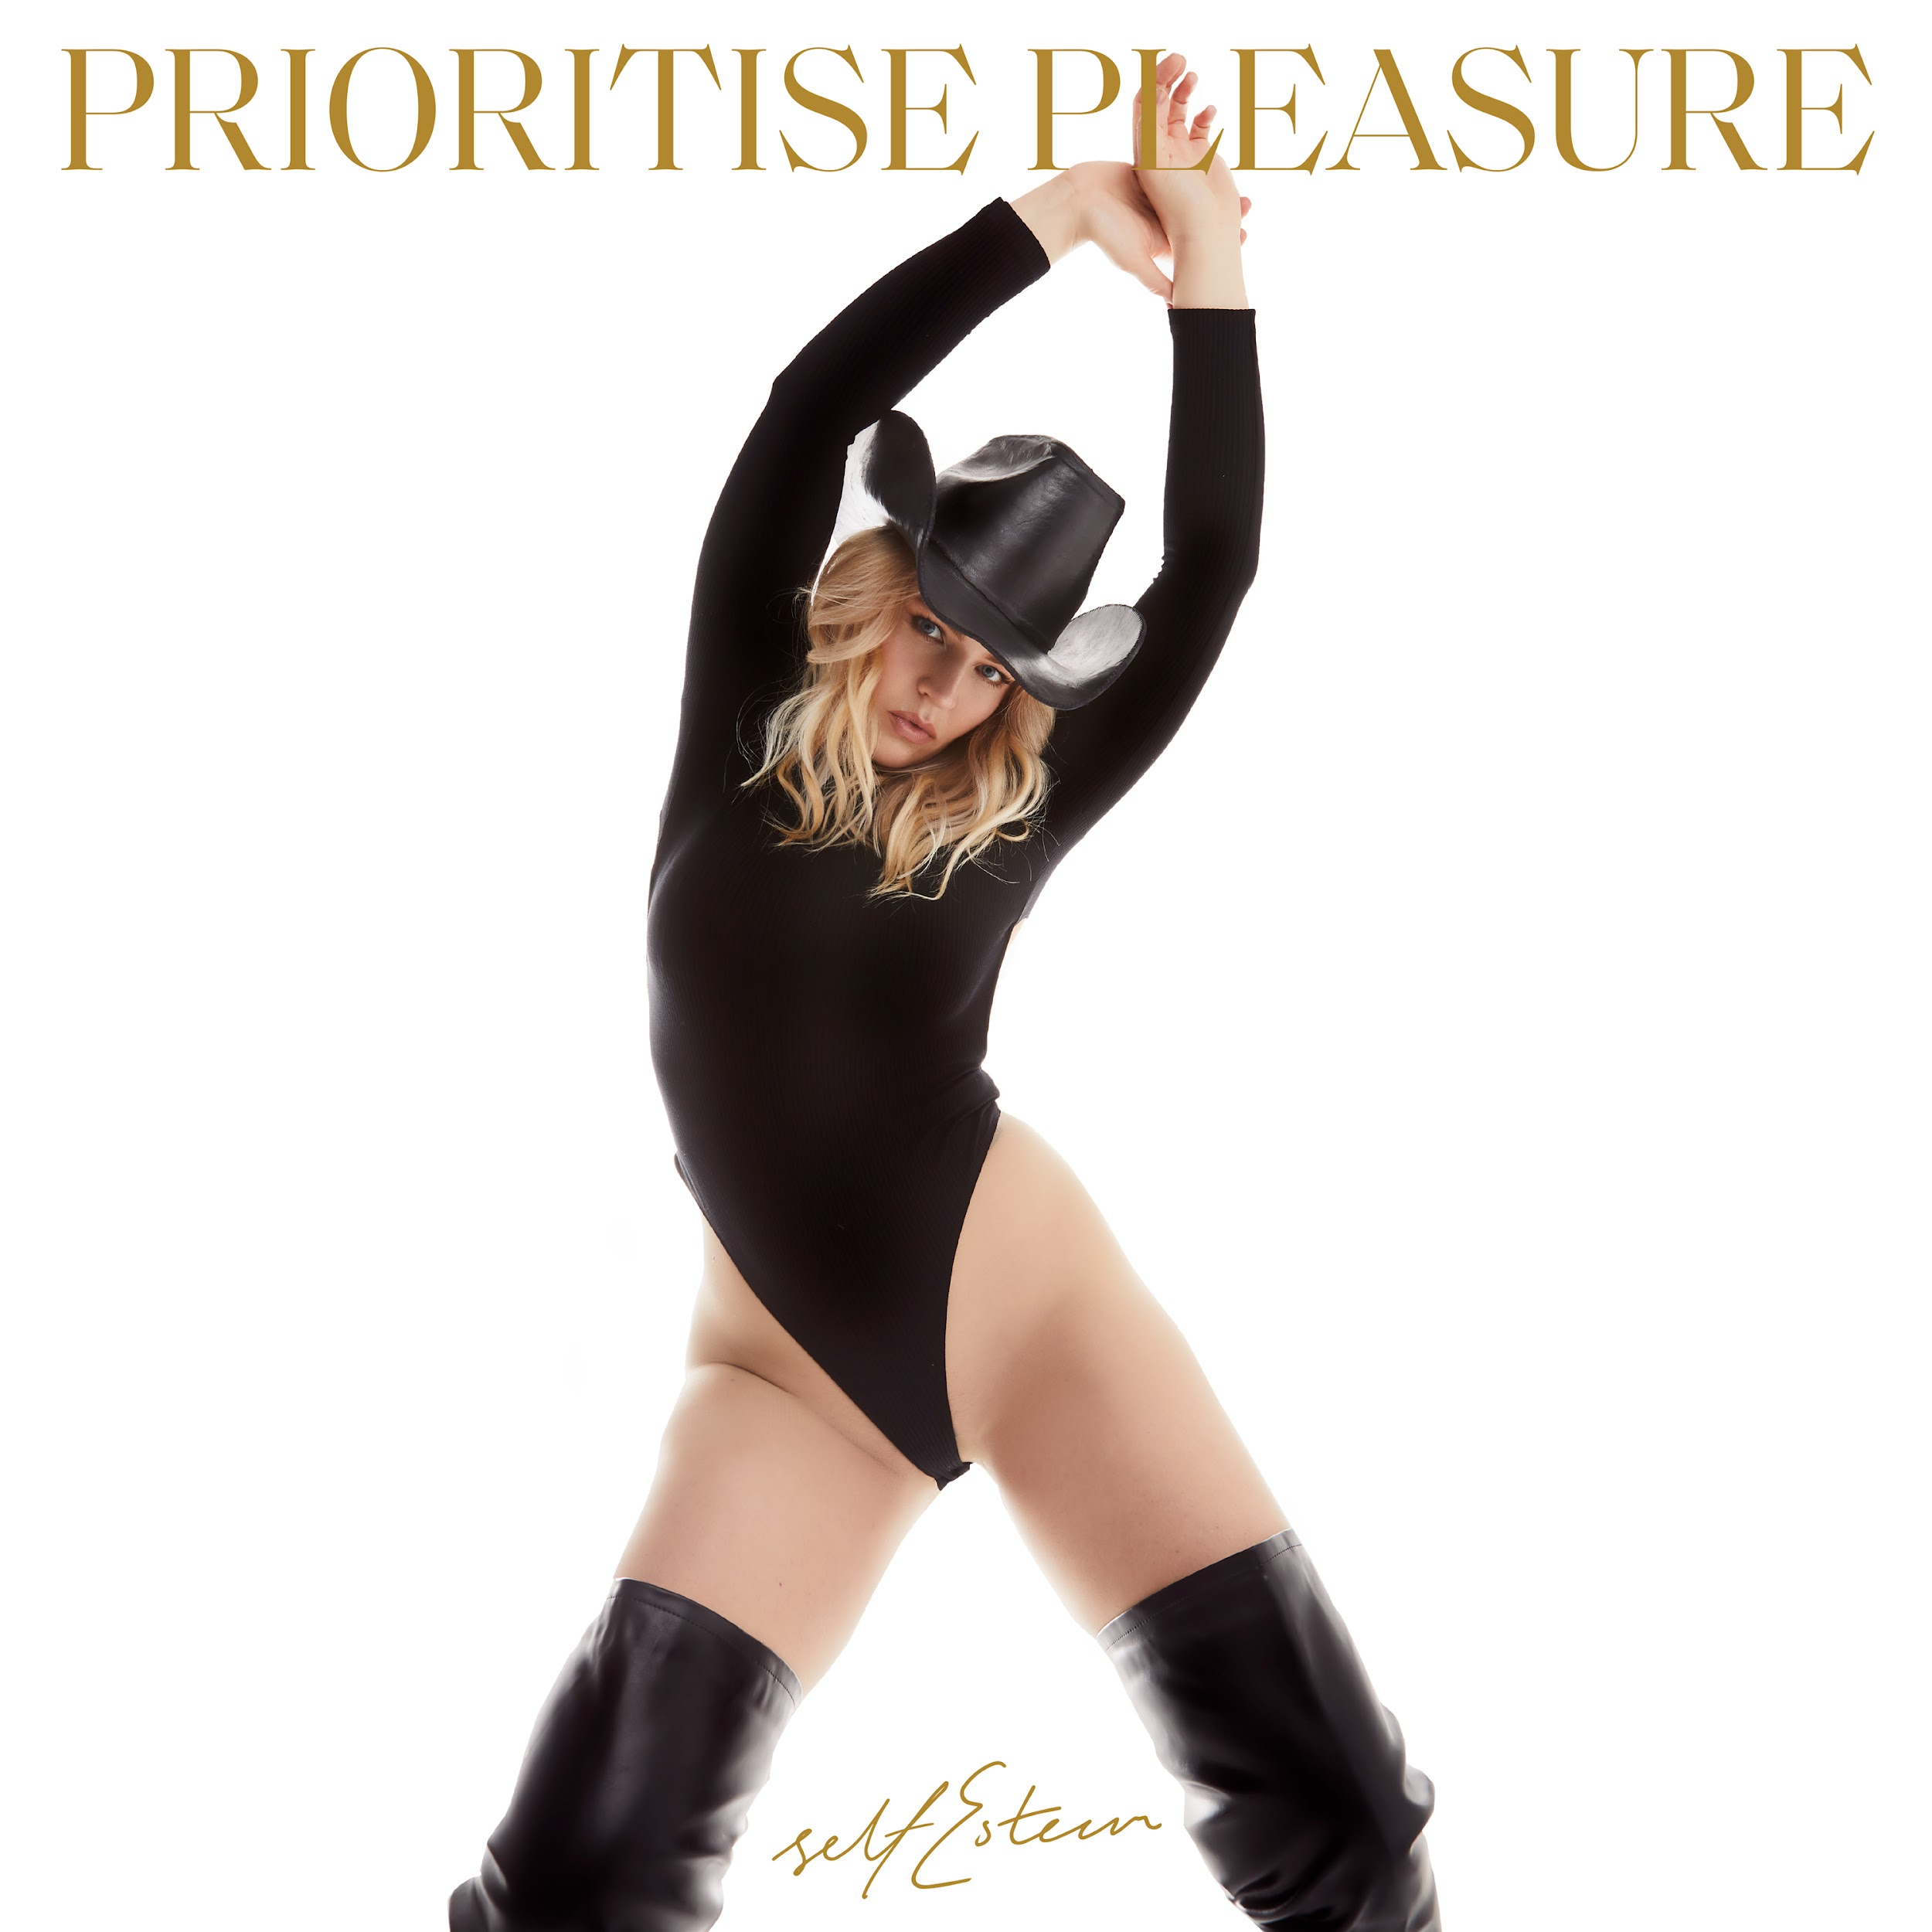
Prioritise Pleasure tracklisting

I’m Fine
Fucking Wizardry
Hobbies 2
Prioritise Pleasure
I Do This All The Time
Moody
Still Reigning
How Can I Help You
It’s Been A While
The 345
John Elton
You Forever
Just Kids

The follow up to Self Esteem’s acclaimed 2019 debut album Compliments Please, Prioritise Pleasure is a record that reminds us all of the importance of being our unapologetic selves, putting your insecurities out there in the hope that it can be the first step towards healing them. Honest disclosure has always been Self Esteem’s forte, and so each track on Prioritise Pleasure handles difficult themes with nuanced perspective, comforted and counter-balanced with an array of rhythmic flourishes that speak to the eclecticism of her experience and influence.

The funk-pop shimmy of ‘Moody’ is anthemic in its analysis of self-sabotaging habits, while opener ‘I’m Fine’ builds a stomp-and-clap wall of solidarity, staking out defiant new ground. Making use of Taylor’s penchant for voice notes, the song’s striking outro draws on snippets of conversation taken from work she did in 2019 with The National Youth Theatre, devising a short play with a group of young female-identifying creatives on the topic of consent.

“It turned into the most amazing month, sitting in a circle and having all these teenage chats,” Taylor says. “But every now and again, there would be some particular insight that would just put goosebumps all over my body.” One such moment was a story shared by a woman in her early twenties, whose fear of walking at night can be heard on the track. “It sounds so stupid, but me and my friends…if we are approached by a group of men, we will bark like dogs…there is nothing that terrifies a man more than a woman who appears completely deranged.”

“It sets the precedent for the whole record; like really, is that what we have to do to feel safe?” says Taylor. “I am so angry that I can't go on holiday alone. I'm so angry I can't walk home without someone freaking me out, or worse. And the idea that the only defence we have is to be terrifying is so wrong, but it’s as normalised in society as the idea of feeling heartbroken by a guy that doesn't text you back enough.”

Breaking a personal cycle of trauma-suppression, Taylor says, starts with laying out these instances of her personal experience – self-doubt, heartbreak, sexual assault, the urge to compare – and realising that one stands out as something that truly can’t be justified as part and parcel of life.

“What's the one thing that none of us deserve to have happened to us, but almost all women have had? But in order to fucking live and survive and not spend every day wanting to slay every man I see in the street, I've had to normalise it.” She pauses, finding a moment of clarity. “I guess this album, the reason it's so full of love for myself, is that I’m finally seeing that none of those things are my fault.”

Having allowed itself grace, Prioritise Pleasure is also a record of great joy. Working again with trusted producer Johan Karlberg [of afro-fusion trio The Very Best], it was stitched together throughout the pandemic in chunked sessions, the time between each batch encouraging Taylor to fully flesh out her ideas. With Prioritise Pleasure, Self Esteem comes one step closer to reminding listeners – and herself – that true success begins and ends with self-acceptance, telling your story in the way that only you can.

SELF ESTEEM UK TOUR DATES

2021

1st November - Fleece, Bristol (SOLD OUT)
2nd November - Wylam Brewery, Newcastle
3rd November - Clwb Ifor Bach, Cardiff (SOLD OUT)
4th November - O2 Academy, Oxford (SOLD OUT)
6th November - The Bongo Club, Edinburgh
7th November - Audio, Glasgow (SOLD OUT)
9th November - The Workmans Club, Dublin
10th November - Gorilla, Manchester (SOLD OUT)
11th November - Belgrave Music Hall, Leeds (SOLD OUT)
12th November - The Leadmill, Sheffield (SOLD OUT)
14th November - Norwich Arts Centre, Norwich (SOLD OUT)
15th November - Sub 89, Reading
16th November - The Joiners, Southampton (SOLD OUT)
17th November - Heaven, London (SOLD OUT)
19th November - Elsewhere, Margate (SOLD OUT)
20th November - Patterns, Brighton (SOLD OUT)
23rd November - Phoenix, Exeter
24th November - Hare & Hounds, Birmingham (SOLD OUT)
25th November - Metronome, Nottingham (SOLD OUT)

2022

28th February - The Parish, Huddersfield
1st March – St Lukes, Glasgow
2nd March – Stylus, Leeds
3rd March – CHALK, Brighton
4th March – Trinity, Bristol
23rd March – Cathedral, Manchester
24th March – The Forum, London
25th March – Octagon, Sheffield

Website / Instagram / Facebook / Twitter / TikTok

For all media enquiries contact warren@chuffmedia.com on 07762 130510

