BROOKE COMBE

BEST FEMALE BREAKTHROUGH WINNER AT THE SCOTTISH MUSIC AWARDS SHARES BRAND NEW SINGLE & VIDEO ‘MISS ME NOW’

HUGE RUN OF SUMMER FESTIVALS ANNOUNCED INCLUDING TRNSMT, NBHD & MORE

Photo credit: Island Records (hi-res HERE)

“One to keep an eye on” - Dork

“It epitomises her tranquil intimacy, and her glorious promise” - CLASH

“Scottish indie star-in-waiting already mingling with the greats” - NME

Listen to ‘Miss Me Now’ HERE

Watch the ‘Miss Me Now’ video HERE

Soulful Edinburgh-born newcomer Brooke Combe has today unveiled her brand new single and video ‘Miss Me Now’ on Island Records. The music video for ‘Miss Me Now’ spirits Brooke Combe a world away from the small working class town she grew up in just outside of Edinburgh with her harking back to her heroes of soul music - icons like Diana Ross, Gladys Knight & Whitney Houston who were introduced to her by her mother and grandmother when she was a child.

The 21 year old - now based in East and Midlothian - enjoyed a remarkable breakthrough year in 2021, which culminated in winning the Breakthrough Female prize at the Scottish Music Awards. Combe’s 2022 kicked off in similarly scintillating fashion with her debut single ‘Are You With Me?’ topping the Official Vinyl Singles chart upon its release on 7”.

The rising soul star has been adopted by indie royalty such as The Courteeners and The Snuts, who Combe supported last year; now she joins a clutch of hotly-tipped female artists making waves on the live circuit like Wet Leg in announcing a run of UK festivals - including Liverpool Sound City, Warrington's Neighbourhood Weekender and a slot at Glasgow's TRNSMT. Brooke Combe has also announced further support slots with The Coral and Miles Kane.

‘Miss Me Now’ is another stellar offering from the performer and multi-instrumentalist (Combe is proficient on no less than six instruments and initially recorded the bass part on the new single acoustically in her bedroom), with swaggering rhythms, captivating hooks and signature smoky vocals coming to the fore. Explaining the meaning behind the song, which easily resonates with youth culture and the buzz of the weekend, Combe says: “I wrote ‘Miss Me Now’ after seeing an old flame when I was on a night out and thinking it was a good idea to leave the club with them. It’s never a good idea… but it makes for a good tune.”

As with previous singles ‘Impress You’, ‘A-Game’ and ‘Are You With Me?’, ‘Miss Me Now’ was produced by The Coral’s James Skelly (with additional production from Mark Ralph this time) at Liverpool’s legendary Parr Street Studios.

The singles were praised by the likes of NME, Dork, and CLASH (who crowned ‘AYWM?’ Track Of The Day), and Brooke Combe found herself featured in Ones to Watch lists with NME (“Scottish indie star-in-waiting already mingling with the greats”), The Daily Star, and more. Combe has also been heavily supported at radio by Jack Saunders, Emily Pilbeam and Gemma Bradley at BBC Radio 1, George Godfrey, Adam Brown and John Kennedy at Radio X, Radcliffe and Maconie and Craig Charles at BBC Radio 6 Music and Apple Music’s Matt Wilkinson. Combe was also included in Amazing Radio’s Ones to Watch list for 2022.

Brooke Combe discovered a love for music aged just 5 years old, after getting her first toy drum kit. Eventually she added playing saxophone, trombone, guitar, bass and piano to her repertoire while at secondary school and began to find her own uniquely powerful voice along the way. Combe, influenced by the ‘90s R&B played in her mum and dad's house, as well as the Motown her grandparents would play her, developed a love of great songwriting and vocalists and lyricists with their own idiosyncrasies - such as Amy Winehouse and Fleetwood Mac - before beginning to work on her own material.

Now, with ‘Miss Me Now, her stunning fourth statement out in the world, Brooke Combe has confirmed herself as a genuine artist to watch in 2022 and provides another tantalising window into the world of a singularly talented and hugely exciting young artist.

***

See Brooke Combe live in 2022:

26 Mar | Invisible Wind Factory, Liverpool^
30 Apr | Sound City, Liverpool
11 May | Concorde 2, Brighton#
12 May | Engine Rooms, Southampton#
13 May | Rock City, Nottingham#
14 May | O2 Academy, Liverpool#
16 May | o2 Academy, Bristol#
17 May | Roadmender, Northampton#
19 May | Newcastle University#
20 May | O2 Academy, Glasgow#
21 May | Parr Hall, Warrington#
23 May | Tramshed, Cardiff#
24 May | O2 Institute, Birmingham#
25 May | Albert Hall, Manchester#
27 May | Leadmill, Sheffield#
28 May | Neighbourhood Weekender, Warrington
29 May | O2 Academy, Leeds#
31 May | Roundhouse, London#
8 Jul | TRNSMT, Glasgow
21 Jul | Truck Festival, Abingdon
22 Jul | Tramlines, Sheffield
29 Jul | Deer Shed Festival, North Yorkshire
30 Jul | Kendal Calling, Cumbria
31 Jul | Y Not Festival, Derbyshire
14 Aug | 110 Above Festival, Leicester

^supporting The Coral
#supporting Miles Kane

***

Brooke Combe - ‘Miss Me Now’ - out 11/03/2022 via Island Records

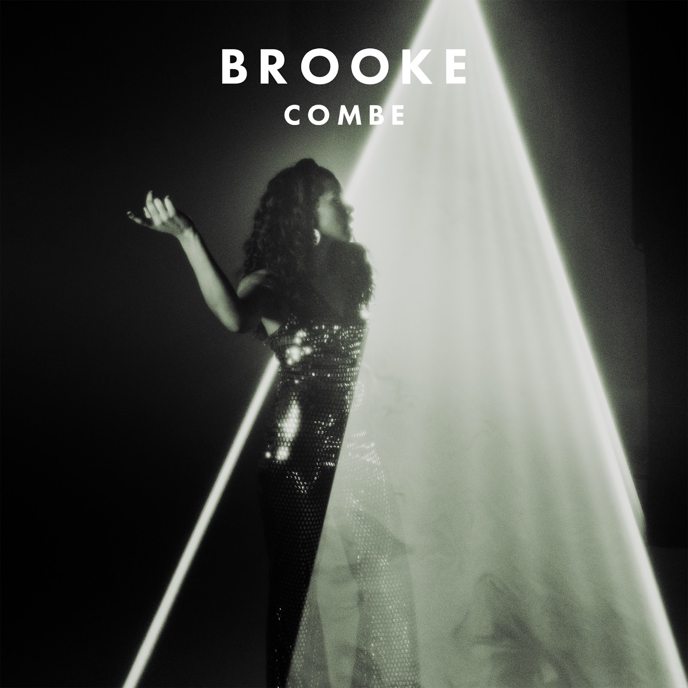
1. Miss Me Now

