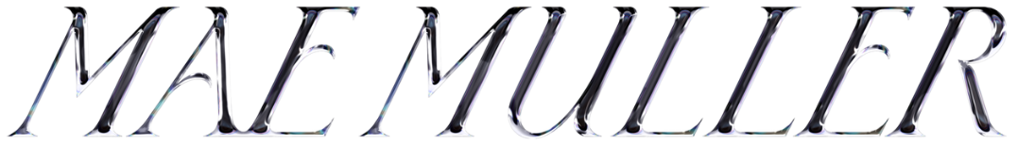

**MAE MULLER DROPS EMPOWERING NEW SINGLE, ‘ME, MYSELF & I’**

[**LISTEN**](https://maemuller.lnk.to/MMandIPR)**/**[**WATCH HERE**](https://maemuller.lnk.to/MMandI/YouTube)

**DEBUT ALBUM, ‘SORRY I’M LATE’ OUT SEPTEMBER 15TH**

**Pre order ‘Sorry I’m Late’** [**here**](https://maemuller.lnk.to/SorryImLatePR)

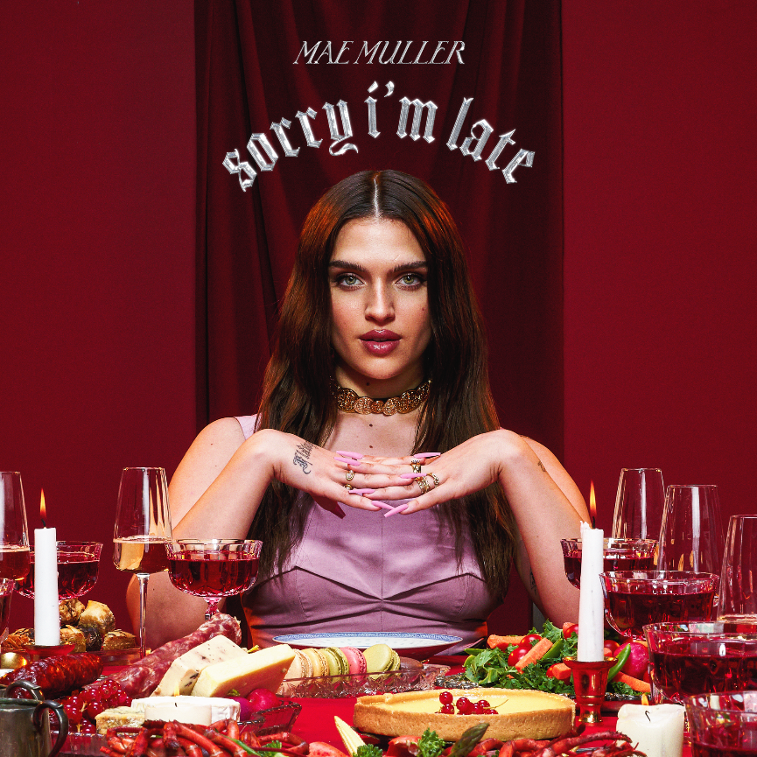

**ACCUMULATED TOTAL STREAMS HIT OVER 2.7 BILLION!**

**NOVEMBER UK TOUR INCLUDES LONDON ROUNDHOUSE SHOW**

**FESTIVAL DATES INCLUDE TRUCK, TRAMLINES AND BRIGHTON PRIDE**

***‘****Muller’s fearlessness is refreshing’* **– The Guardian**

*‘Mae’s authentic sound, butter like vocals and vibrant nature will undoubtedly send her to pop superstardom’* **Clash Magazine**

**‘***Exuding sassy ‘take no shit from anyone’ energy’ –* ***Vogue***

**‘***There’s no denying the star power of Mae Muller’* **– Dork Magazine**

*‘Mae Muller's witty and brutally honest lyrics set her apart from her peers’ -* ***GQ***

**‘***Opinionated, brash and actually talented’ -* ***Sunday Times Culture***

Today, fast rising pop superstar Mae Muller shares her highly anticipated empowering new single, ***Me, Myself & I*** - an instantly infectious and uplifting summery bop – **LISTEN/WATCH HERE**. After a period of intense self-reflection, the track marks a turning point for the North London native both as an artist and a woman.

Vowing to stop turning to others for validation, Muller penned the unapologetic anthem as a way of working through her feelings. Produced by **NEIKED**, the track opens with lyrics in Mae’s signature tongue in cheek style as she playfully reels off a string of failed relationships, whilst celebrating her newfound independence - ‘*I think I found a keeper, it’s* ***Me, Myself & I’***

Of the song Mae says,

*‘Me, Myself & I came so naturally because it was exactly how I was feeling. I became self-aware enough to realise that I’d always had a problem with needing male validation and thinking about how I was being perceived by men. I had to ask myself, who am I even doing this for? I got so sick of caring about other people's opinions: I went celebate for ten months, I focused on more important things. Going through that process showed me how happy I can be on my own.’*

**Me, Myself & I** follows recent top 10 single and No.1 airplay hit, **I Wrote A Song** which The Guardian described as, ‘a bolshy meta- hit about channeling anger at an ex into pop poetry’ and the Independent called an ‘uber catchy dance pop hit’. The dance pop anthem was chosen to represent the UK at the 67th Eurovision Song Contest in Liverpool, and followed the release of the late 2022 single[**“I Just Came To Dance”**](https://www.youtube.com/watch?v=uqVHr8UYHJw) — a gorgeous piece of pop escapism and the platinum-certified smash hit **“**[**Better Days**](https://www.youtube.com/watch?v=GQAOrCOknCY)**”** (a US chart-topping collaboration with **NEIKED** and **Polo G**) All four tracks will feature on Mae’s hugely anticipated debut album ‘**Sorry I’m late**’ - a message to fans who have stuck by her during a period of growth and self-discovery, out on September 16th **Pre order** [**here**](https://maemuller.lnk.to/SorryImLatePR)

A bold voice for a frustrated generation, Mae Muller has amassed a huge following, garnering over 2.7 billion streams. A singular talent, Mae makes pop music that packs a real punch and her debut album, **Sorry I’m Late** is no exception. The 17 track LP is full of songs that are deeply personal yet demonstrate her deft ability to celebrate the female experience at large, capturing the mood of her generation with playful precision. Mae explores love and loss, dating and relationships with fearless honesty, confronting her own experiences whilst also capturing the broader frustrations of young women today. Whilst a fierce feminism often informs her songwriting, her new music exposes a much more vulnerable side. ‘**Sorry I’m Late’** is a love letter to the multiplicity of women.

Over the summer Mae will play several festivals including Truck festival, Brighton Pride and Sundown Festival (full dates below) and tours the UK throughout November, which includes a show at London’s Roundhouse on November 23rd.

**Catch Mae at the dates below**

**Summer Festival dates**

July 8th – Silverstone Circuit, Northamptonshire

July 21st – Truck Festival, Oxfordshire

July 22nd – Tramlines Festival, Sheffield

August 5th – Brighton Pride, Brighton

August 25th – Victorious Festival, Portsmouth

August 27th – The Big Festival, Cotswold’s

September 1st – Coca Cola Music Experience, Madrid, Spain

September 3rd – Sundown Festival, Norwich

**MAE MULLER TOUR**

Mon 20 Nov - Glasgow SWG3 (TV Studio)

Tue 21 Nov 2023 - Manchester O2 Ritz

Thu 23 Nov 2023 -London Roundhouse

Fri 24 Nov 2023 -Birmingham O2 Institute

Sat 25 Nov 2023 -Leeds Beckett Student’s Union

Mon 27 Nov 2023 -Dublin Academy*

**Album tracklisting**

01. I Just Came To Dance

02. Sorry Daniel

03. Bitch With A Broken Heart

04. I Wrote A Song

05. Me, Myself & I

06. Tatiana (feat. Dylan)

07. Somebody New

08. I Wish I Could Hate You

09. Little Bit Sad

10. MTJL

11. Breathe

12. Something Real

13. Nervous (In A Good Way)

14. Better Days (NEIKED x Mae Muller x Polo G)

15. Porn Lied To Us

16. Miss America

17. Written By A Woman

**Follow Mae Muller**

[**Website**](https://www.maemuller.com/) **| I**[**nstagram**](https://www.instagram.com/maemuller/) **|** [**Twitter**](https://twitter.com/maemuller_) **|** [**Facebook**](https://www.facebook.com/maemullerx/) **|** [**YouTube**](https://www.youtube.com/channel/UCJUE0ZnNiQ5HLdyaMz1JA3g) **|**[**TikTok**](https://www.tiktok.com/@maemuller_?lang=en)

**For more information and press enquiries please contact**

**Warren Higgins**

[**warren@chuffmedia.com**](mailto:warren@chuffmedia.com)