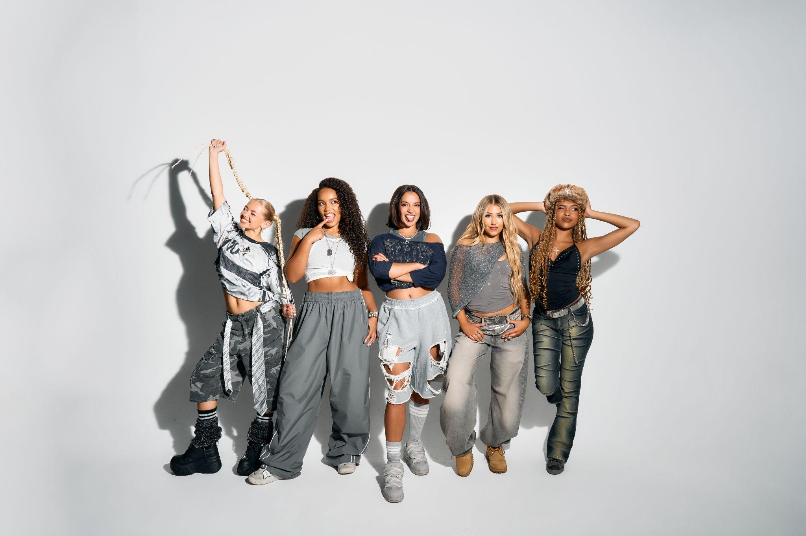
L-R: Zoe, Summer, Reanna, Emmy, Shali

XO - ‘Lovesick’
Listen/Watch the video: https://XO.lnk.to/lovesick

Introducing XO, the essential new UK girlband whose debut single, ‘Lovesick’, is out now on Polydor Label Group.

XO are force-of-nature five-piece Emmy, Reanna, Shali, Summer and Zoe. In sound and spirit they evoke that classic lineage of world-class British girlbands, but with a contemporary, cutting-edge and completely inclusive twist. Think the unstoppable British energy of Spice Girls, as raised on the global pop-girls (Tate McRae) plus that new wave of all-choreo and all-conquering groups like Katseye and Blackpink. Yet XO strive for something more imperfect and unapologetic in their firebrand of Pop: a true representation of what it means to be young and figuring life out as it comes at you. They couldn’t have it any other way, really - because “we’re XO, and we’re probably the most chaotic girlband you’ve ever met in your life.”

XO enter the stage with ‘Lovesick’, a mission-statement banger written alongside alt-pop stars Willow Kayne, GRACEY and produced by Gil Lewis. ‘Lovesick’ summons those ephemeral symptoms of unexpectedly catching feelings - and then catching the night-bus - on a big night out (“I know it’s love / if it’s not I’m sick with something”). Fusing head knocking electropop, personality-packed vocals and a tender chorus, like much of their work to come ‘Lovesick’ is as applicable to a romantic situation as it is the more universal; themes of friendship, sisterhood, and XO’s thoroughly Gen Z vision of Girl Power.

Hailing from Essex, London, Liverpool, Derbyshire and Hong Kong, XO only formed in autumn 2024 but are quickly amassing an ardent fanbase. The band dropped a fly-on-the-wall visual for DIY track ‘Ponytail’, a highlight from their recent schools-tour where the girls earned their stripes performing up and down the country. Asked what their hopes are for ‘Lovesick’ and this first chapter, XO’s answers are as suitably unique to each girl as they are utterly unified: “to set the tone,” says Summer, keen to stay in the moment. Zoe, however, simply states: “World Domination.” You really wouldn’t put it past XO, the next, best British girlband we’ve all been waiting for.

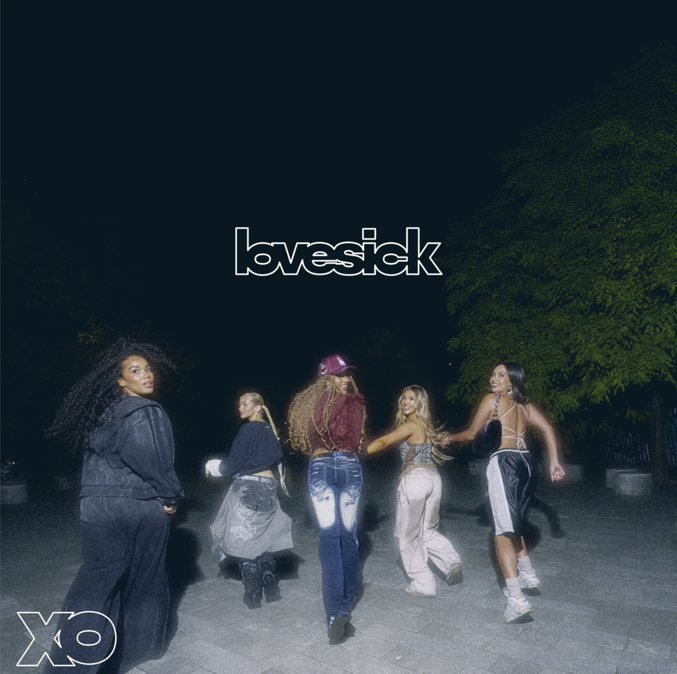
‘Lovesick’ artwork

FOLLOW XO!
Instagram || Tiktok || Official Site || Youtube

For more on info contact warren@chuffmedia.com

