GLOBAL SUPERSTAR NELLY FURTADO RELEASES HIGHLY ANTICIPATED SINGLE “LOVE BITES”
FEATURING TOVE LO AND SG LEWIS

LISTEN HERE
WATCH THE OFFICIAL VISUALIZER HERE

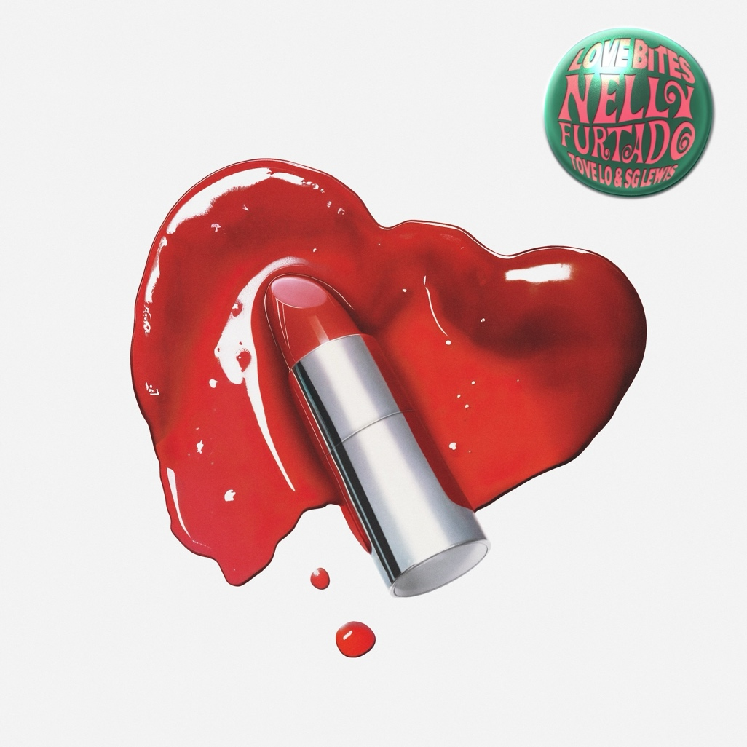

Download Media Assets HERE

22 May 2024 (Toronto, ON) – GRAMMY® Award-winning, multi-platinum artist and global superstar, Nelly Furtado releases her brand-new single “Love Bites” featuring Tove Lo and SG Lewis today via Nelstar/21 Entertainment/Universal Music Canada/Republic Records/Casablanca Records/Polydor Records.

Co-written by Nelly Furtado, Tove Lo, and SG Lewis, and produced by SG Lewis, “Love Bites” is a sultry dance anthem that channels the energy and escapism of dance floors and live DJ sets that sparked Furtado’s inspiration.

“I felt called back to music from the DJ community,” says Furtado. “DJs were remixing my songs at concerts, clubs, and on social media, and I realized how much people like to dance and escape to my music. It’s the healthiest vice you can have, and I love the opportunity to write music that lets people escape more than anything.”

Listen to “Love Bites” HERE and watch the official visualizer HERE

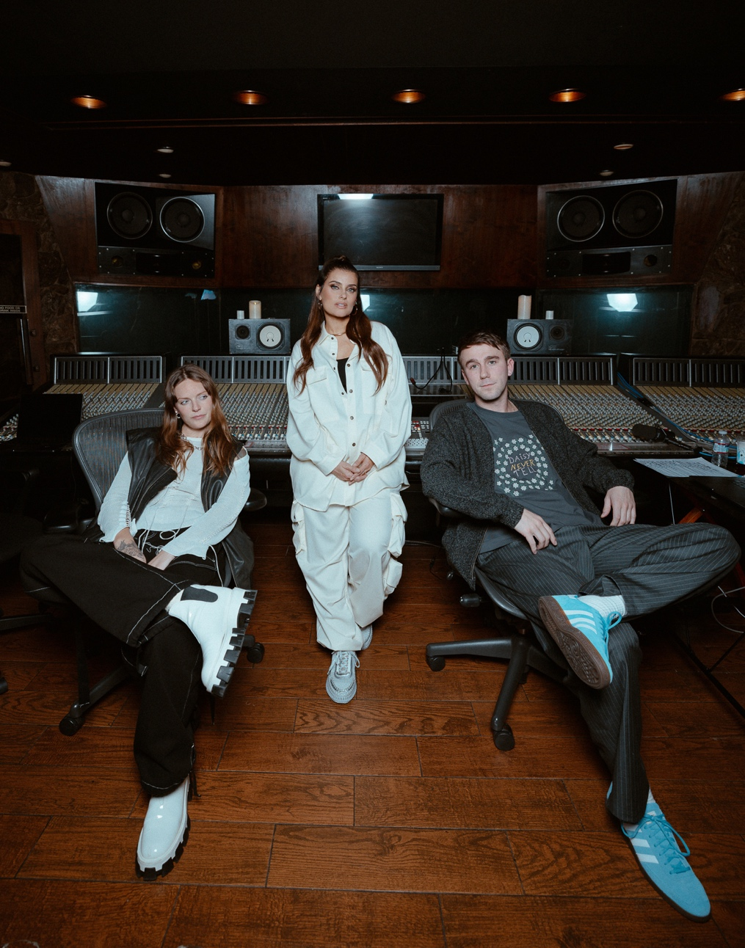
Photo Credit: Jordan Kelsey Knight

Over the past year, the undisputed icon of millennium pop has connected with a brand-new audience of Gen Z fans who have surged her multi-platinum hit singles. In 2023 alone, Furtado racked up 1.5 billion streams bringing her global streaming tally to over 20 billion. Last week, Nelly Furtado entered the YouTube Billion Views Club as the music video for her RIAA 4x Platinum Certified single “Say It Right” reached over 1 billion views. While her music trends on social media and is remixed by DJs around the world, Nelly Furtado has been thrilling her global fan base with new collaborations and surprise performances on stages such as Coachella and Lollapalooza.

This weekend, Furtado is performing at Gröna Lund Festival in Sweden, the latest in her summer-long run of festival dates in the US, UK, Mexico, and Europe which includes co-headlining sets at Fan Fest EURO 2024 alongside Ed Sheeran and Isle of MTV Malta alongside DJ Snake and RAYE. See Nelly Furtado’s announced performance dates below and visit her website HERE for ticket details.

Nelly Furtado - 2024 Festival Tour Dates:

- May 24 - Gröna Lund - Stockholm, Sweden
- May 25 - Jelling Musikfestival - Jelling, Denmark
- May 26 - North Festival - Porto, Portugal
- June 1 - Mighty Hoopla - London, UK
- June 2 - Forbidden Fruit Festival - Dublin, Ireland
- June 12 - Fan Fest EURO 2024 - Munich, Germany
- June 20 - Electric Forest - Michigan, US
- July 16 - Isle of MTV Malta - Malta
- July 20 - Gurtenfestival - Bern, Switzerland
- August 3 - HARD Summer - Los Angeles, US

Sign up to Nelly Furtado’s mailing list HERE for exclusive content, music news, merch drops, upcoming performances, and more.

Follow Nelly Furtado:

Website | YouTube | TikTok | Instagram | X | Facebook

Photo Credit: Sammy Rawal

About Nelly Furtado:

With over 20 billion streams, 35 million albums sold worldwide, and multiple #1 hit singles, Nelly Furtado is an undisputed icon whose innovative songwriting shaped an era and transformed pop music. Her unique "Nelly sound" has earned her Grammy and Latin Grammy Awards, 10 JUNO Awards, Multi-Platinum certifications, and millions of fans around the world. Effortlessly maintaining her place at the forefront of culture, the multi-talented musician and songwriter has landed three #1 songs on the Billboard Hot 100, five within the top ten, has charted #1 on the US Latin Billboard chart, and has sold-out arenas around the world. Since teasing her new album over the past year, her ever-growing global fan base has been glued to her socials, buzzing with anticipation, as she shares glimpses into collaborative studio sessions that last from sunset to sunrise. Inspired by an "inner-revolution", Nelly Furtado has been drawn to the studio, prolifically creating some of her most personal and innovative music to date, sure to dominate the charts and further cement her superstardom.

For more information and press enquiries please contact
Jenny Entwistle
Jenny@chuffmedia.com

