**THE HORRORS**

**RELEASE “**[**LOTUS EATER**](https://thehorrors.lnk.to/lotuseaterPR)**”**

**NEW ALBUM ‘NIGHT LIFE’ OUT MARCH 21ST**

**SOLD-OUT WINTER UK SHOWS**

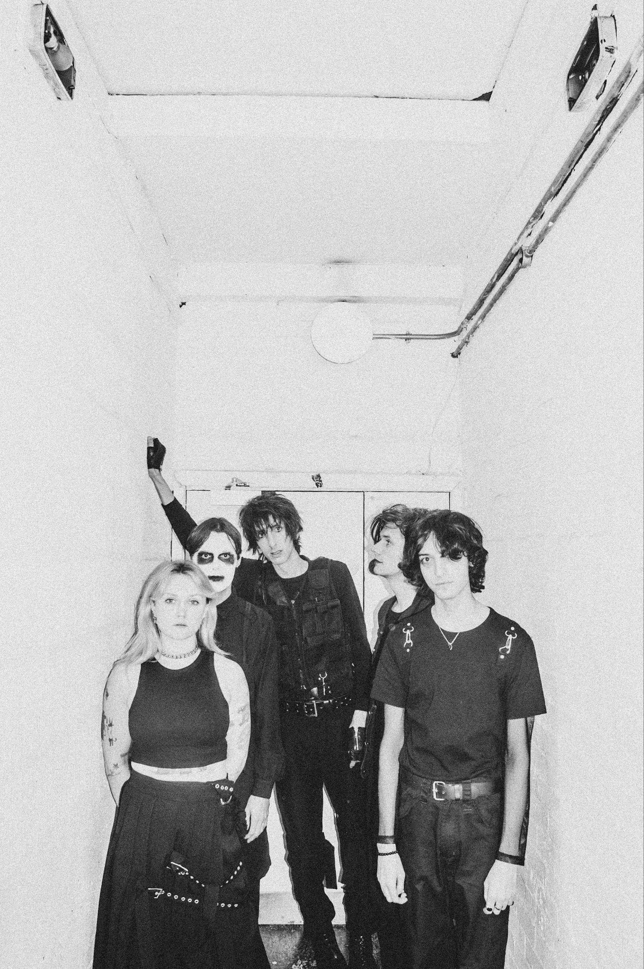

Credit: Cal Moores

The Horrors today release ‘Lotus Eater’, the third track to be taken from their forthcoming sixth studio album ‘Night Life’, out March 21st via Fiction Records. The band are currently in the middle of a run of sold-out UK dates including a stellar show at London’s ICA last week. Final dates listed below.

[**LISTEN TO “LOTUS EATER” HERE**](https://thehorrors.lnk.to/lotuseaterPR)

*“Lotus Eater has had several past lives.”* explain the band; *“It was one of the first songs from the Night Life sessions that we felt really excited about - Rhys’ original lyric had a feeling that made me think of “5 Years” by David Bowie, and I started to build on the idea.*

*A lotus eater lives in a state of blissful ignorance, and the song to me describes the moment of coming back to reality. We wanted it to have a feeling of both melancholy and euphoria, letting go of the past and starting again.*

*The spoken word section was improvised in the studio, and the mid-section of chopped-up electronics came from Amelia’s world of synth programming. It feels almost like a sister track to Sea Within a Sea in some ways, and it’s one of our favourite songs on the new album.”*

As The Horrors approach their 20th anniversary as a band, ‘Night Life’ sees them shapeshift into a new form, with a new sonic outlook and a new line up centred around the core duo of vocalist Faris Badwan and bassist Rhys Webb, now joined by Amelia Kidd on keys and Telegram’s Jordan Cook on drums, making the new album the band’s first to not feature all 5 original members. While demos began modestly in Webb’s basement flat in North London with the pair thriving on the immediacy of, as Faris describes, *“shortening the distance between having an idea and expressing it”*, the record truly took shape in LA under the guidance of producer Yves Rothman (Yves Tumor, Blondshell) before finishing touches were applied back in London along with guitarist Josh Hayward, with Kidd bouncing parts and production ideas remotely from Glasgow.

The resulting album is a record of weight and space, of melancholy and euphoria; a record that has the ability to make bedfellows of seemingly disparate ideas as only The Horrors can. The ‘Night Life’ here is not the vim and vigour of pubs and clubs. It’s the thoughts that happen under the cover of darkness; the places your mind takes you when the rest of the world is asleep. A record born out of a desire to revive the raw, instinctive spirit of the band’s early work.

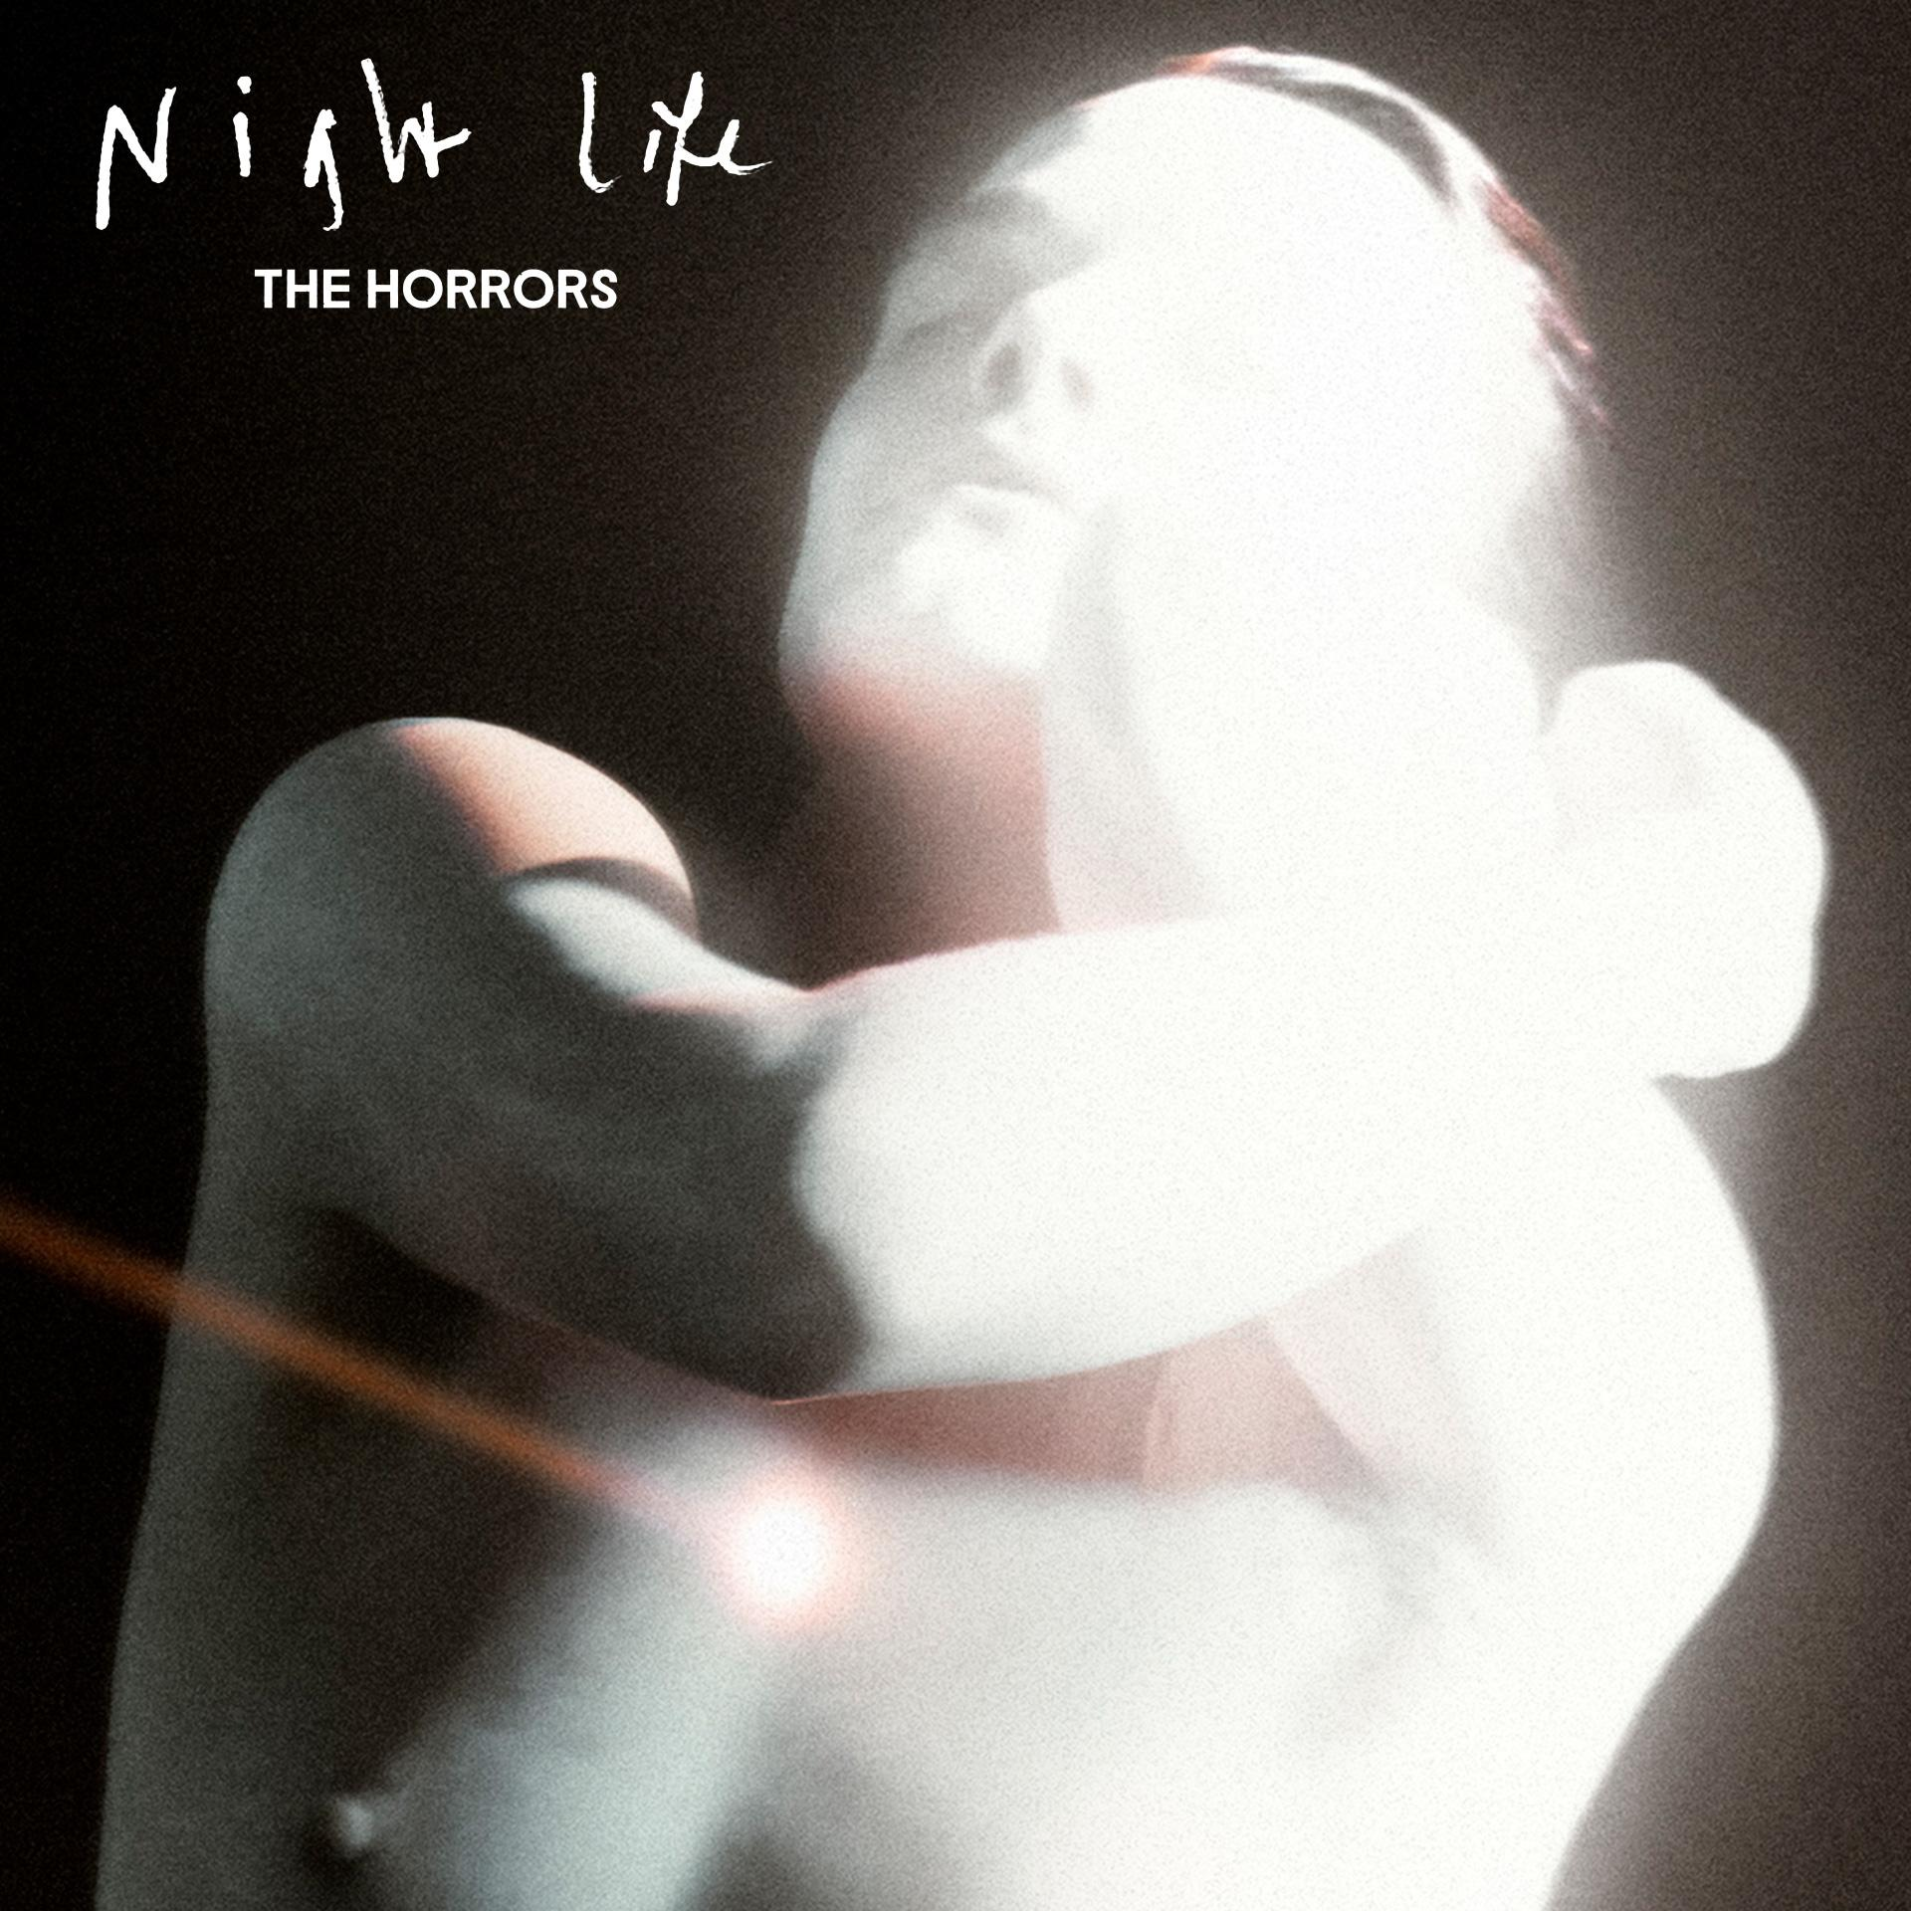

After nearly 20 years making music, there are few bands who’ve created a canon as determinedly innovative and consistently critically-acclaimed as The Horrors. Emerging as zeitgeist-shaking garage-goths on their 2007 debut ‘Strange House’, before taking a sharp left turn for their Mercury-nominated follow up ‘Primary Colours’, since the beginning they’ve roamed freely between genres. 2011’s ‘Skying’ won the NME Award for Best Album; ‘V’ was heralded as “a triumph” in a five-star Guardian review, while 2021’s pair of EPs - ‘Lout’ and ‘Against The Blade’ - marked a new chapter with their most industrial, uncompromising output yet.

[**Preorder/Pre-save ‘Night Life’ HERE**](https://thehorrors.lnk.to/nightlifePR)

**The Horrors Live Dates:**

Wed 4 Dec 2024, Leeds, Belgrave Music Hall **SOLD OUT**

Thu 5 Dec 2024, Glasgow, Room 2 **SOLD OUT**

Thu 12 Dec 2024, Blackpool, Bootleg Social **SOLD OUT**

Fri 13 Dec 2024, Bristol, Strange Brew **SOLD OUT**

Sat 14 Dec 2024, Southend, Chinnerys **SOLD OUT**

**‘Night Life’ tracklisting:**

1. Ariel
2. Silent Sister
3. The Silence That Remains
4. Trial By Fire
5. The Feeling Is Gone
6. Lotus Eater
7. More Than Life
8. When The Rhythm Breaks
9. LA Runaway

[www.thehorrors.co.uk](https://www.thehorrors.co.uk/)

**For more info contact** [**warren@chuffmedia.com**](mailto:warren@chuffmedia.com)