ONLY THE POETS
SHARE HEARTBREAK ANTHEM ‘LOOKING AT YOU’
LISTEN HERE
SOLD-OUT UK TOUR THIS OCTOBER!
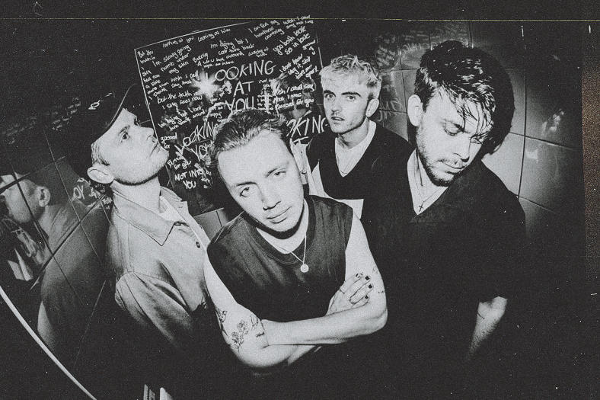

“Their respect and appreciation for their fans feels genuine, and it’s never more apparent than when they share the room together” – CLASH
“It was banger after banger…You'll be itching to see their next show” – GIGWISE
Today, alt- pop four-piece Only The Poets finally drop the full studio version of fan favourite track ‘Looking At You’, produced by the band and mixed by frequent collaborator Dan Grech (Rina Sawayama, Muna, Tom Grennan, Dylan).
Initially released on their ‘demos.’ EP back in 2021, the eagerly anticipated fan release is a sure-fire highlight in the band’s rousing live set. With lyrics that perfectly capture the sinking feeling of seeing someone move on, the single is set to become a huge live anthem to add to their arsenal of fist-bumping bangers.
The band played ‘Looking At You’ as part of their euphoric set at their first Reading Festival performance, which drew in the biggest crowd across the weekend at the BBC Introducing stage. As a band from Reading and nearby Banbury, they grew up going to the festival witnessing many iconic moments, notably Arctic Monkeys’ first headline slot which galvanized them to form a band themselves.
Frontman Tommy says, “This song is all about a night in a club when I ran into my ex-girlfriend for the first time since we’d broken up and she was with someone else. The day after I wrote this song to air out how it made me feel. It’s a song all about heartbreak and a little jealousy.”

The Reading four-piece, comprising Tommy Longhurst, bassist Andy “Roo” Burge, guitarist Clem Cherry and drummer Marcus Yates, have established themselves in just a few short years as one of the UK’s biggest emerging live acts. Unsigned until recently, the band’s DIY ethos saw them build things from the ground up, from playing student house parties, pub circuits and small venues to selling out 1,600-capacity venues in the UK and across Europe last year. The band will be celebrating the release of ‘Looking At You’ tonight by playing the track at a student house party in Reading, in celebration of their early roots as a band.
Recent single Crash fuses propulsive drums and driving guitar with an undercurrent of synth-pop elements and has seen huge support from the likes of Radio 1 including a recent Maida Vale session. Whilst previous track Jump is a rousing call to arms set to widescreen, galloping riffs, blending sparkling indie-pop and the everyman swagger of Bruce Springsteen and Sam Fender.
Having played a huge sold-out EU tour in spring earlier this year which culminated in a triumphant sold-out slot at Shepherd’s Bush Empire, Only The Poets have also announced a small ‘Homecoming’ UK tour, taking in Glasgow, Newcastle, Leeds, Manchester, Bristol and London – all dates have now sold out.

Catch Only The Poets:
23rd September: Reeperbahn Festival, Hamburg
21st October: Colours, London (SOLD OUT)
22nd October: Vinyl signing event, Sunflower Lounge, Birmingham
23rd October: Nice & Sleazy, Glasgow (SOLD OUT)
24th October: Think Tank, Newcastle (SOLD OUT)
25th October: Lending Room, Leeds (SOLD OUT)
26th October: Vinyl Signing event – 33 Oldham Street, Manchester
29th October: Deaf Institute, Manchester (SOLD OUT)
31st October: Louisiana, Bristol (SOLD OUT)
1st November: Joiners, Southampton (SOLD OUT)

DON’T MISS A THING:
OTP // INSTA // TWITTER // FB

For more information and press enquiries please contact
Jenny Entwistle
Jenny@chuffmedia.com

